
MSIS 2.0
Training Guide

OTSS
Data Use & Professional Learning

Creation Date: May 2023
Last Updated: September 10, 2025
Contact: Barbara Young
Email: byoung@mdek12.org
Table of Contents
Preface 4
Initial Login/Registration to MSIS 5
Microsoft Users 5
Google Users 7
MSIS Login Screen 9
MSIS Application Access 9
Administration 10
Manage Users 11
Multi-District Users Only 15
Home 18
Inactivity 19
Data Submission 20
Upload a File 20
Submission Status 21
Data Quality Dashboard 22
Accreditation 24
Reports 25
Data Analytics 25
Data Entry Download 25
Profiles 25
Reports 26
Certification Reports 26
Students 29
MSIS ID Requests 29
Student Ownership 30
Data Input 32
LEA & School Info 32
LEA Management 33
School Management 33
Charter Schools 34
LEA Sharing 34
Board Members 35
Salary Scale 35
Student 36
Student Intervention 36
Non Public Student 37
Summer Activity 39
Seal of Biliteracy 39
Update Grades And Promotions 39
Cohort 40
Senior Snapshot 40
MDE/OTSS (MDE Only) 41
Course Codes 41
SEA Organizations 46
Data Governance Resource 48
Frequently Asked Questions 48
Glossary 49

Preface
Welcome to MSIS 2.0! The new student information system is designed with the help of users in the LEAs. It is a web-based platform and user-friendly. MSIS receives data every night from the student information systems (SIS) and other vendors. It does not have planned downtime during the summers or other times. You will have the ability to view and correct data (that has not been certified) daily. (More info about the project, events, and resources is available online: https://www.mdek12.org/msis2.0).
Please read this guide thoroughly to understand its purpose and use. Share this guide with all new and current MSIS users in your LEA. If you need in-person or virtual training, please check our site for past or upcoming events here: https://www.mdek12.org/msis2.0/events. There are additional training materials available on the MDE website here: https://www.mdek12.org/msis2.0/resources.
Note: This guide is a living document and will be updated as frequently as needed. The Last Updated date will be shown on the cover page of this document.
Please note screenshots may be slightly different while changes continue to be released, but the steps should still apply.

Initial Login/Registration to MSIS
Go to msis.mdek12.org to login to MSIS. You will be required to register your account using your LEA username and password.
If your LEA uses Microsoft, then select Microsoft Account.
If your LEA uses Google, select Google SSO.
Note: If your LEA can use either Microsoft or Google, make sure you choose the account you will use for email and continue to use that account. You cannot use both Microsoft and Google for your registration/login. You must only use one.
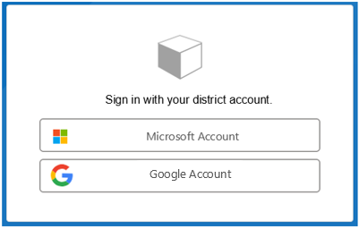

Microsoft Users
Microsoft users enter your LEA email and select Next.
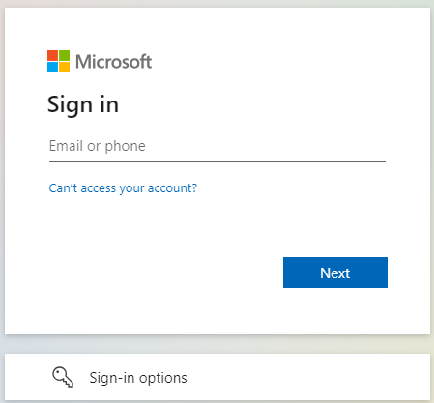
Enter your password, and select Sign in. The screen will look like the below.
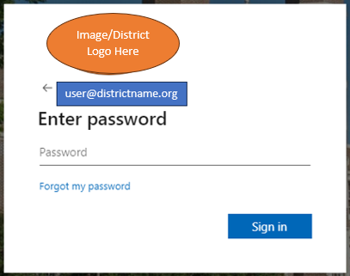
If required, follow any multi-factor authentication or two-factor authentication requirements.
Note: If your LEA is using multi- or two-factor authentication methods and you have recently authenticated, you may not be required to enter your password.
Once these steps are completed, you should be able to login MSIS, but will need to wait on an administrator to assign your permissions. The below message is NOT an error message and should be the expected result of a successful registration.
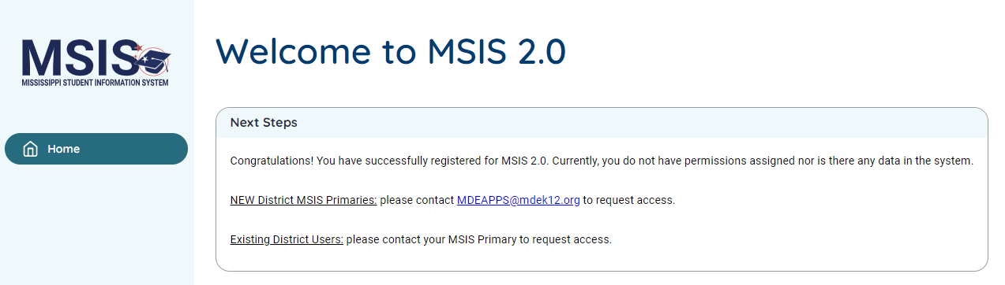
Note: If you are a LEA administrator (MSIS Primary or Secondary), be sure to submit your security form to mdeapps@mdek12.org. If you are any other LEA user, contact your MSIS Primary to grant permissions. (Go to https://www.mdek12.org/OTSS/MSIS/security-documents to retrieve the document(s) you may need.)

Google Users
Google SSO users enter your LEA email and select Next.
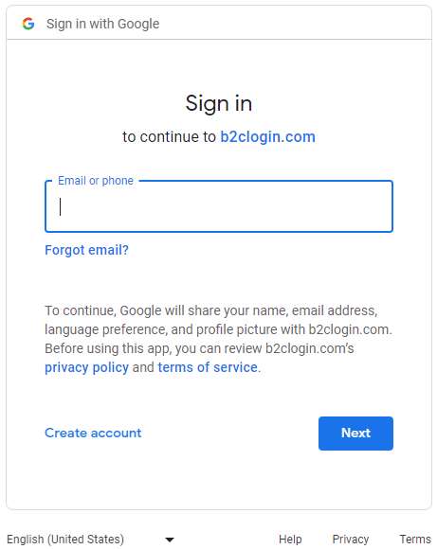

Enter your password and select Next. The screen will look like the below.
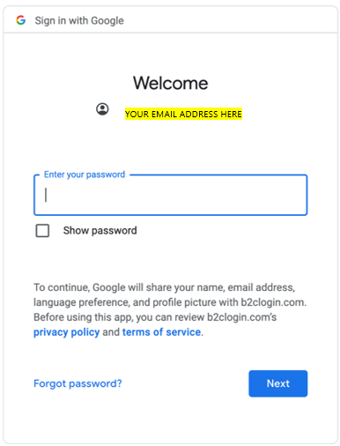
If required, follow any multi-factor authentication or two-factor authentication requirements.
Note: If your LEA is using multi- or two-factor authentication methods and you have recently authenticated, you may not be required to enter your password.
Once these steps are completed, you should be able to login MSIS, but will need to wait on an administrator to assign your permissions. The below message is NOT an error message and should be the expected result of a successful registration.
Note: If you are a LEA administrator (MSIS Primary or Secondary), be sure to submit your security form to mdeapps@mdek12.org. If you are any other LEA user, contact your MSIS Primary to grant permissions. (Go to https://www.mdek12.org/OTSS/MSIS/security-documents to retrieve the document(s) you may need.)

MSIS Login Screen
Go to msis.mdek12.org to login to MSIS. Enter your LEA username and password. Remember, MDE does not control your username or password information, your LEA controls this information.
Note: If you are having difficulty logging in and are receiving errors such as username invalid, or password incorrect, then reach out to your MSIS Primary or Technology Staff regarding your account. If you are receiving messages such as, page can’t be reached, or page not found, or 404 error, then please contact MDEAPPS@mdek12.org.
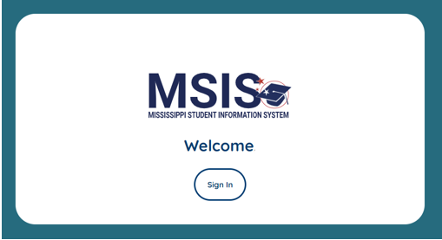

MSIS Application Access
Rule(s): If you are adding or modifying the MSIS Primary or Secondary, you may need to complete a security form and email it to the MDE Helpdesk. The Oath of Confidentiality and Security Forms for Public and Non-Public Schools are available on the MDE website: https://mdek12.org/msis/msis-security-documents/.
The MSIS Primary assigns the permissions to each user in your LEA. If your permission is incorrect, needs to be modified, etc., then please contact your MSIS Primary in your LEA. If there is no MSIS Primary, then contact your Technology Department or administrator to determine who manages the MSIS user information. If you are a new or current MSIS Primary and need new or different permissions, please contact mdeapps@mdek12.org.
If you have been granted access to MSIS, but do not have any permission(s), then you will see the Welcome screen with a message alerting you of this. If you feel this message is in error, please contact your MSIS primary to ensure access has been completed.
Note: It may take 24 hours before report rights are updated and available to a user.

Administration
If you are an MSIS Primary or Secondary, then you have administrative rights and are responsible for managing users for your LEA and school(s). You will see an Administration option in the left menu and see the Manage Users option. If you do not see the Administration option, please email mdeapps@mdek12.org.
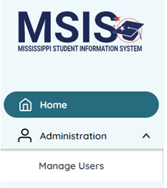

Manage Users
As an administrator, when you select this option, you will see all users that have registered in your LEA. You will see the name, email, status, and actions available. Users will be Active (green bubble) or Inactive (gray bubble). You may view, edit, activate, or deactivate users. Please refer to the QRG: User Menu Options for more information regarding which options are available for which permission.
Note: Multi-District users, please refer to subsection “Multi-District Users”.
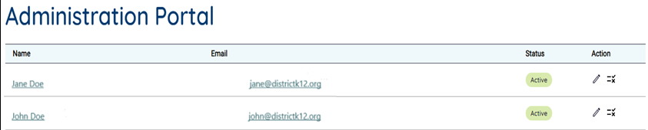
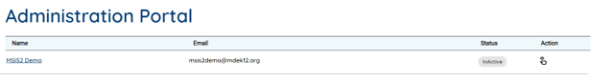
Select the user’s name to go to User Detail View. This allows you to view the user without making any changes.
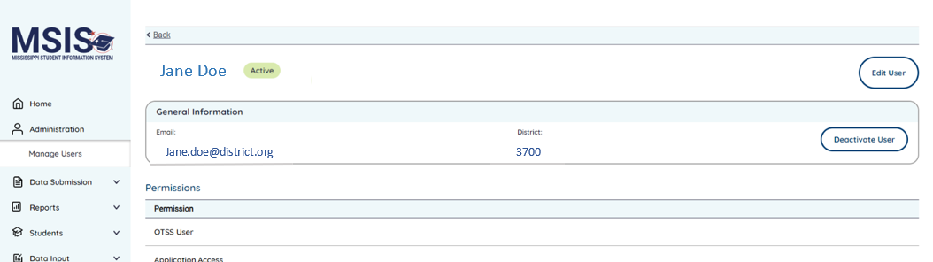
(larger view below)
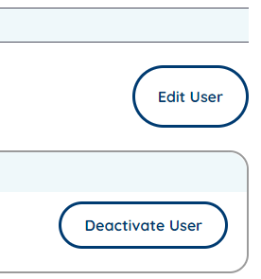
You may edit a user to modify their permissions. You may deactivate a user to remove their rights to view or edit data. You may activate a user to allow them to access MSIS and then grant them permissions.
Select the pencil icon to Edit User Access (below) or select the Edit User button from the previous screen (above). Select the checklist icon (below) or the Deactivate User button (above) to deactivate a user. Select the finger-point icon or the Activate User button to activate a user.
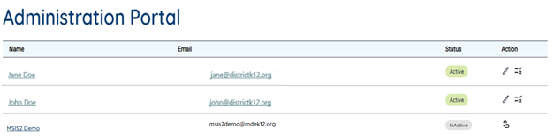
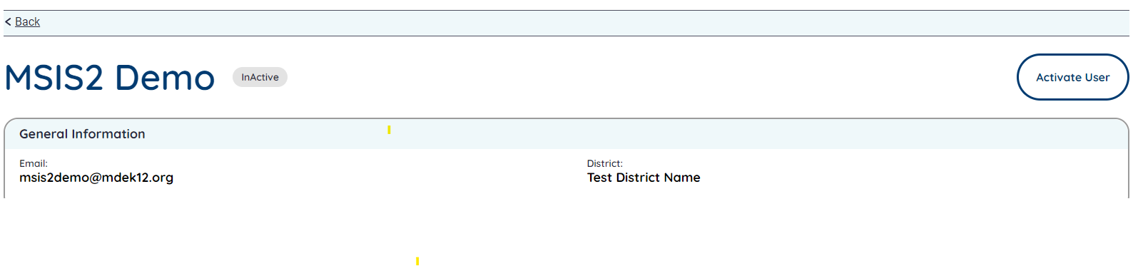
The Edit User Access screen allows you to view the user’s name, email address, LEA, and school assignments. You may view and modify the Permissions.

(larger view of Action buttons)
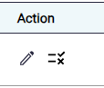
At this time, you cannot delete users from the Manage Users screen. We are working on a future enhancement to allow you to delete users with no activity/history or hide deactivated users from current view in the future.
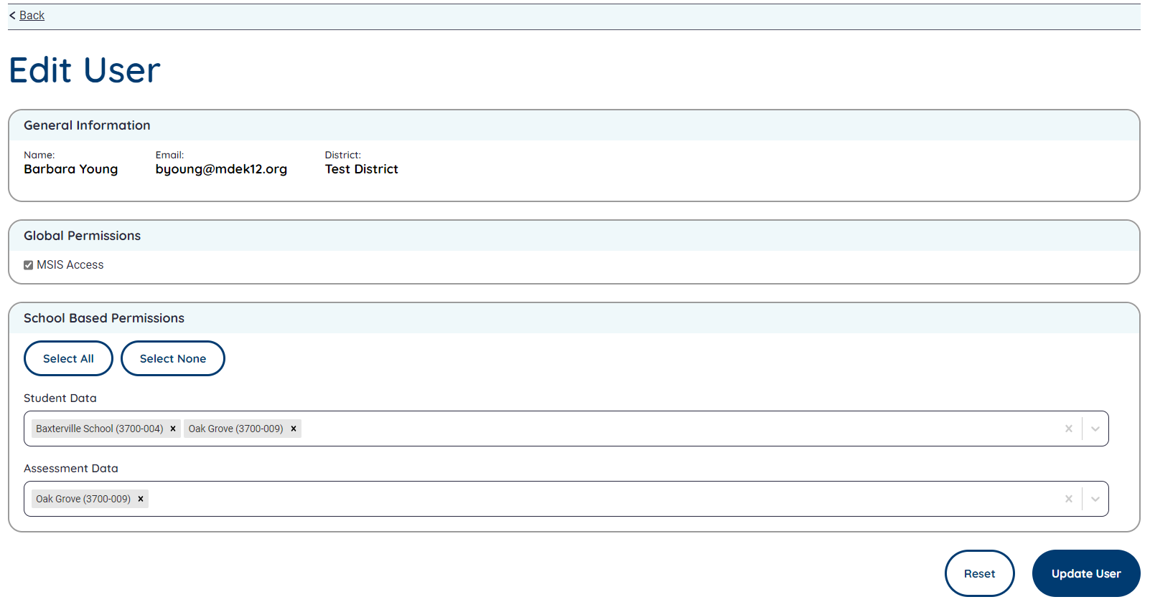
You may make changes to permissions that are assigned, then select Update User to save. If you check or uncheck an option and want to undo changes, then select Reset to clear any unsaved changes. If no changes are needed, select Back in the upper left corner of the screen to return to the Manage Users screen.
Note: If you make changes and select the Back option without selecting Update User, then your changes will not be saved.
Users must be assigned to at least one school to access Student Data and Assessment Data sections (below). School permission is for school-level data for each school selected. If you want the user to have access to view data for the entire district, then Select All schools so the user will have LEA permission for LEA-level data.
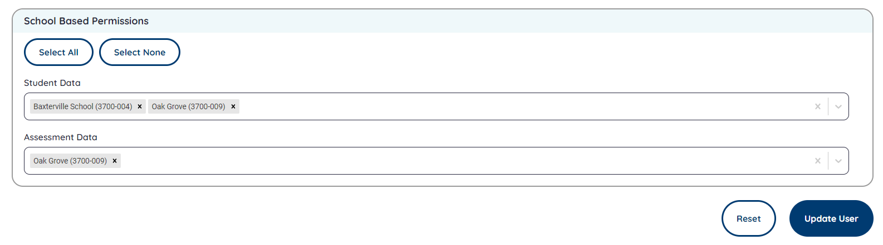
Users will only see student data for school(s) assigned to them. If all schools are selected, then they will see LEA data.
Users will only see assessment data for school(s) assigned to them. If all schools are selected, then they will see LEA data.
Users must have CTE permission to add or view CTE students and must have Special Education permission to add or view Special Education students.
Users must have access to Can Certify District to certify LEA data.
Users must have access to Can Certify Schools to certify school level data (only available for Student domain.
Users must have access to MSIS ID Requests to access the Students > MSIS ID Request screen or upload MSIS ID Request files.
Users must have access to Student Ownership to access the Students > Student Ownership screen.
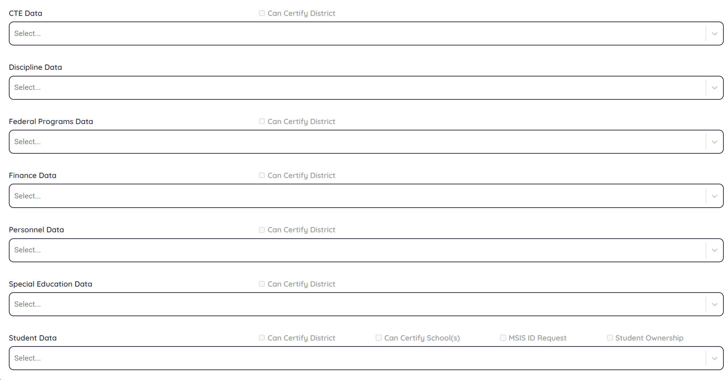
Larger view:
Note: Checkboxes will be disabled if no schools are selected.
Select Deactivate User to deactivate a user. You will be prompted with a confirmation screen to confirm you want to deactivate the selected user. Select Yes to continue or No to cancel and remain on the User Detail screen.
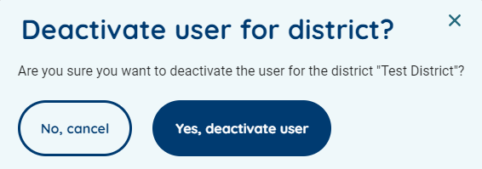
A message will be displayed alerting you that the user was deactivated successfully.
Note: Deactivating a user will not remove them from MSIS. It will only remove their permission to view or edit data. They will no longer have options and will display as Inactive on the Manage Users screen.
Select Activate User to activate a user. You will be prompted with a confirmation screen to confirm you want to activate the selected user. Select Yes to continue or No to cancel and remain on the User Detail screen.
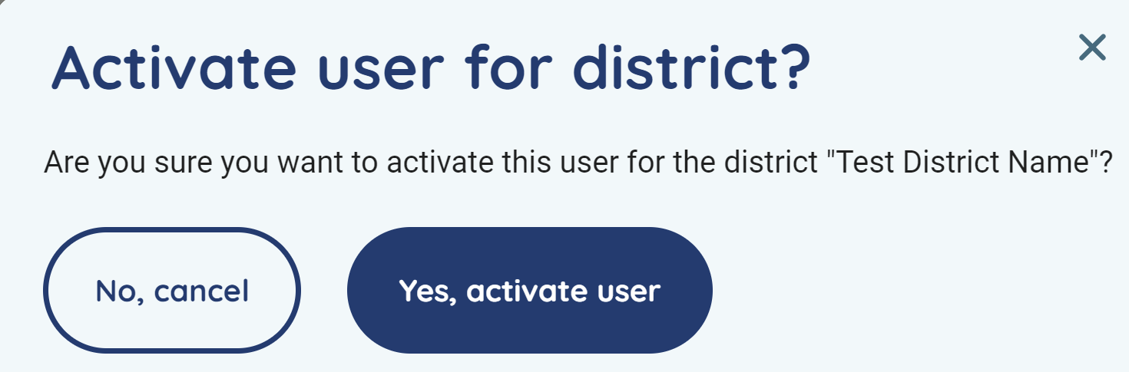
A message will be displayed alerting you that the user was activated successfully.

Multi-District Users Only
The above section still applies for multi-district users. However, there are slight differences that primaries and secondaries will see on the User Profile and Edit User screens.
Notice all districts assigned to the user will be displayed under their email address. This must be emailed to the help desk by the district primary or secondary. Once the help desk has added the district assignment, then the user’s permissions can be set for each district.
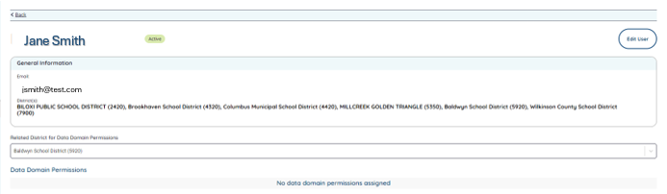
(larger view below)
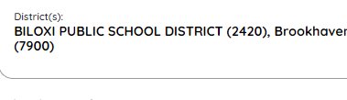
The Primary or Secondary will need to set the user’s permission for each district they are assigned to by selecting the district from the Related District for Data Domain Permissions. (see screenshot)
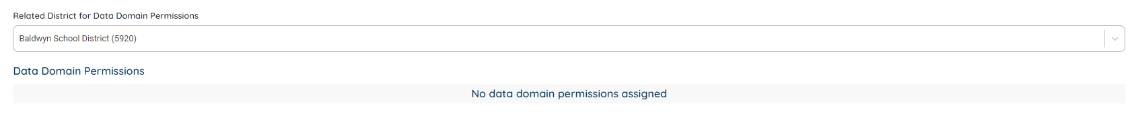
(larger view below)
Select the district from the dropdown and then assign the appropriate permissions and select Update User to save changes. Select another district and then assign the appropriate permissions and select Update User to save changes for that district.
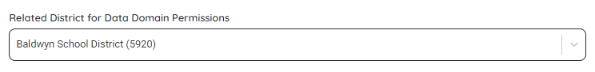
If the user does not have any permissions assigned, their profile will look like the below with No data domain permissions assigned.
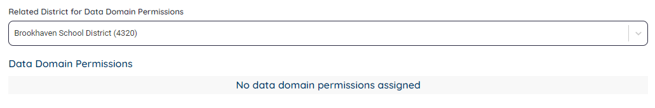
If the user has permissions assigned, their profile will look like the below and show which permissions they have.
Example 1:
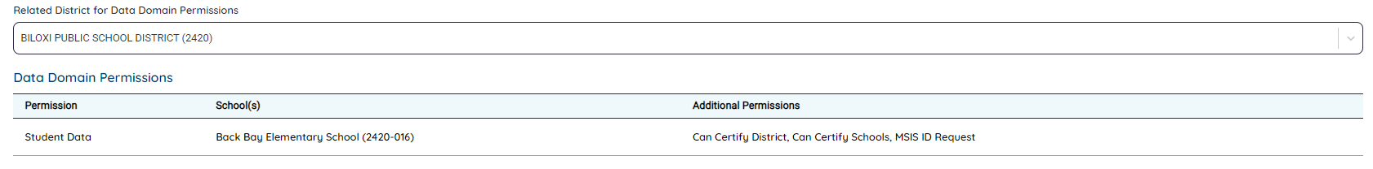

Example 2:
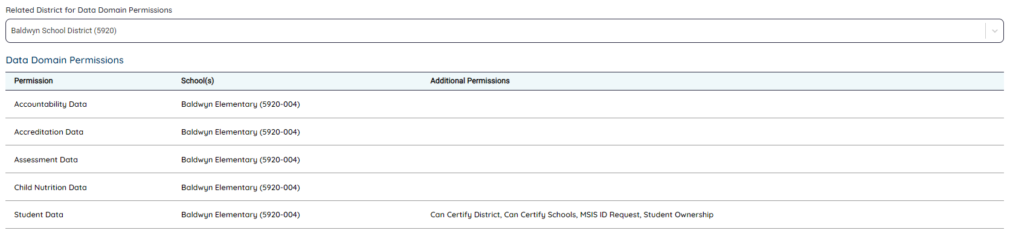
(larger view)
Multi-district users, including state users will also see an LEA selection in the left navigation menu. Users will only see the LEAs they have been assigned. Example: User is assigned to two LEAs, so only those two LEAs will be available in the dropdown.
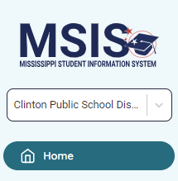

The Universal District Dropdown is only on certain pages of the menu and will only display data for the selected LEA. This dropdown will only be available on the following pages:
- Home/Landing page
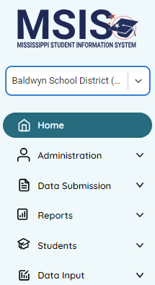
- Administration > Manage Users (not view or edit user profile pages)
- Data Submission > Upload a File
- Data Submission > Submission Status
- Data Submission > Data Quality Dashboard (not details page)
- Data Submission > Accreditation
- Reports > Data Analytics (not View Report page)
- Students > MSIS ID Requests
- Students > Student Ownership
- Data Input > LEA & School Info > School Management tab
- Data Input > LEA & School Info > Salary Scale tab
- Data Input > LEA & School Info > Board Members
- Data Input > Student > Student Intervention
- Data Input > Student > Non Public Student List page (not entry page)
- Data Input > Student > Summer Activity
- Data Input > Student > Update Grades And Promotions

Home
After successfully registering and being granted permissions for MSIS, you will see a Welcome screen, alerts or notifications, and a left menu navigation.
Your name will be at the top and bottom left of the screen and any options you have access to will be shown on the left of the screen.
Based on your permission settings, you may also see success or error messages on the screen regarding file uploads and any deadlines that may be approaching.
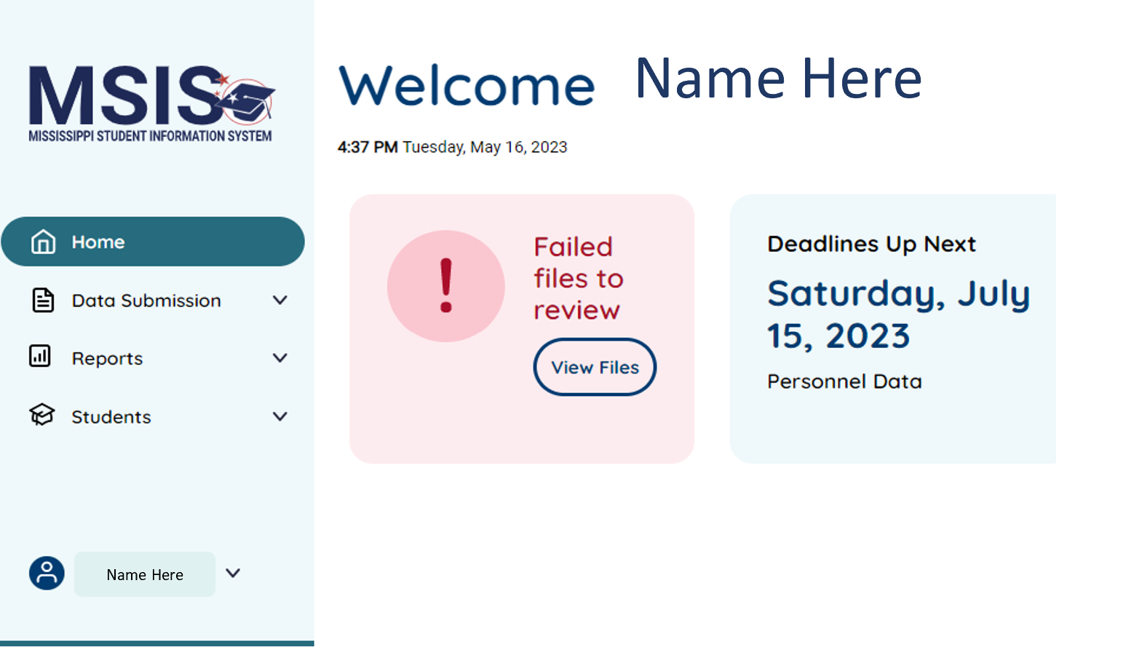
When you are ready to logout of MSIS, select the arrow next to your name (bottom left) and select Logout. Once you have logged out of MSIS, you will be returned to the Login screen.
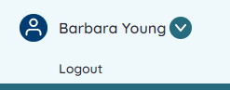
Name Here

Inactivity
If you are inactive for at least 15 minutes, then you will receive a message about inactivity. You will be automatically logged out if you do not respond within 30 seconds.
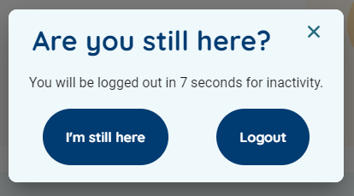
If you are logged out, a note will be displayed on the login screen letting you know you were logged out due to inactivity.
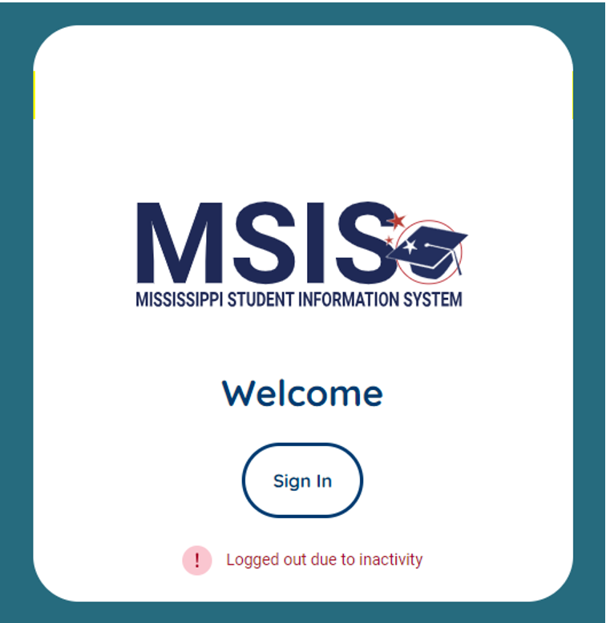
When you login again, the system will place you on the page where you were when you became inactive. For example, if you were viewing a report and then timed out, when you login again you will be placed on the report page rather than the Home page.

Data Submission
Rule(s): It is important to make sure your data is up to date in your SIS or other vendor package(s), or upload timely and accurate files. If your data is sent via API, then you should NOT also upload files for the same data. For example, you should not upload SpecEd.** data files if your Special Education vendor is sending the same data via API.
Select from the following options based on your permission(s): Upload a File, Submission Status, Data Quality Dashboard or Accreditation.

Upload a File
If necessary, users may upload a file in MSIS. Select Data Submission then select Upload a File. File specifications are shown on the screen including naming convention, file size, file quantity, and file format. Users may upload 1 file at a time and must use Microsoft Excel or Google Sheets when creating files in .csv format. We recommend viewing your file in Notepad (windows) or TextEdit (Mac) to check for any extra spaces in cells, or empty rows/extra commas at the bottom of the file. (See our https://mdek12.org/msis/msis-resource-library/ for Video Tutorials for formatting your spreadsheets.
The only file accepted in .xml format is the Finance.FETS file. This file should be exported from your finance vendor software and not modified, except for renaming the file. Any changes should be made within the financial package and then re-export the file again before renaming and uploading to MSIS.
Users may be required to have special permissions to upload files such as having MSIS ID Request permissions in the Manage Users screen will allow the user to upload MSIS ID Request files and to view those files in the Submission Status screen. Users will only see files they have uploaded or that others have uploaded based on their school permissions. So, users assigned to School A may only see files for that school and when any special permissions are enabled for that user, if applicable.
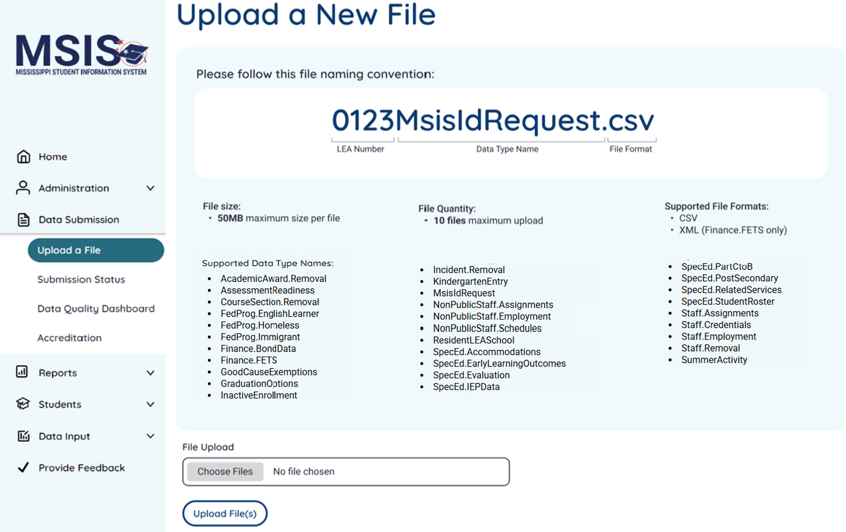

Submission Status
Select Data Submission then select Submission Status. Users may view the status of files that have been uploaded including the name, date & time, uploaded by, and status. If a file is in Failed status, users may utilize the trash can icon to delete the file from the list. Users may also select filters to view a subset of data.
Note: It is recommended that users delete failed files after a successful file upload has been achieved for the specific data type.
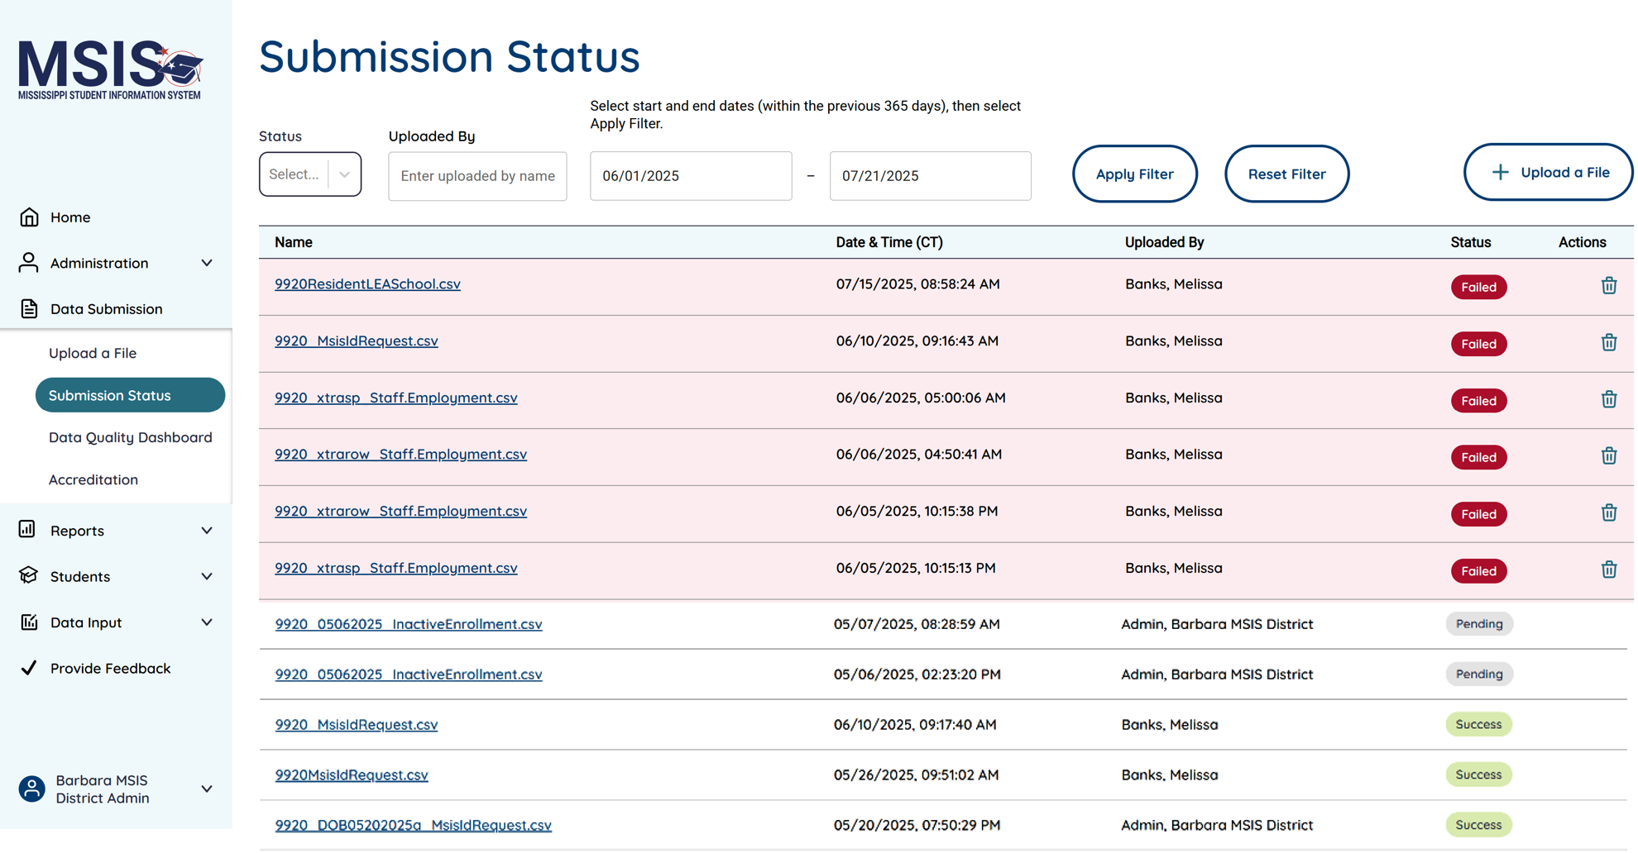
Users will only see files for schools they have permission to and only when special permission has been enabled, if applicable.
When using the filter(s), users select the criteria and must select the Apply Filter button to search. Users should select the Reset Filter button to clear the filter(s). The available filters are: Status (Failed, Pending, Success), Uploaded By (any part of the username who uploaded the file), and a from and to date (within the previous 365 days). Any or all filters may be applied. 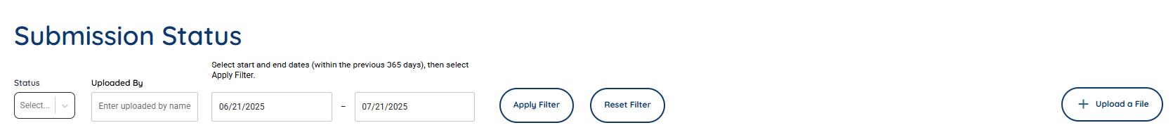
If a file is in Failed status, users may select the filename link and view errors with details about resolution.
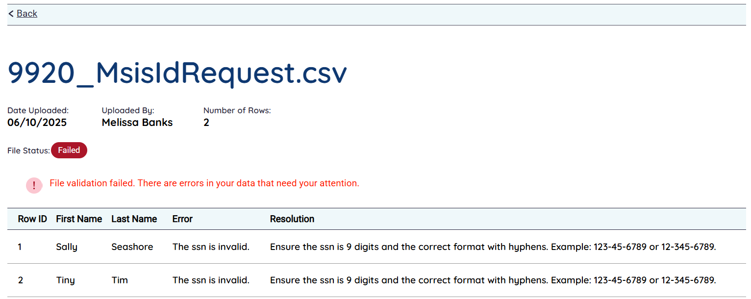
If the file contains errors, a red pill will be in the status column to show Failed status. If a file has not been processed, a gray pill will be displayed in the status column to show Pending status. When a file has been successfully processed, a green pill will be displayed to show Success.
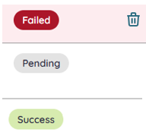

Data Quality Dashboard
The Data Quality Dashboard (DQD) allows users to view errors related to their data. Available Dashboards include the following bubbles: Assessment, Attendance, Child Nutrition, Course Section, CTE, Discipline, Enrollment, Federal Programs, Finance, Organization, Personnel, Special Education, and Student Demographics.
Note: Accreditation is a separate dashboard with LEA, School, and Personnel bubbles later in this manual.
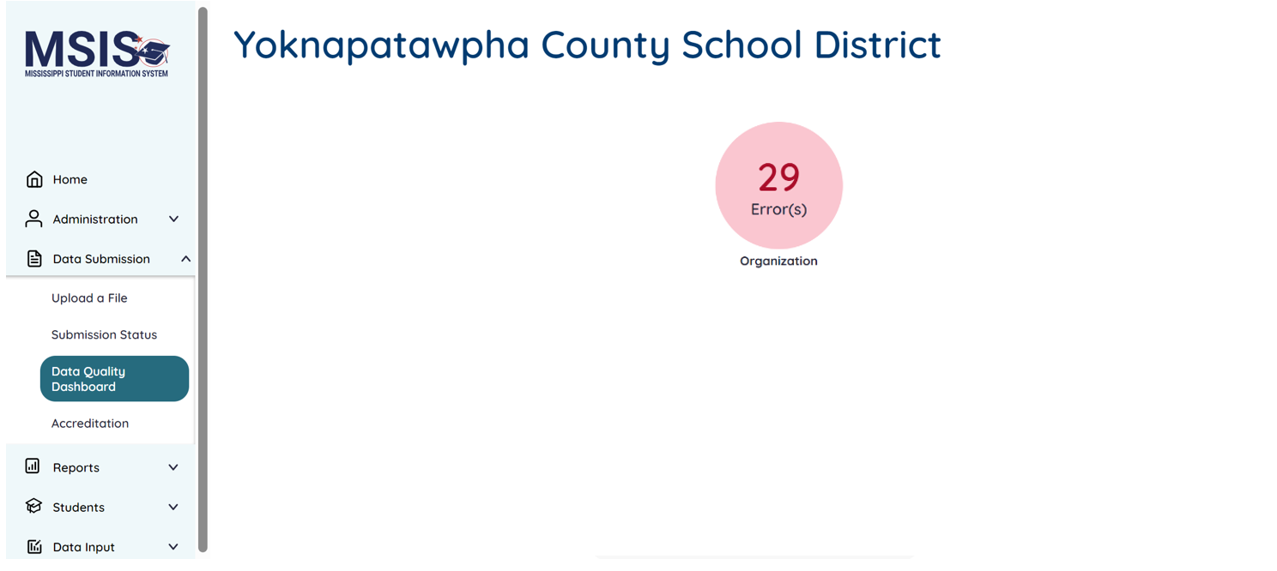
Note: Only admins will see the Organization bubble.
Users must have data domain permission to view areas of the DQD.
Bubbles are displayed separately as Errors (pink/red) and Warnings (yellow/golden).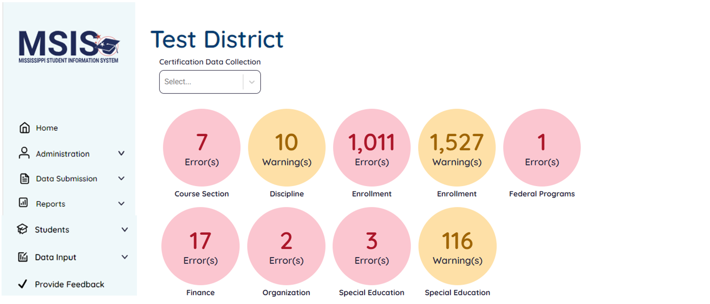
Users can select a bubble to view the errors or warnings. Users cannot edit data in MSIS and must make corrections in the SIS package or other vendor package (financial, HR, personnel, etc.) or via file upload (where applicable) to correct errors. Data will be updated nightly, and users can view the DQD the next day to monitor resolution of errors.
Note: Errors and Warnings are displayed for the current school year. Users may select the Back button at the top of the DQD to return to the main DQD screen. If all errors/warnings for a domain/bubble are corrected, then the bubble will disappear from the dashboard.
The Data Quality Dashboard details screen will have tabs across the top that are for each business rule. As errors are corrected, the tabs will be hidden from view.
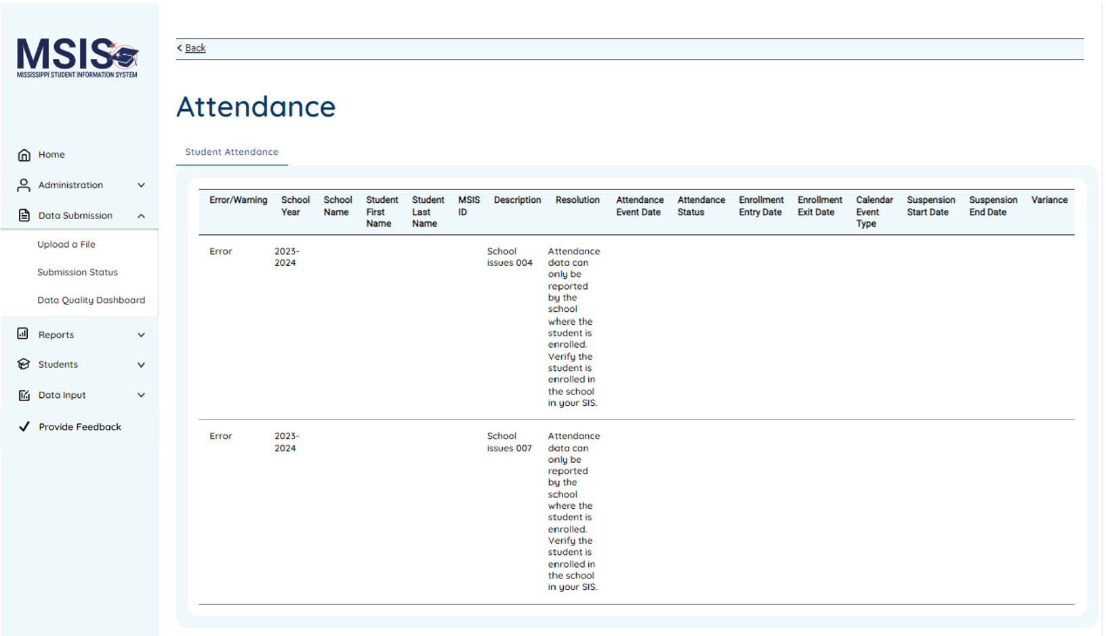

Accreditation
The Accreditation Dashboard displays errors related to accreditation standards. Users must have Accreditation permission to view this dashboard. Users must use the left menu to view Accreditation under Data Submission. There will be three bubbles: LEA, School, and Personnel.
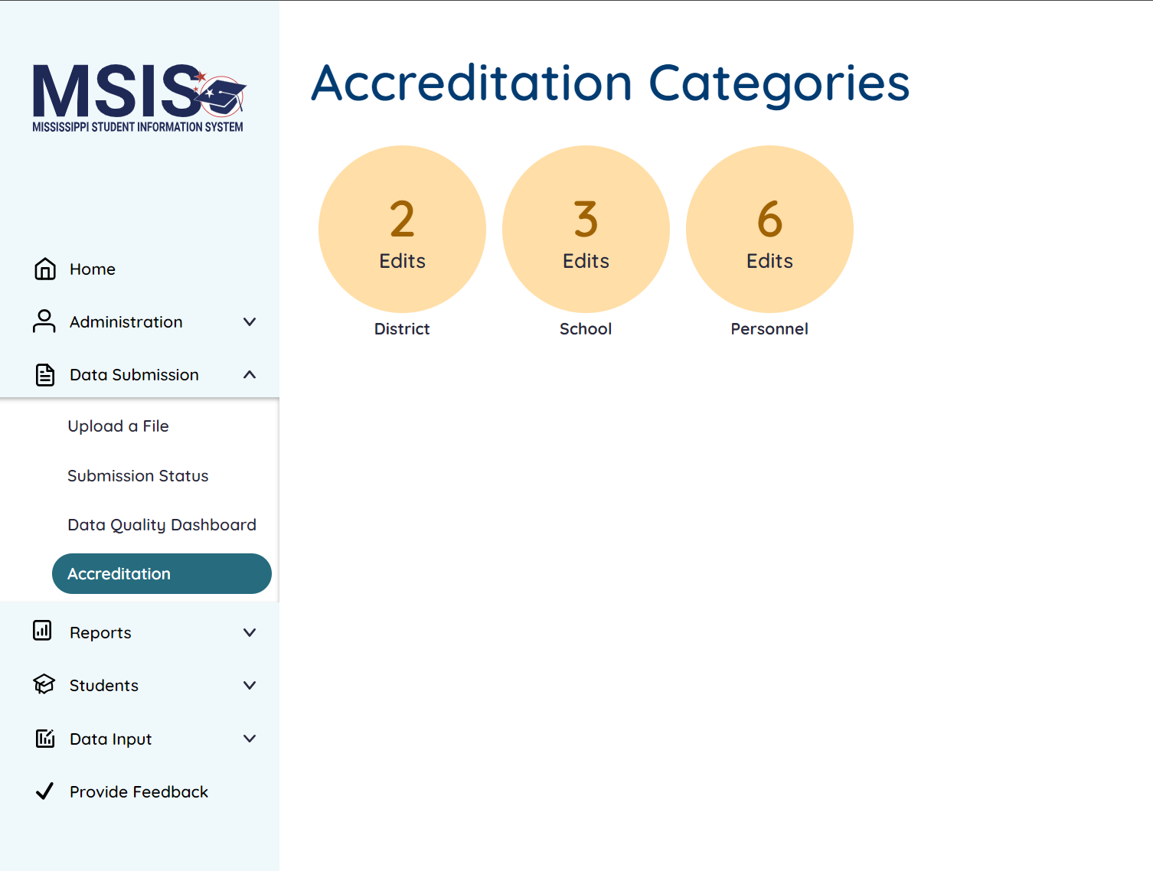

Reports
Rule(s): TBA.
Users can download and view reports based on their data domain permissions.

Data Analytics
Users may see the following tabs: Data Entry Download, Profiles, Reports and/or Certification Reports.

Data Entry Download
The reports on this tab are meant to be downloaded and uploaded via the Upload a File screen. The report would be downloaded in the correct format so the user can rename it appropriately, make minor changes and then upload into MSIS as a CSV file. Examples are: English Learner Roster, Homeless, Immigrant, Kindergarten Entry, and Part C to B. 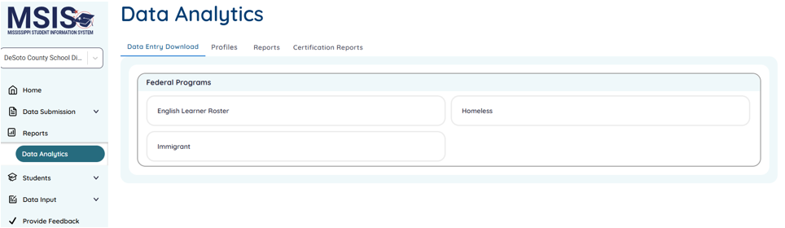

Profiles
Based on your permissions, you can view the LEA, School, and/or Student profiles.
(Not yet available) The LEA profile has the following tabs: Overview, School List, Enrollment, Attendance, Personnel, District Calendar, Financials, Teacher Pay Scale, and Board Members.
(Not yet available) The School profile has the following tabs: Overview, Enrollment, Attendance, and Personnel. The overview tab contains general information, Accountability Score, and School Improvement Identification.
(Enhancements coming soon) The Student profile allows users to search by student name, MSIS ID, or birth date. (Future enhancements) It contains several tabs including Demographics, Academic Record, Attendance, Enrollment, Assessments, Discipline, Transportation, Special Education, CTE, and Federal Programs.

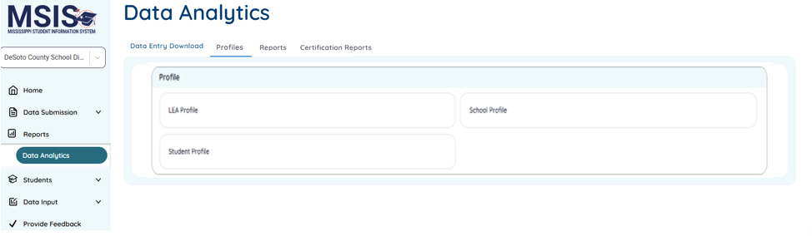

Reports
On the Reports tab, you can view various reports in these categories: Assessment, Child Nutrition, Discipline, Enrollment and Attendance, Finance, General, Personnel, Special Education and Student.
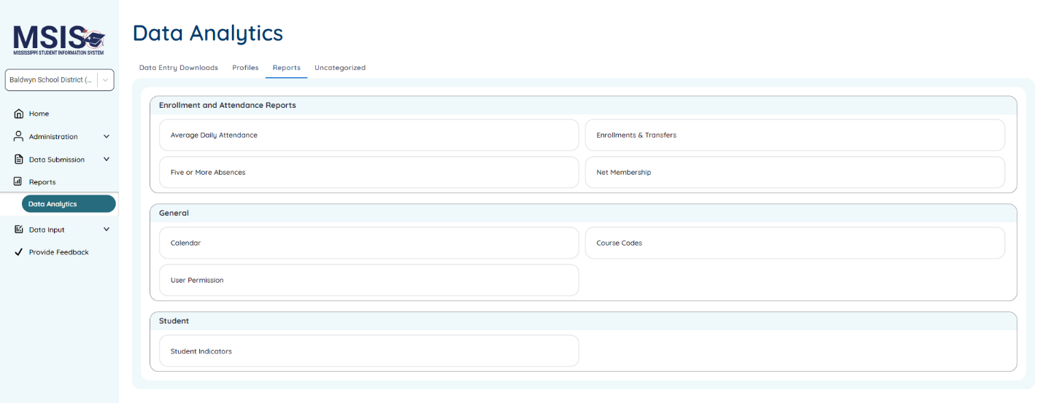

Certification Reports
On the Certification Reports tab, you can view various certification windows and certify if you have Can Certify District or Can Certify School(s) permission. Select the School Year from the left dropdown and then select the Data Collection from the right dropdown.
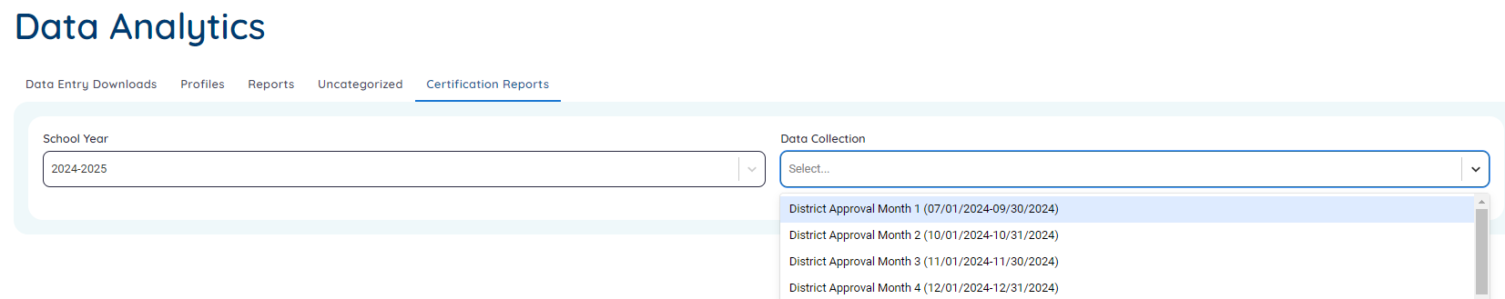
The selected data collection information will be displayed along with links to the reports for that data collection period. Pay attention to the Certification Open and Close dates in the yellow banner. Users that have the appropriate permissions will be able to view or certify for the school(s) and/or LEA(s) they are assigned to.
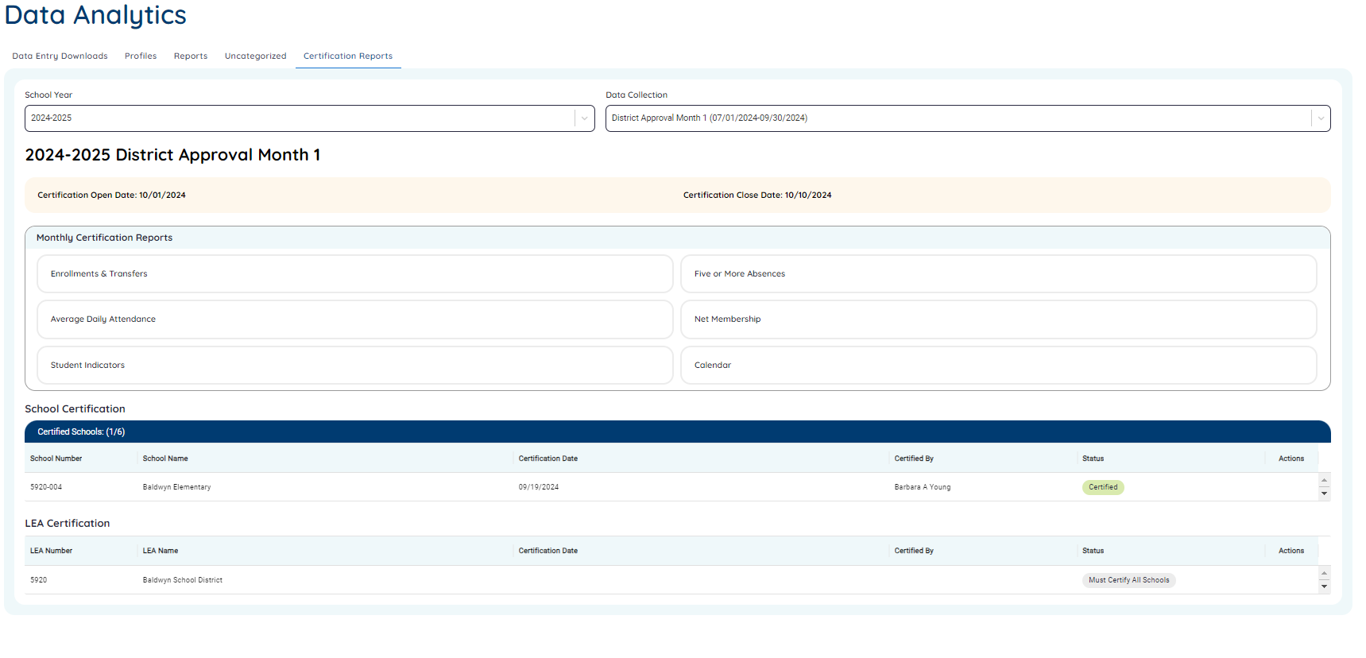

All Schools must be certified before the District can be certified, except for the Data Collections that are district level only (i.e. Personnel).
A district must be certified before the State can certify for the Data Collection (only Finance).
The status for Schools will be Needs Certification (blue, 2nd screenshot) when there are no errors preventing you from certifying. The status for Districts will be Must Certify All Schools if all schools have not been certified for the district.
The status will change to Certified (green) once the school/district is certified.
(larger view)
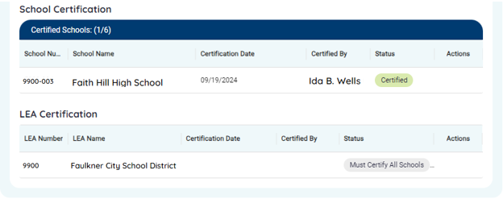
(larger view of the right side of the screen above)
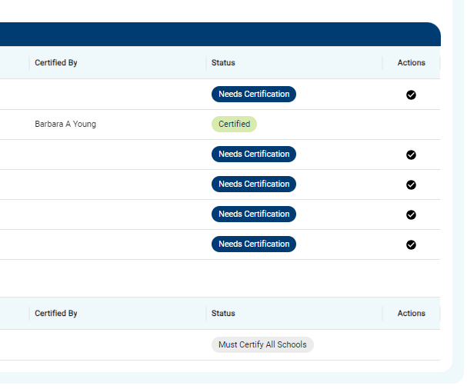
000
Users with the appropriate permissions will see a checkmark icon on the right side of the screen when they are in the certification period and need to certify. Users will not be able to certify the LEA until all schools have been certified.
Once the user selects this icon, they will receive a message like below that contains the name of the school they have selected. Users may select No to cancel or Yes to confirm.
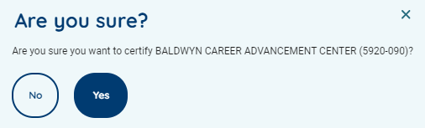
If you have errors preventing you from certifying during the certification period, you will see a View Errors status and can select the  exclamation icon to be directed to the Data Quality Dashboard to view errors.
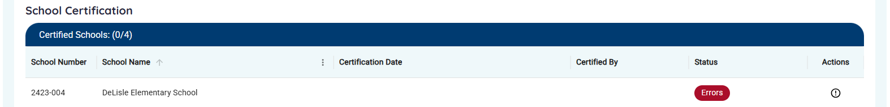
000
When it is outside of the date range for the Certification period, you will see the status below:
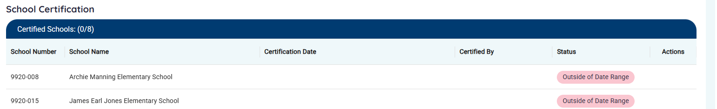

Refer to the QRG: Reports Overview for more information about each report.

Students
Rule(s): TBA.
Users can review/assign MSIS IDs, Export IDs, and/or review Student Ownership conflicts with permission.
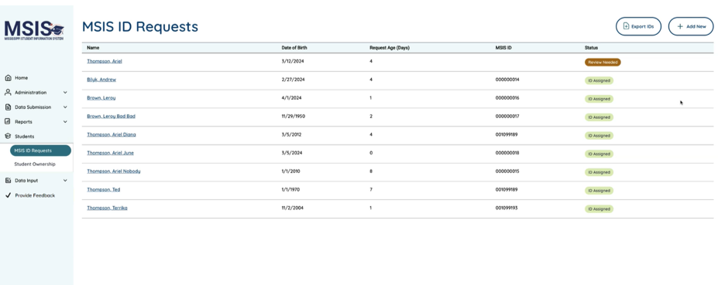
Note: Actual student data is not shown.

MSIS ID Requests
Users must have access to MSIS ID Requests to access the Students > MSIS ID Request screen. Review students that are potential matches or create an MSIS ID. Users can view Max Request Age in days (1, 3, 10, 30, 60, or 90 days).
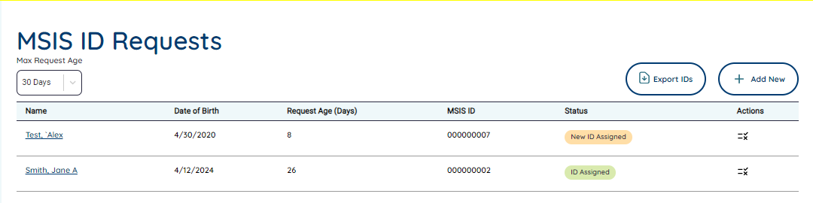
An MSIS ID request will have a status of: Review Needed, New ID Assigned, Existing ID Assigned, ID Assigned,
Note: Requests are shown with the records that need to be reviewed first/on top.
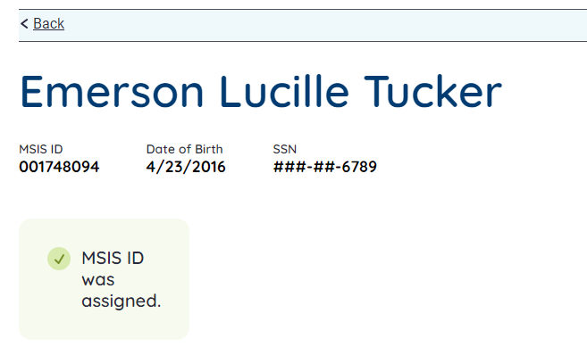
Note: Actual student data is not shown.
Some students may already exist in the system and MSIS may not be able to make an exact match. Users will see Strong, Possible, and Weak matches. You can select one of the students on the screen to confirm a match or select the checkbox at the bottom of the list if there are no matches and create an MSIS ID for a particular student.
Note: If corrections need to be made to the spelling of a student’s name or a correction made to their SSN, you may correct his information in your SIS, and it will update the information in MSIS. If you have two MSIS IDs for the same student due to these types of errors, you may email mdeapps@mdek12.org and request to merge the MSIS IDs.

Note: Actual student data is not shown.
Users can select + Add New to manually request a single MSIS ID. Users may select Export IDs to export a file containing MSIS IDs for students that are in New ID Assigned or Existing ID Assigned. Any students in a status of Review Needed will not have an MSIS ID and will be in the export file, but the MSIS ID column will be blank.

Student Ownership
Users must have access to Student Ownership to see notifications for ownership conflicts on the Home screen or to access the Students > Student Ownership screen. If a student is leaving or has left one LEA and is trying to enroll in a different LEA, you will see ownership conflicts in this screen if the other LEA has not entered an Exit code for the student.
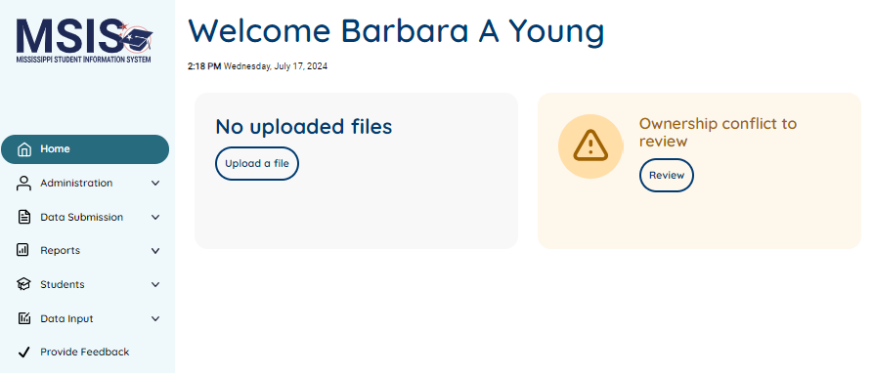
(See Guidance document for students that are transferring to another LEA: insert link.)

Review conflicts and contact the other LEA via email or phone. If the conflict is with a student that has graduated, please email mdeapps@mdek12.org for assistance. If you need to submit a record change, please review the District MSIS Record Change Documentation Form on our website at: www.mdek12.org/otss/msis/security-documents.
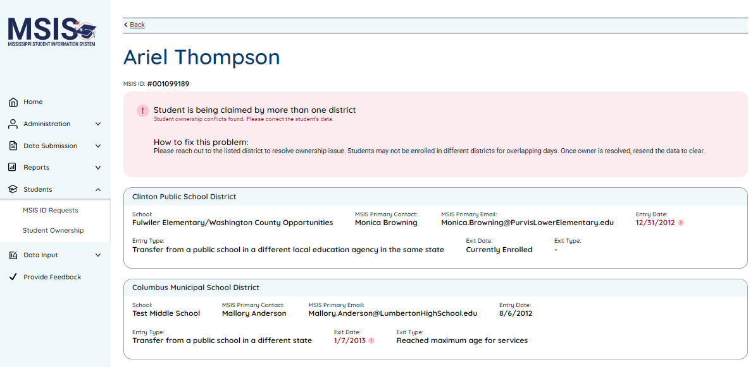 Note: Actual student data is not shown.

Data Input
Rule(s): TBA.
Some options are for MDE use only and are not available to LEA users. OTSS uses the LEA & School Info screens to add new LEAs and schools or to update information for current LEAs/schools including Charter schools which is not available via API.
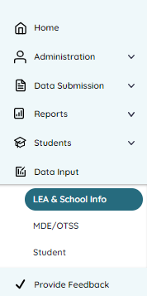

LEA & School Info
The following options may be available: LEA Management, School Management, Charter Schools, LEA Sharing and Salary Scale. These screens and options may vary depending on your permissions.

LEA Management
Admin users must update the Primary and Secondary information in MSIS. All other information must be updated in the SIS and will update MSIS via API, or (if optional field) MDE would have to manually enter. MDE uses this screen to create a new LEA. 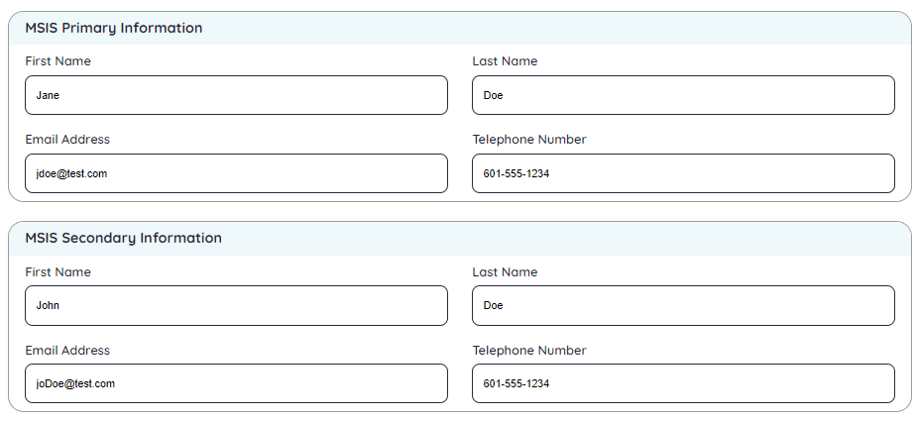

School Management
Users must update school information in their SIS and cannot make updates in this screen in MSIS. All information will come from the SIS via API. MDE uses this screen to create a new school.
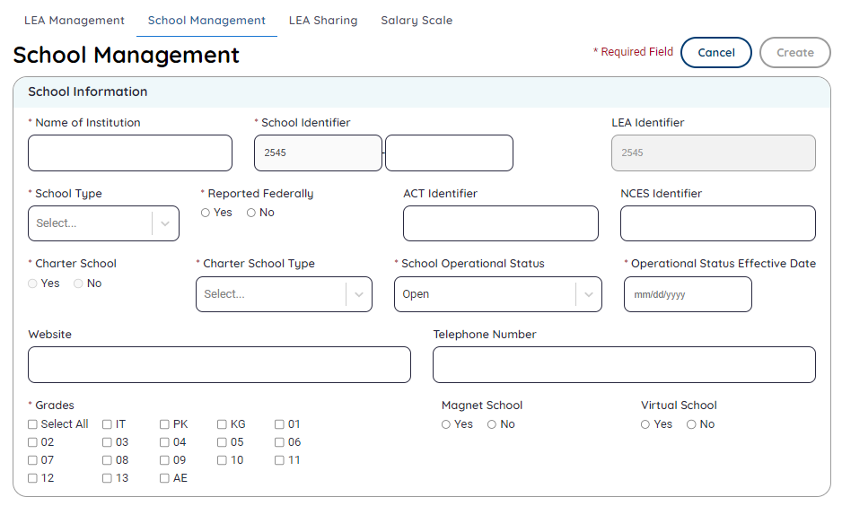

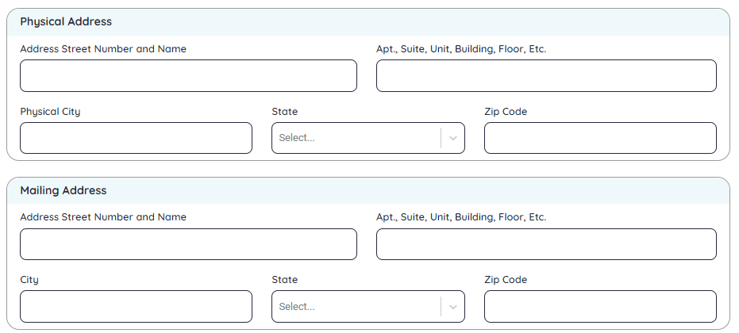

Charter Schools
(insert text)
(Insert screenshot)

LEA Sharing
OTSS users may create LEA sharing entries. If a LEA has a new sharing agreement in place or needs to inactivate a current agreement, then they must email the help desk to establish or update the sharing entry. Only LEA admins (primary/secondary) can view this screen. Other LEA or school users cannot access this screen.
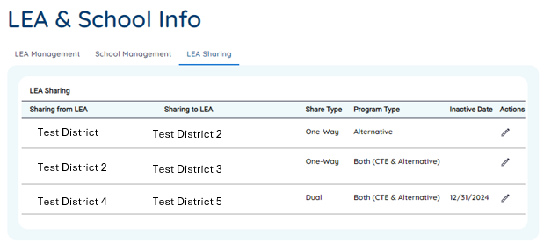

Board Members
<Add text blurb>
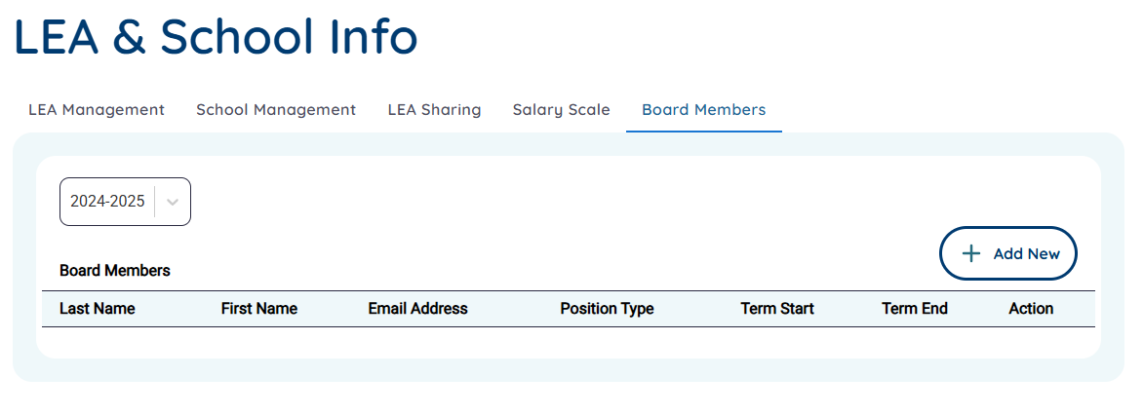
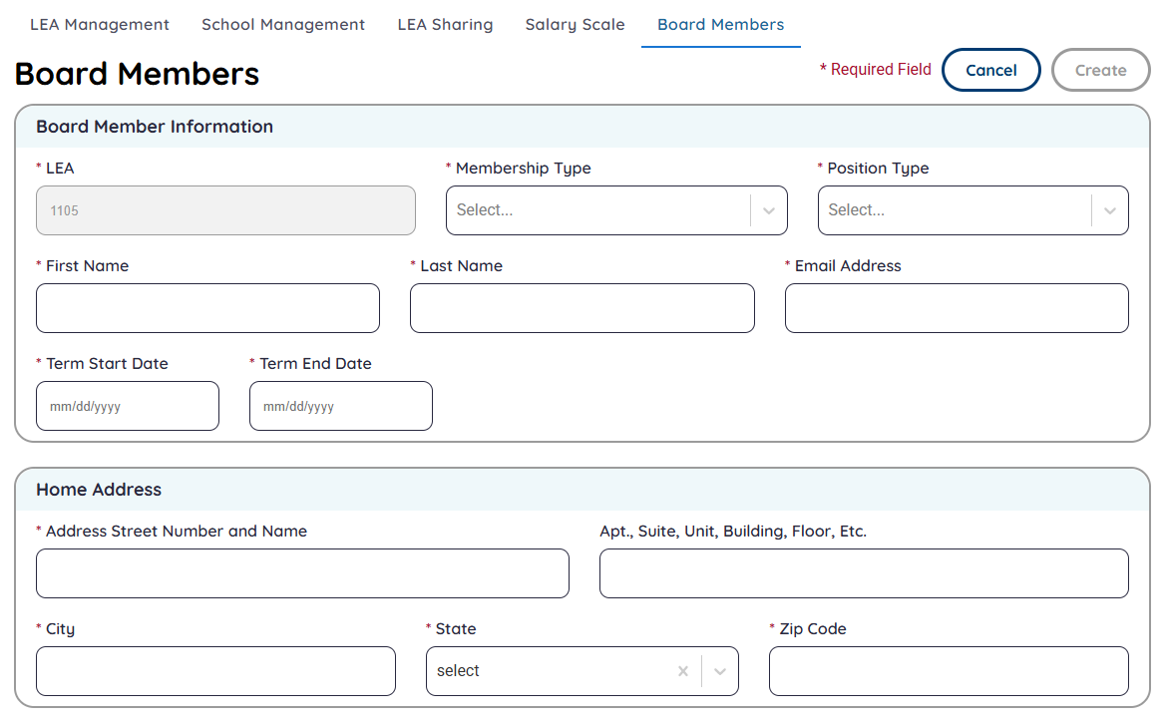

Salary Scale
Users can make changes to the state minimum salary values. The changes can be made for just one year and one certificate type, or multiple years and one certificate type, or multiple years and multiple certificate types. Users can also use the Apply to All to apply an Additional Salary to all years and certificates at once without having to select each value in the table.
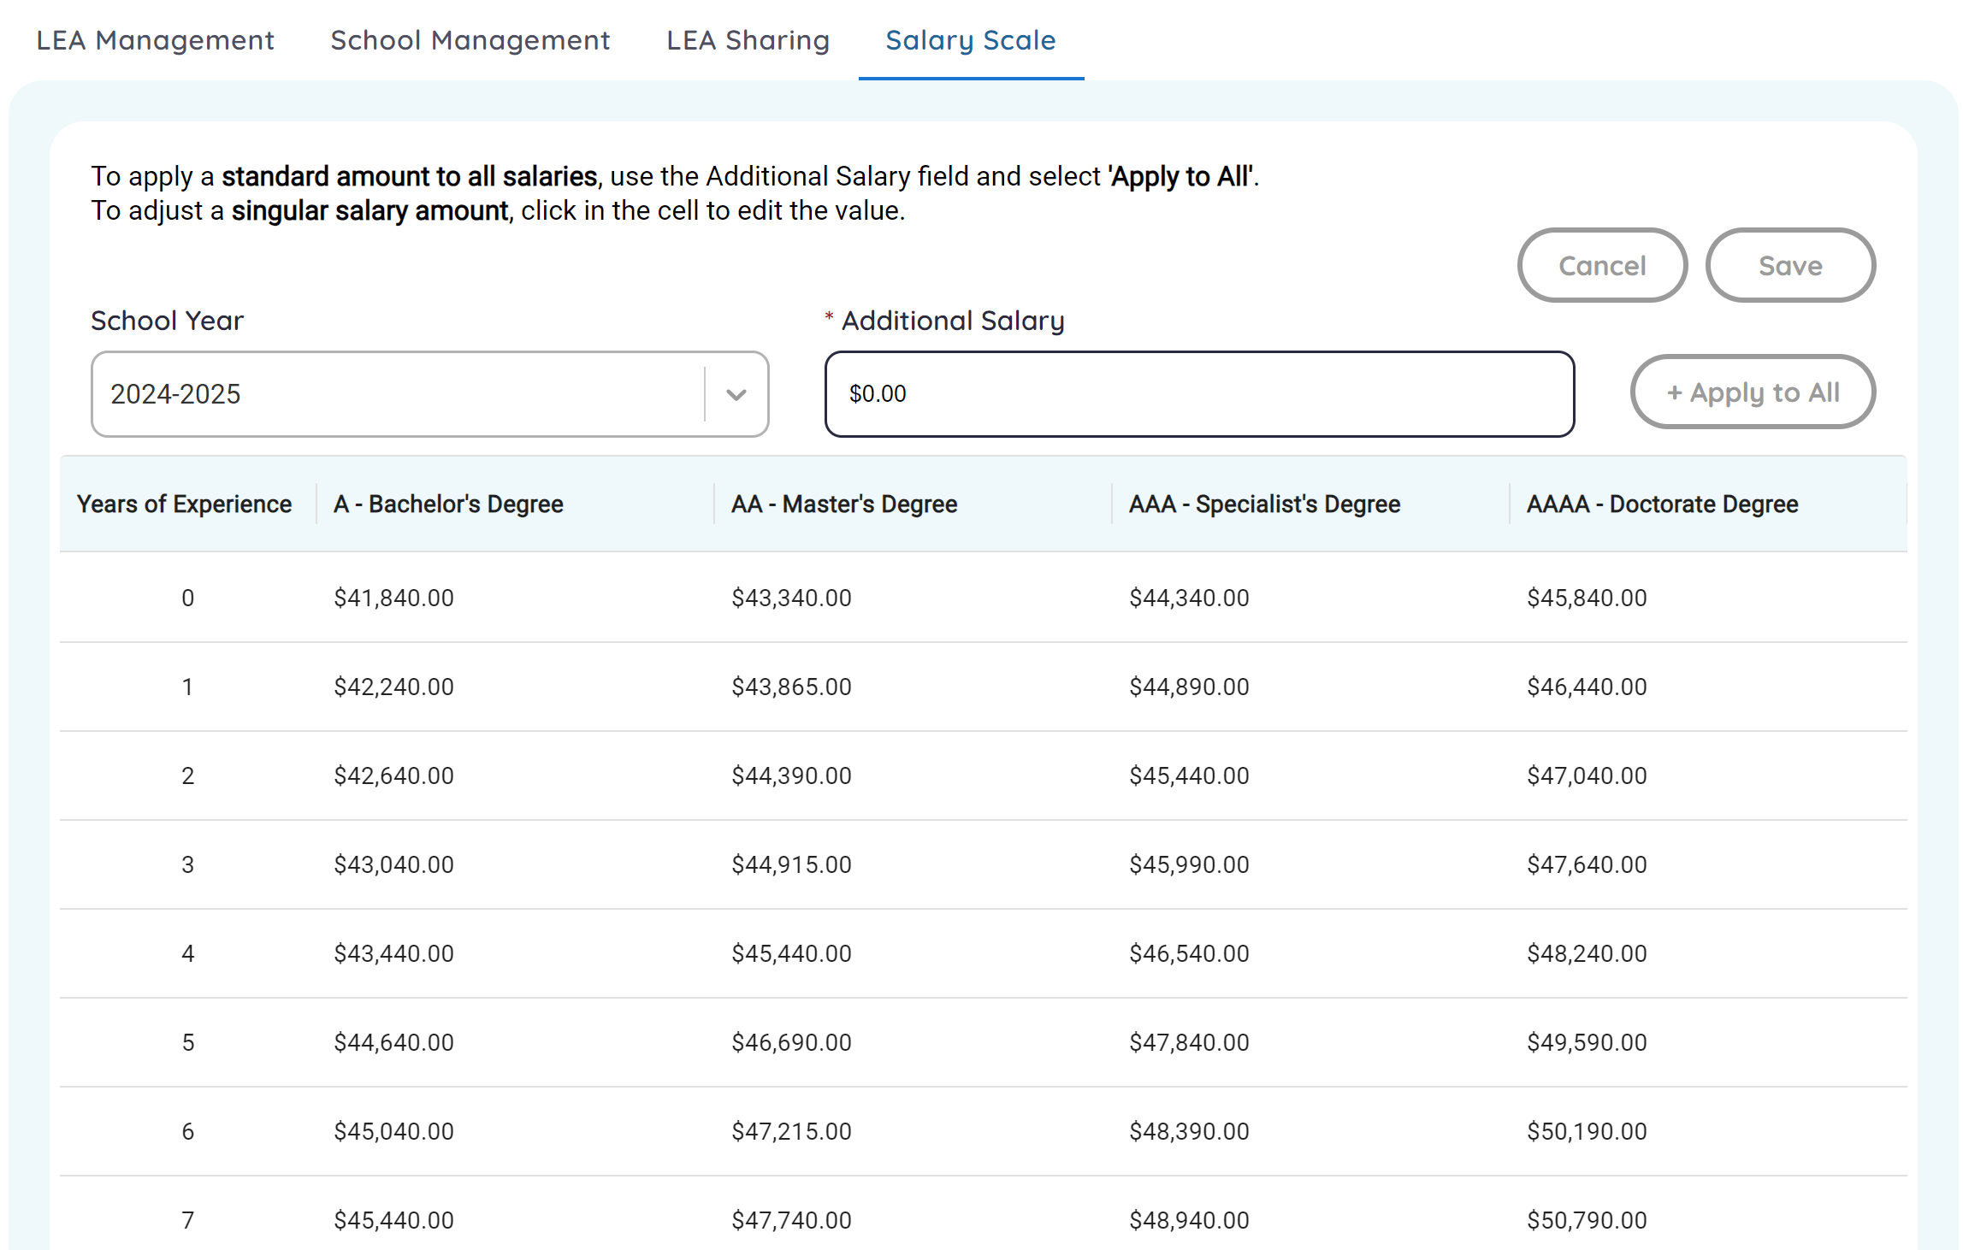

Student
The following options may be available: Non-Public Student, Summer Activity, Student Intervention, and Seal of Biliteracy. These screens and options may vary depending on your permissions and role (State/District admin or non admin, and state non-admin roles: Program Office, State Helpdesk, School Attendance Officer).

Student Intervention
This screen contains pre-populated students or manually entered referrals. Users should review and update each year, as needed: Tier Placement, Intervention Decision Date, Intervention Success, Documented Review Date, and Cumulative Documented Review Date. Students are prepopulated based on Intervention Criteria (see next screenshot for criteria 1-5). If students had 20 or more days of suspension, this value is also populated and not editable.
Note: This screen is not accessible by School Attendance Officers.
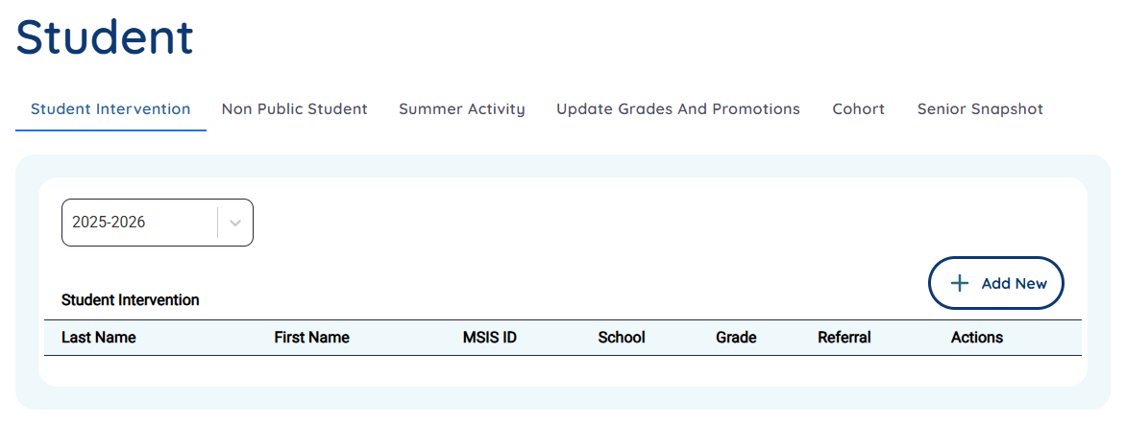
Some fields are grayed out and disabled because they are prepopulated by the system. Fields such as name, date of birth, social security number, LEA & School information, and student demographics. If this information is incorrect, users must update the student in their SIS and data will be updated overnight.
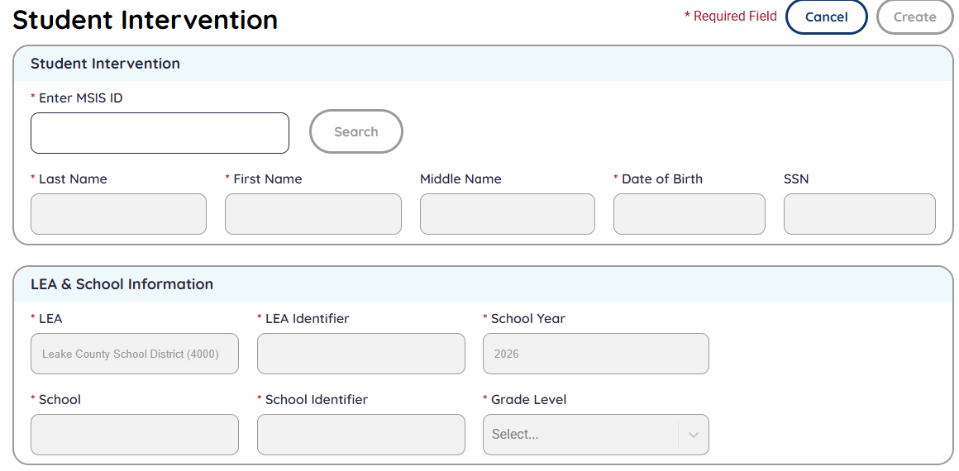
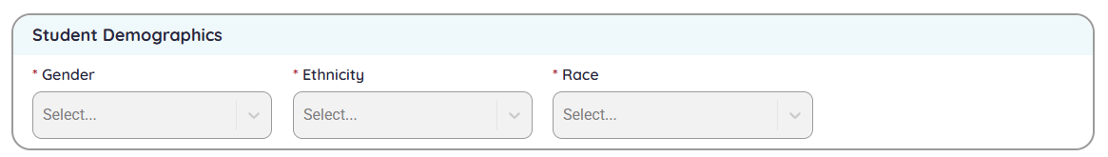

Students are prepopulated based on criteria 1-5 and may meet more than one criterion. If a student is a referral, then criteria 6 is automatically selected and cannot be edited.
Note: Students could be a referral and in a later year they could have criteria 6 and any others automatically selected.
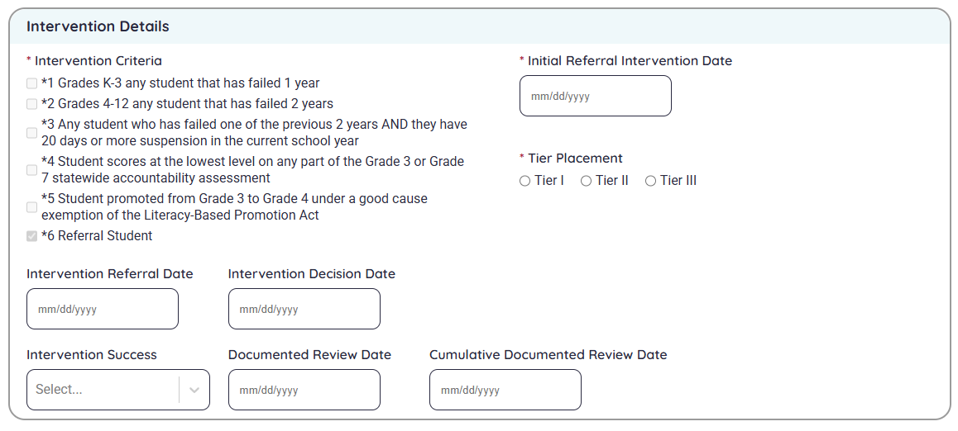
For more information, review the Intervention Services webpage and reach out to the Office of Elementary Education and Reading: https://mdek12.org/elementaryedu/interventionservices/.

Non Public Student
This screen is used to enter non public students who are in school 200 or school 500. Users must have CTE and/or Special Education data domain permissions to access and edit.
Note: This screen is not accessible by School Attendance Officers.
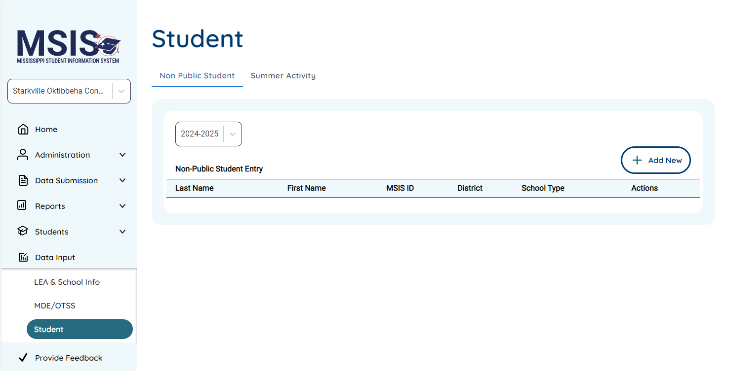
Users may only Create or Edit students for their corresponding permissions. Example: A user must have CTE permissions to create or edit CTE students for the assigned students. A user must have Special Education permission to create or edit Special Education students for the assigned schools.
Users select + Add New to add new students for the selected school year.
Note: Users need to add new students each school year as they are not sent via API or carry over from year to year.
Users must enter an MSIS ID and select Search. The student must not be enrolled in another school (regular school type), or the user will receive an error message saying, “Student is already enrolled. This student is enrolled in <name of School District> and cannot be enrolled in School 200/500.”
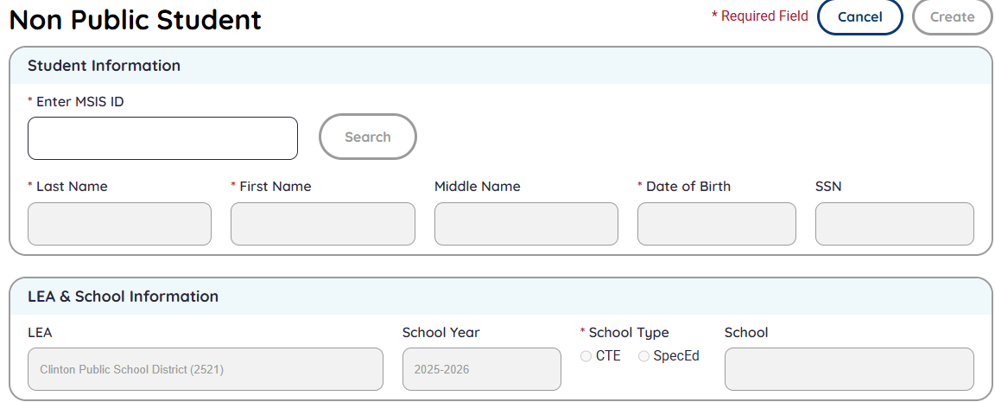
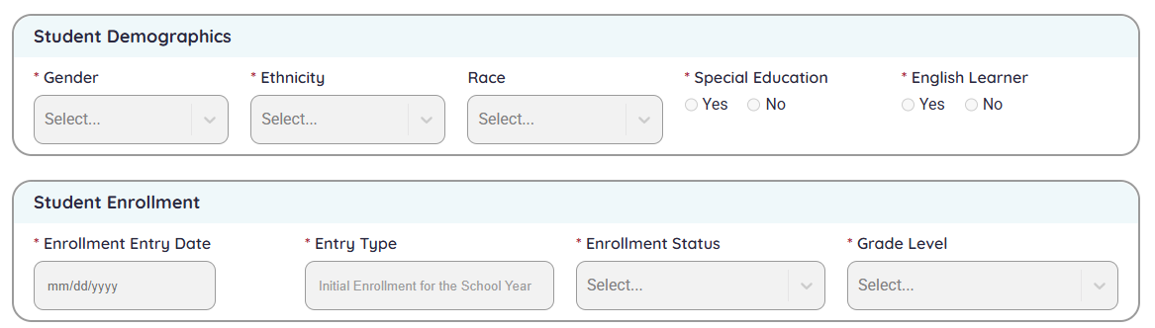
<enter CTE/Student Schedule screens and instructions
<enter CTE/SpecEd instructions>

Summer Activity
The manual input screen is only available for editing by School Attendance Officers. All other users with Student permission have view only access.
Note: District users must review the Summer Activity report via the Data Downloads tab in Reports, make updates and upload via the Upload a File page.
<Add text blurb>
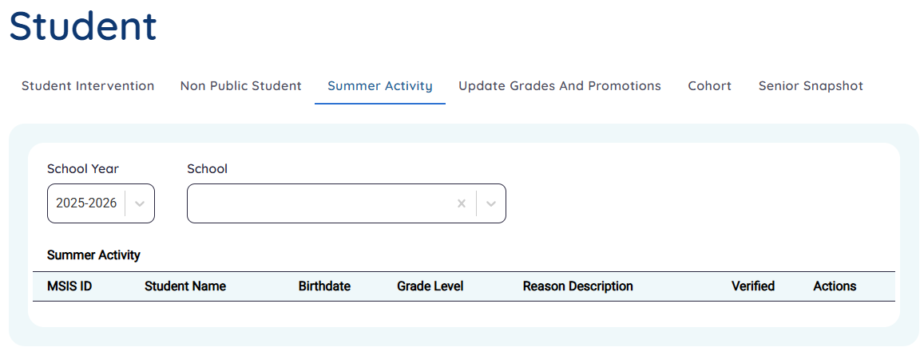

Seal of Biliteracy
<coming soon>
Note: This screen is not accessible by School Attendance Officers.

Update Grades And Promotions
Users will select the Search button, then enter an MSIS ID for a student.
Note: Users need special permission to Update Grades, otherwise this screen has view only access. This screen is not accessible by School Attendance Officers.

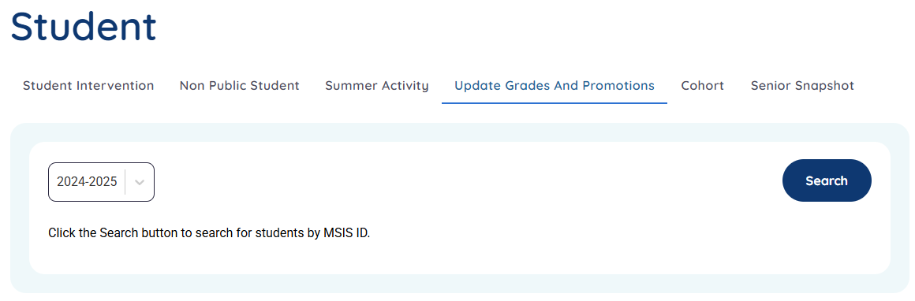

Cohort
This screen only contains removal requests which have been entered by users. All users with Student permission have access to view/edit students in their assigned schools.
Important: Users must select Apply Filter to update the list page based on selected criteria.
Users will use the Request New button to submit a Cohort Removal Request to MDE for approval. Users select the pencil icon to update students that are in pending or denied status during the specified timeframe each year.
Note: This screen is not accessible by School Attendance Officers.
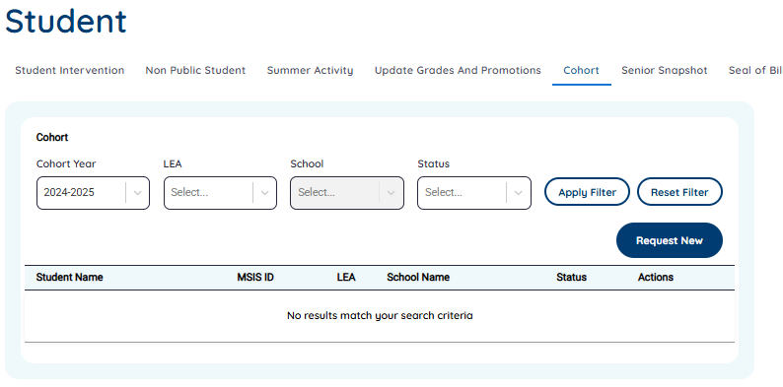
If users have not submitted any requests, they will see a message saying, “No results match your search criteria.”

Senior Snapshot
This screen is prepopulated with seniors from the selected school year. All users with Student permission have access to view/edit students in their assigned schools. Users must select Apply Filter to update the list page based on selected criteria. Users will use the pencil icon to update students and submit for approval by MDE.
<updates coming soon>
Note: This screen is not accessible by School Attendance Officers.

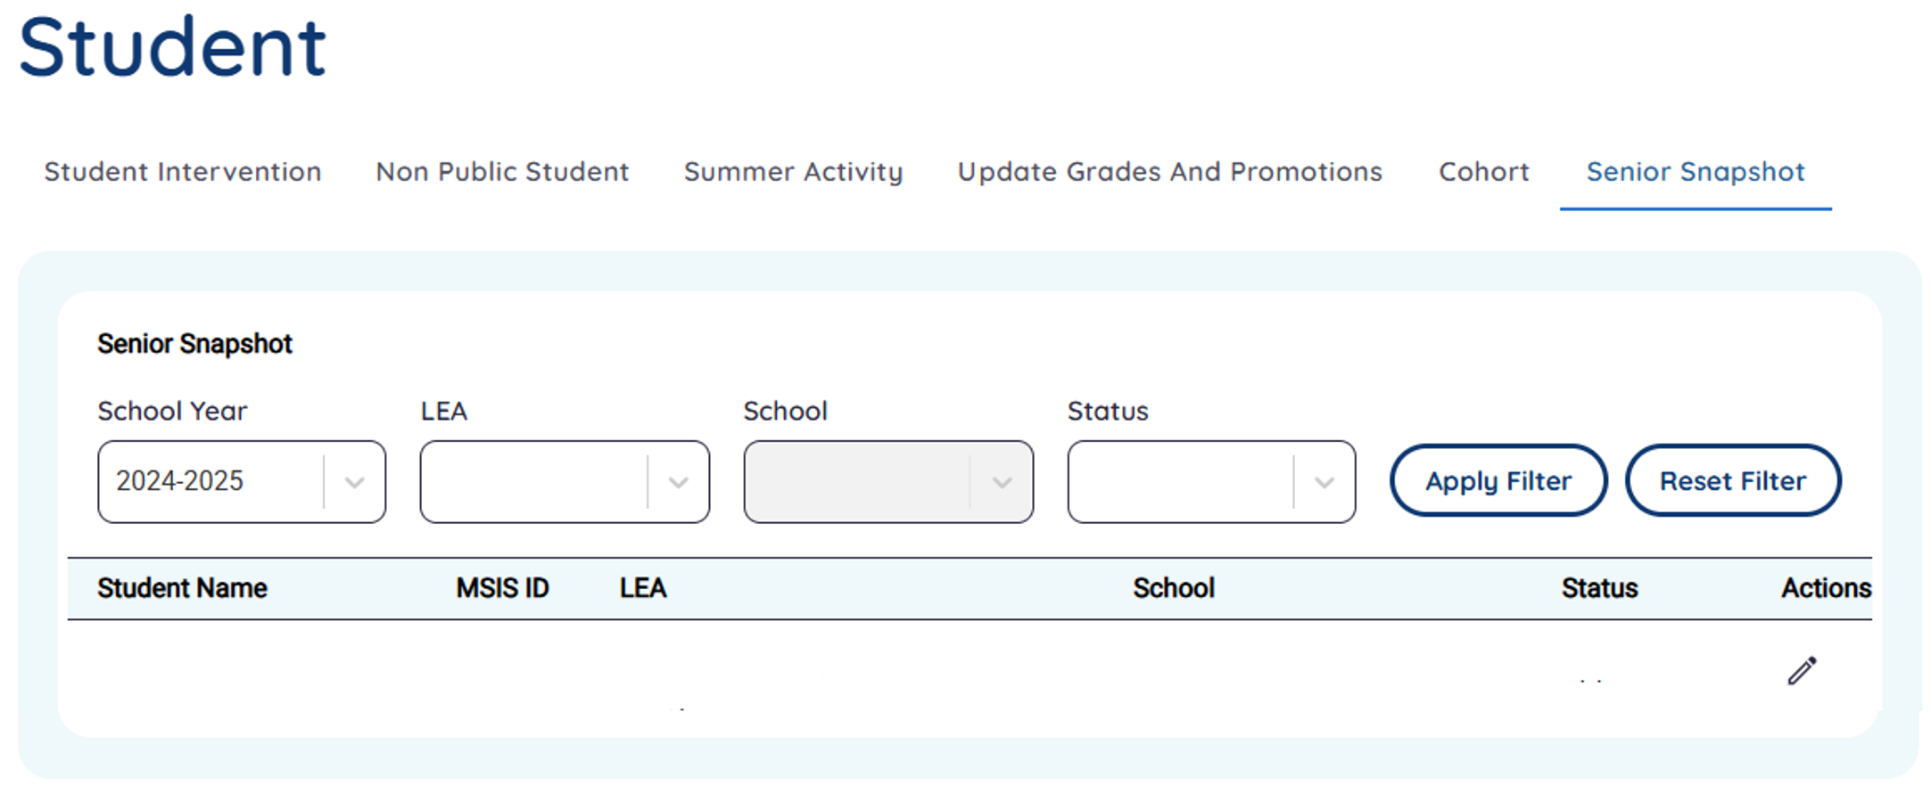

MDE/OTSS (MDE Only)

Course Codes
Courses may be added or updated using this screen by MDE/OTSS/CTE. Select +Add New to add a new course code. Select the pencil icon to modify an existing course code.
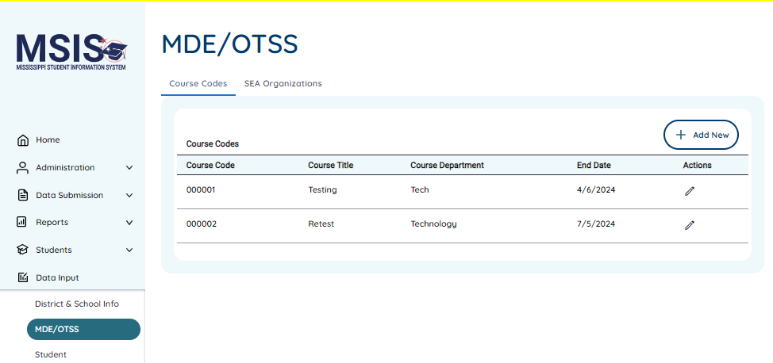
When adding a new course code, any required fields are marked with * next to the field name and Field is required or noted with an asterisk and label like the Grades field or Course Level Characteristics field below.
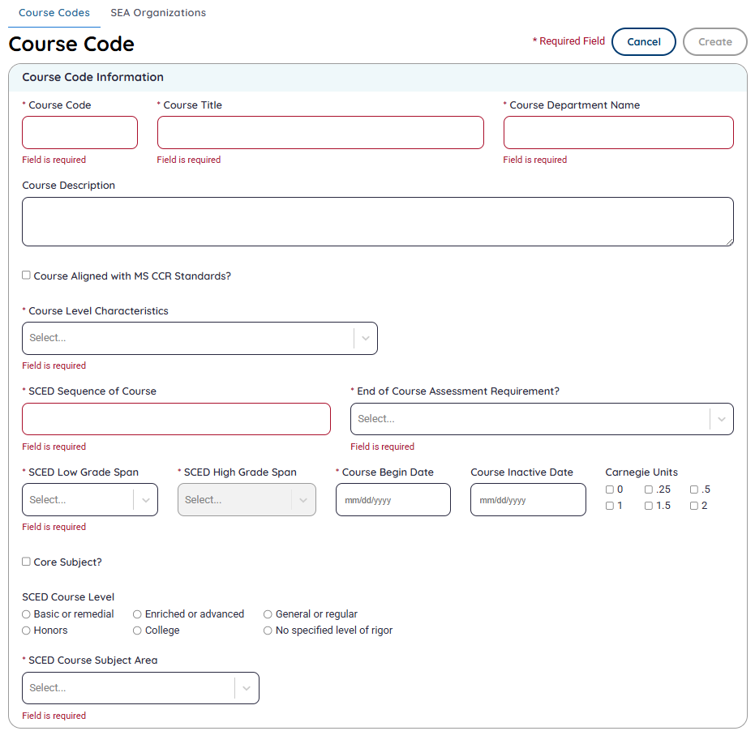
Create mode:
Course codes must be six-digits. Course Titles can be up to 60 characters. Course Department Name can be up to 60 characters. The Course Description can be up to 1,024 characters.
The Create button will be disabled and grayed out until all mandatory fields have been entered, or if any editable fields have been modified, then become enabled for users to save.
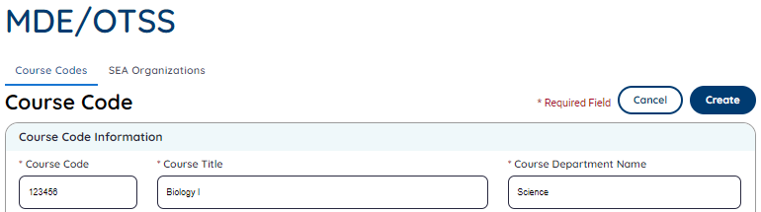
Edit mode:
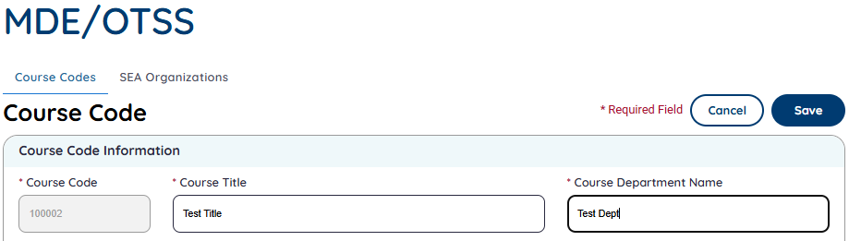
The Save button will be disabled and grayed out until all required fields have been populated.
Once you modify the course code, the Save button will be enabled. You may select Cancel to discard any changes and return to the Course Code List screen.
If you make changes and select the Cancel button, you will receive a message alerting you that the changes have not been saved. Select Yes to continue, discard changes and return to the Course Code List screen. Select No to keep any unsaved changes, remain in Edit mode and continue making changes or allow you to select the Save button.
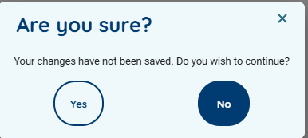

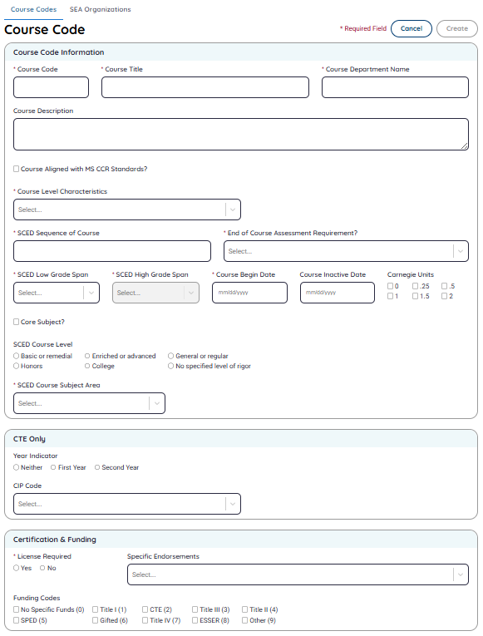
Note: Enlarged view.

Course Code List screen:

SEA Organizations
OTSS users may create or edit the SEA organization. Select the pencil icon next to the existing SEA organization to edit it. Select Add New button to create a new one.
SEA Organizations list screen:
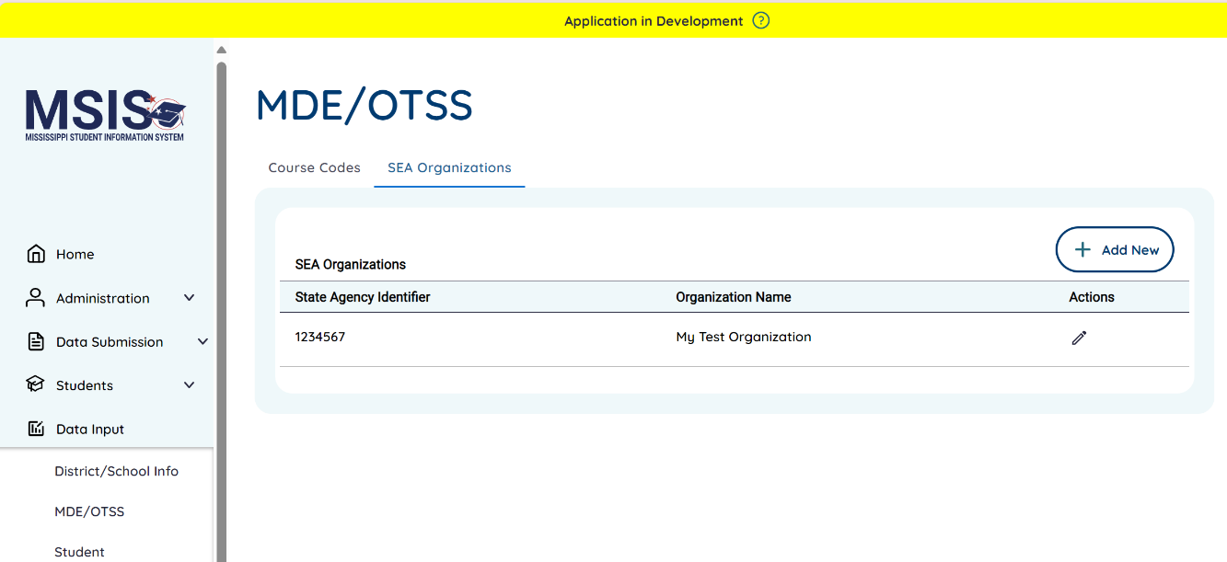

Enter the information into the fields and select Save to save the entry. The grayed-out fields cannot be modified and are defaulted to the correct values.

Once users set the year, this field cannot be changed. When a new year is needed, users can select the Duplicate option to create a new record for a new school year (SY).
Add New screen:
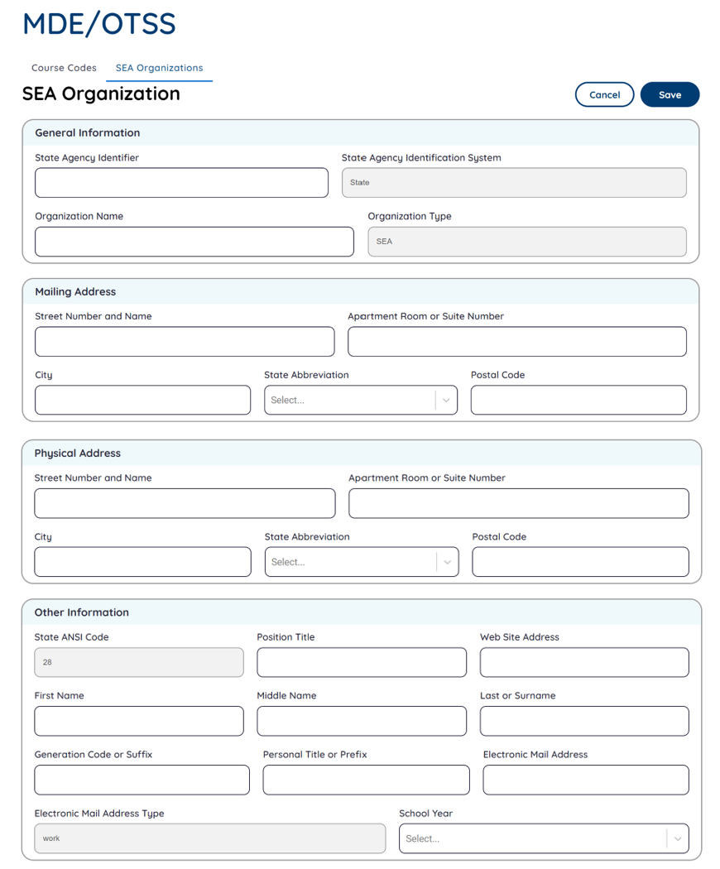
(Enlarged View)

Data Governance Resource
The MDE has created a Data Dictionary for our MS Student Information System (MSIS), that provides a list of data domain names, definitions, justification for their collection, their uses and the user groups involved. You can access it here: Data Dictionary 2024. The resource can also be found on the Data Governance page: https://mdek12.org/otss/datagovernance/.

Frequently Asked Questions
- User is attempting to register using their LEA credentials and is receiving a message for invalid email address.
  - Make sure MDE is made aware of any domain changes for LEA email accounts. Example, your LEA changed from jane@LEAname.k12.ms.us to jane@LEAname.ms.
- User logged in yesterday and had access to options. User logged in today and no longer has access.
  - Make sure they have not registered using two different LEA email accounts.
- User has completed registration steps and sees a “Congratulations….” message when they sign in.
  - Check with your MSIS Primary/Secondary to make sure permissions have been granted.
  - If the user is a Primary/Secondary, then contact MDE to ensure the role is assigned correctly by MDE.
- User cannot see any reports.
  - Check permissions to ensure the user has rights. If rights were given recently, then they will need to wait until the system refreshes (about 15 minutes).
- User cannot certify reports.
  - Check permissions to ensure user has rights to Can Certify District or Can Certify School and has permission to the LEA (select all schools), (or specific school(s) for Student domain).
- User cannot navigate to MSIS ID Requests.
- Check permissions to ensure user has rights to MSIS ID Requests and has permission to the school or district (all schools).
- User cannot navigate to Student Ownership screen.
  - Check permissions to ensure user has rights to Student Ownership and has permission to the school or district (all schools).

Glossary
The following are acronyms used in this document.
OTSS | Office of Technology and Strategic Services
MSIS | Mississippi Student Information System
SIS | Student Information Package
CTE | Career & Technical Education
MDE | Mississippi Department of Education
FY | Fiscal Year
SY | School Year
LEA | Local Education Agency (alias: district)
SEA | State Education Agency
ID | Identification
SPED/SpEd | Special Education
DQD | Data Quality Dashboard
IEP | Individualized Education Program
EL or ELL | English Language Learner (Federal Programs)
EL | Early Learning (Special Education)
QRG | Quick Reference Guide
GCE | Good Cause Exemption(s)

