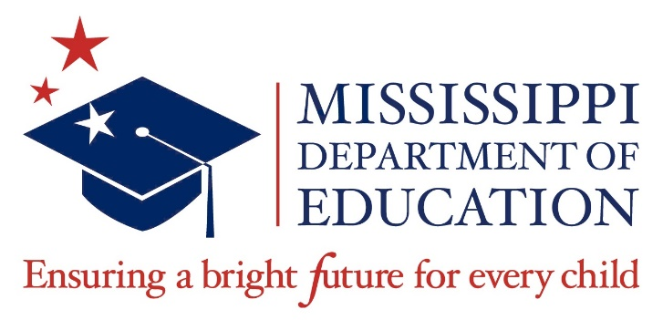

Data Governance Committee Agenda
November 6, 2025
9:00 a.m.
Via Livestream

- Call to Order
- Establishment of Quorum
- Approval of Meeting July 9, 2025, Minutes
- Approval of Agenda
- Workgroup Reports
1. Information: Report from Chair [Elizabeth Simmons]

2. Information: Report from OTSS regarding MSIS [Deborah Donavan]

3. Information: Data Sharing Agreement Workgroup [Donna Hales]
- Update
- Interagency Agreements Update

4. Information: Course Code Workgroup [Ma’Kesha Adams]
A. Update
B. Work Area Code update [Jo Ann Malone]

- Approval Items

- 2025 Data Dictionary

- Future Meetings
- February 4
- May 20

- Meeting Adjourn

