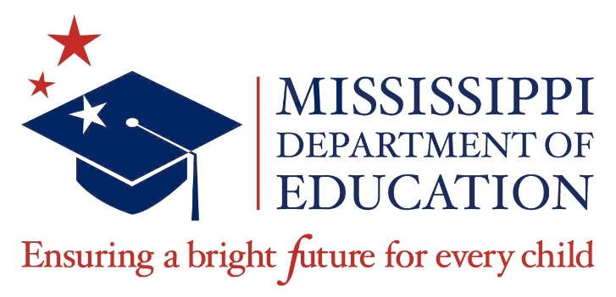

**Data Governance Committee**

**February 13, 2025**

**9:00 a.m.**

**Via Livestream**

**Agenda**

1. Call to Order
2. Establishment of Quorum
3. Approval of Meeting November 13, 2024, Minutes
4. Approval of Agenda
5. Workgroup Reports  
     
   1. Information: Report of Chair [Deborah Donovan]

2. Information: Data Sharing Agreement Workgroup [Donna Hales]

1. Update
2. Interagency Agreements Update

3. Information: Course Code Workgroup [Wendy Clemons]

A. Update

1. Approval of Change Request

Requesting the addition of JRTOC dropdown as a diploma endorsement option (Wendy Clemons)

1. Meeting Adjourn