
FORM 5
Acknowledgment of Amendments

Request for Proposals (Q&A)
Blended Pre-K Classroom Program Cohort V

Amendment Number One (1)
February 23, 2026

The Mississippi Department of Education amends the Request for Proposals (RFP) for
Blended Pre-Kindergarten Classroom Program Grant Cohort 5 released on February 10, 2026, as follows:

- To amend Page 21: (Section 7) Grant Award and Responsibilities to agree as listed in the RFP.

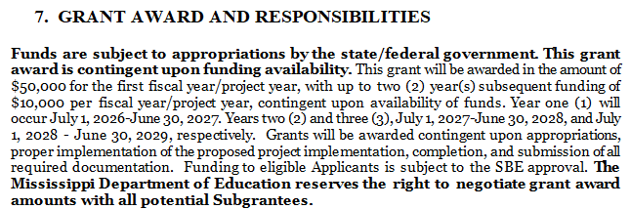

NOTE: Adjustments to the schedule may be made as deemed necessary by the MDE.

Amendment Number One

NOTE: This amendment one is hereby made a part of the Mississippi Department of Education’s Request for Qualifications. The Vendor acknowledges receipt of said amendment and is made aware of the changes contained therein. By signing this form, the Offeror accepts the changes as part of the contract requirement.

________________________________________ ___________________________
Authorized Signature Date

________________________________________
Printed Name

