Procurement Year End Program Assistance

The Office of Procurement will conduct a Request for Quote (RFQuote) process to secure a contract or purchase order for services. If the program is unsure of the cost for services, it must provide contact information for at least two vendors to support price comparison.

Procurement requirements based on service amount are as follows:

- Services up to $5,000: Only the vendor of choice is required; no additional quotes are necessary.
- Services over $5,000 and up to $10,000: A purchase order process must be completed with vendor agreement; a formal contract is not required.
- Services over $10,000 and up to $49,999: An executed contract is required prior to the delivery of services.

Because timeliness is critical, programs must plan ahead and submit procurement requests proactively for services exceeding $10,000. To avoid delays, please plan to submit your Procurement Form before the May 30, 2025, deadline for all services expected to exceed $10,000.

Please note: The program office may only contract for services that will be fully delivered on or before June 30, 2025. No services may be performed after that date under any circumstances. Also, there are limited funds available for services. Requests will be processed based on the availability of funds.

A PF will be posted on the procurement webpage for easy access.

Bid Checklist and Forms – Procurement

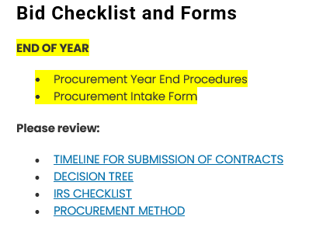

Procurement Year End Procedures

Programs office task:
- Complete a PF
  - Provide any information that will assist in procuring services
    - vendor name, email address, webpage, etc.
    - Ensure applicable fields are completed; if not applicable, insert “N/A”

- Submit request/form to the Grants and Contracts grantsandcontracts@mdek12.org for processing
- A procurement analyst will be assigned

Procurement office task:
- Review PF
- Contact program office to develop, confirm, and agree to scope
- Procure services
- If a contract is required, conduct the contract process
- Submit PF and contract for review and approval
- Execute contract
- If a service is less than $10,000 forward PF, RFQuote, and vendor quote to the program to request a PO

Hope this helps.

