**School Plan**

**School Planning Team**

**School Planning Team**

1. Please identify all school planning team members, including titles. Section 1114(b)(2)

**School Planning Summary**

1. Briefly describe the process the planning team used to develop the Schoolwide Plan or Targeted Assistance Plan based upon a comprehensive needs assessment. Include the process that the school will use to regularly monitor and revise, as necessary, based upon student needs ensuring all students are provided opportunities to meet the challenging State academic standards. For a Targeted Assistance Plan, please include the process for selecting students. Section 1114(b)(1, 3 and 6) and Section 1115(b)(1)

Prepopulates for the schools

**School Plan Needs Assessment**

**Demographics**

Student Demographics (Enrollment)

|  |  |  |  |  |  |  |  |  |  |  |  |  |  |  |  |  |  |  |
| --- | --- | --- | --- | --- | --- | --- | --- | --- | --- | --- | --- | --- | --- | --- | --- | --- | --- | --- |
| Year | School Enrollment | Female | Male | Asian | Black | Hawaiian Pacific | Hispanic | Native American | White | Multi- Racial | Economically Disadvantaged | IEP | English Learners | Immigrant | Migrant | Homeless | Foster Child | Military Child |
| 2020-21 |  |  |  |  |  |  |  |  |  |  |  |  |  |  |  |  |  |  |
| 2021-22 |  |  |  |  |  |  |  |  |  |  |  |  |  |  |  |  |  |  |
| 2022-23 |  |  |  |  |  |  |  |  |  |  |  |  |  |  |  |  |  |  |

School Data

|  |  |  |
| --- | --- | --- |
| **Year** | **Students’ Attendance Rate (%)** | **Teachers’ Attendance Rate (%)** |
| 2020-21 |  |  |
| 2021-22 |  |  |
| 2022-23 |  |  |

1. Provide a description of the ***school’s*** characteristics (i.e., census, poverty, rural status, businesses/industries, natural disasters).
2. Provide a description of the ***community’s*** characteristics (i.e., census, poverty, rural status, businesses/industries, natural disasters).

**Accountability Data**

Check the box that reflects your school accountability designation.

|  |  |  |  |  |
| --- | --- | --- | --- | --- |
| **Three-Year School Accountability Designation** | | | | |
| **Year** |  | **CSI** | **TSI** | **ATSI** |
| 2020-21 |  |  |  |  |
| 2021-22 |  |  |  |  |
| 2022-23 |  |  |  |  |

|  |  |  |  |  |  |  |  |  |  |  |  |  |  |  |
| --- | --- | --- | --- | --- | --- | --- | --- | --- | --- | --- | --- | --- | --- | --- |
| **Elementary and Middle Schools** | | | | | | | | | | | | | | |
|  | **Language Arts** | | | **Mathematics** | | | | **Science** | | | | **Participation Rates** | | |
|  | **20-21** | **21-22** | **22-23** | **20-21** | | **21-22** | **22-23** | **20-21** | **21-22** | | **22-23** | **20-21** | **21-22** | **22-23** |
| **Proficiency** |  |  |  |  | |  |  |  |  | |  |  |  |  |
| **Growth All Students** |  |  |  |  | |  |  |  |  | |  |  |  |  |
| **Growth in Lowest 25%** |  |  |  |  | |  |  |  |  | |  |  |  |  |
|  | | | | | | | | | | | | | | |
|  | **2020-21** | | | | **2021-22** | | | | | **2022-23** | | | | |
| **Accountability Grade** |  | | | |  | | | | |  | | | | |
| **Total Points** |  | | | |  | | | | |  | | | | |

|  |  |  |  |  |  |  |  |  |  |  |  |  |  |  |  |  |  |  |  |  |  |  |  |  |
| --- | --- | --- | --- | --- | --- | --- | --- | --- | --- | --- | --- | --- | --- | --- | --- | --- | --- | --- | --- | --- | --- | --- | --- | --- |
| **High Schools** | | | | | | | | | | | | | | | | | | | | | | | | |
|  | **English** | | | **Algebra** | | | **Biology** | | | **US History** | | | **Acceleration** | | | **Participation Rate** | | | **Graduation Rate** | | | **College and Career Readiness** | | |
| 20-21 | 21-22 | 22-23 | 20-21 | 21-22 | 22-23 | 20-21 | 21-22 | 22-23 | 20-21 | 21-22 | 22-23 | 20-21 | 21-22 | 22-23 | 20-21 | 21-22 | 22-23 | 20-21 | 21-22 | 22-23 | 20-21 | 21-22 | 22-23 |
| **Proficiency** |  |  |  |  |  |  |  |  |  |  |  |  |  |  |  |  |  |  |  |  |  |  |  |  |
| **Growth All Students** |  |  |  |  |  |  |  |  |  |  |  |  |  |  |  |  |  |  |  |  |  |  |  |  |
| **Growth in Lowest 25%** |  |  |  |  |  |  |  |  |  |  |  |  |  |  |  |  |  |  |  |  |  |  |  |  |
|  | | | | | | | | | | | | | | | | | | | | | | | | |
|  | **20-21** | | | | | | | | **21-22** | | | | | | | | **22-23** | | | | | | | |
| **Accountability Grade** |  | | | | | | | |  | | | | | | | |  | | | | | | | |
| **Total Points** |  | | | | | | | |  | | | | | | | |  | | | | | | | |

**Student Achievement (School’s Performance)**

**Reading/Language Arts/Literacy (Progress Monitoring Instrument)**

Please provide the percentage of students for each administration that did **NOT** meet at/or above the benchmark. If there are no grade levels represented by the school, please place “n/a” in the appropriate box.

Name of assessment tool used ___________________________________________.

|  |  |  |  |  |  |  |
| --- | --- | --- | --- | --- | --- | --- |
|  | Kindergarten | | 1st Grade | | 2nd Grade | |
| Year | BOY* | EOY* | BOY | EOY | BOY | EOY |
| 2020-21 |  |  |  |  |  |  |
| 2021-22 |  |  |  |  |  |  |
| 2022-23 |  |  |  |  |  |  |

* BOY means Beginning of the Year and EOY means End of the Year

**English/Language Arts (MAAP)**

Please provide the percentage of students who did **NOT** meet proficiency or above. If there are no grade levels represented by the school, please place “n/a” in the appropriate box.

|  |  |  |  |  |  |  |  |
| --- | --- | --- | --- | --- | --- | --- | --- |
| Year | 3rd Grade | 4th Grade | 5th Grade | 6th Grade | 7th Grade | 8th Grade | English II |
| 2020-21 |  |  |  |  |  |  |  |
| 2021-22 |  |  |  |  |  |  |  |
| 2022-23 |  |  |  |  |  |  |  |

**Mathematics (MAAP)**

Please provide the percentage of students who did **NOT** meet proficiency or above. If there are no grade levels represented by the school, please place “n/a” in the appropriate box.

|  |  |  |  |  |  |  |  |
| --- | --- | --- | --- | --- | --- | --- | --- |
| Year | 3rd Grade | 4th Grade | 5th Grade | 6th Grade | 7th Grade | 8th Grade | Algebra I |
| 2020-21 |  |  |  |  |  |  |  |
| 2021-22 |  |  |  |  |  |  |  |
| 2022-23 |  |  |  |  |  |  |  |

**Special Subject Areas (MAAP)**

Please provide the percentage of students who did **NOT** meet proficiency or above. If there are no grade levels represented by the school, please place “n/a” in the appropriate box.

|  |  |  |  |  |
| --- | --- | --- | --- | --- |
| Year | 5th Grade Science | 8th Grade Science | Biology I | U.S. History |
| 2020-21 |  |  |  |  |
| 2021-22 |  |  |  |  |
| 2022-23 |  |  |  |  |

1. After analyzing data for all students, provide a summary of the progress and challenges and identify underlying causes for each. Cite specific examples and address racial/ethnic groups and other subgroups where relevant, such as, gender, ethnicity, EL, homeless, migrant, students with disabilities, military or foster children. Include all local data analyzed as part of the comprehensive needs assessment.
2. Describe the evidence-based strategies that will be implemented to provide opportunities for all children, including each of the subgroups of students (as defined in section 1111(c)(2)) to meet the challenging State academic standards. How will the identified challenges be addressed to ensure that students meet the challenging State academic standards? Section 1114(b)(7)(A)(i-ii)

**College and Career Readiness**

**Not applicable**

|  |  |  |  |  |  |
| --- | --- | --- | --- | --- | --- |
| College and Career Readiness 11th Grade ACT Scores | | | | | |
|  | Composite | English | Math | Reading | Science |
| 2020-21 |  |  |  |  |  |
| 2021-22 |  |  |  |  |  |
| 2022-23 |  |  |  |  |  |

1. **ACT Scores**- Analyze the data and provide a summary of progress and challenges, identifying underlying reasons for each. Describe how the school will address those challenges.

**☐ Not applicable**

|  |  |  |  |  |  |
| --- | --- | --- | --- | --- | --- |
| Postsecondary Preparation Opportunities for Students | | | | | |
|  | Advanced Placement | International Baccalaureate | Dual Enrollment/ Dual Credit | Early College High School | Career and Technical Programs |
| 2020-21 |  |  |  |  |  |
| 2021-22 |  |  |  |  |  |
| 2022-23 |  |  |  |  |  |

1. From the data in the above charts, how has the school addressed these areas ensuring that all students are prepared for and aware of opportunities for postsecondary education and the workforce. This may include career and technical education programs and broadening secondary school students’ access to coursework to earn postsecondary credit while still in high school (such as Advanced Placement, International Baccalaureate, dual or concurrent enrollment, or early college high schools). Section 1114(b)(7)(A)(iii)(II)

**School Climate and Culture**

|  |  |  |  |  |  |  |
| --- | --- | --- | --- | --- | --- | --- |
| **Out-of-School Suspensions** | | | | | | |
|  | **2020-2021** | | **2021-2022** | | **2022-2023** | |
| **Total Number of Days** | **Percent of Total Number of Days** | **Total Number of Days** | **Percent of Total Number of Days** | **Total Number of Days** | **Percent of Total Number of Days** |
| **All** |  |  |  |  |  |  |
| **Asian** |  |  |  |  |  |  |
| **Black/AA** |  |  |  |  |  |  |
| **EL** |  |  |  |  |  |  |
| **Hispanic/LA** |  |  |  |  |  |  |
| **IEP** |  |  |  |  |  |  |
| **NAM** |  |  |  |  |  |  |
| **NH/PI** |  |  |  |  |  |  |
| **White** |  |  |  |  |  |  |

1. What specific discipline issues, if any, impact student achievement/growth?
2. Identify specific steps to be taken to reduce the loss of instructional time. Section 1114(b)(7)(A)(iii)(III) and Section 1115(b)(2)(B)
3. Describe the implementation of a schoolwide tiered model and/or early intervening services to prevent and address problem behavior coordinated with similar activities and services carried out under the Individuals with Disabilities Education Act (20 U.S.C. 1400 et seq.) Section 1114(b)(7)(A)(iii)(III) and Section 1115(b)(2)(B)

**Curriculum and Instruction**

1. Describe the use of methods and instructional strategies that strengthen the academic program in the school, increase the amount and/or quality of learning time, and/or help provide an enriched and accelerated curriculum, which may include programs, activities, and courses necessary to provide a well-rounded education. Section 1114(b)(7)(A)(ii) and Section 1115(b)(2)(B)
2. Describe the evidence-based strategies that will be implemented to address the needs of all children in the school, but particularly the needs of those at risk of not meeting the challenging State academic standards. Please provide the activities to be implemented which may include counseling, school-based mental health programs, specialized instructional support services, mentoring services, and other strategies to improve students’ skills outside the academic subject areas. Section 1114(b)(7)(A)(iii)(I) and Section 1115(b)(2)(C)
3. Describe the evidence-based strategies that will be implemented for assisting preschool children in the transition from early childhood education programs to local elementary school programs. If it is not applicable, indicate "n/a" in the text box. Section 1114(b)(7)(A)(iii)(V)

**Professional Development**

|  |  |  |  |  |  |  |  |  |  |
| --- | --- | --- | --- | --- | --- | --- | --- | --- | --- |
|  |  |  |  |  |  | **Professional Growth System**  **Number of Teachers Scoring** | | | |
| **School Year** | **Number of Teachers** | **Number of Certified Teachers** | **Number of Non-Certified Teachers** | **Number of Out of Field Teachers** | **Number of Inexperienced Teachers (0-3 years)** | **1** | **2** | **3** | **4** |
| 2020-21 |  |  |  |  |  |  |  |  |  |
| 2021-22 |  |  |  |  |  |  |  |  |  |
| 2022-23 |  |  |  |  |  |  |  |  |  |

1. Describe the evidence-based professional development that will be implemented to address the needs of all children in the school, but particularly the needs of those at risk of not meeting the challenging State academic standards. Section 1114(b)(7)(A)(iii)(IV) and Section 1115(b)(2)(D)
2. What activities will be implemented for teachers, paraprofessionals, and other school personnel to improve instruction and use of data from academic assessment? Section 1114(b)(7)(A)(iii)(IV) and Section 1115(b)(2)(D)
3. What activities will be implemented to recruit and retain effective teachers, particularly in high-need subjects? Section 1114(b)(7)(A)(iii)(IV) and Section 1115(b)(2)(D)

**Parent and Family Engagement**

1. Describe how the school will involve parents and family members in the development and evaluation of this plan. Section 1116(c)(3) and Section 1115(b)(2)(E)
2. Describe the process used to develop, implement, and evaluate parent and family engagement activities to improve student academic achievement and school performance. Section 1116(d) and Section 1115(b)(2)(E)
3. Describe how the school will provide programs that reach parents and family members at home, in the community, as well as at school. Section 1116(3)(D)(ii) and Section 1115(b)(2)(E)
4. Describe how the school will ensure that the schoolwide plan/targeted assistance plan is in an understandable and uniform format and, to the extent practical, provided in a language that parents can understand. Section 1114(b)(4), Section 1116(e)(5) and Section 1115(b)(2)(E)

**Prioritized List of Needs**

1. Summarize successes your school has experienced and why.
2. Summarize challenges your school has experienced and why.
3. List, in order of priority, the areas of need as identified through the needs assessment. Prioritizing needs will identify the most critical areas where the work will begin with the creation of goals and strategies for (if not applicable indicate "n/a"):
   1. Student Achievement Data
   2. College and Career Readiness
   3. School Climate and Culture
   4. Curriculum and Instruction
   5. Professional Development
   6. Parent and Family Engagement
4. Describe how Title I funds and services are coordinated and integrated with other federal, state, and local services and programs. These programs include any supported under ESEA, violence prevention programs, nutrition programs, housing programs, Head Start programs, adult education programs, career and technical education programs, and school improvement activities. Section 1114(b)(5) and Section 1115(b)(2)(F)

**School Plan Overview**

Goals and Strategies are provided by the LEA through the LEA Plan. Schools are responsible for creating actions steps and funding sources for the strategies that are listed. **IF the strategy will not be implemented during the 2020-2021 school year the school should edit them to reflect what will be implemented *OR* select that it is not applicable.**

**Action Step**:

Schools must create an action step for each strategy provided. There are six (6) parts to creating an action step.

1. **Title**: Title must be aligned with what the action step will
2. **Description:** Descriptions of the action steps provide general detail regarding the actions to be taken, including as appropriate: what the action is and its purpose, when and how often the action will occur, the audience or recipient of the action, the alignment of the action step to the stated goal and strategy, and how it will be completed.
3. **Benchmark Indicator:** At least one well-developed benchmark indicator exists for each action step identified in the plan.
4. The benchmark indicators identified are sufficient for showing progress of the associated action step toward meeting the goal using data and evidence.
5. The benchmark indicators identified are collected frequently enough to serve as leading indicators (e.g., more than once a year).
6. **Person Responsible:** The person responsible is a specific school staff person’s title (not a person’s name) and is an appropriate individual for the action step.
7. **Estimated Completion Date:** Estimated dates of completion are appropriate (within the school year).
8. **Funding Source:** Each Action Step must have a funding source identified.

Below you find steps to develop an action step in MCAPS.

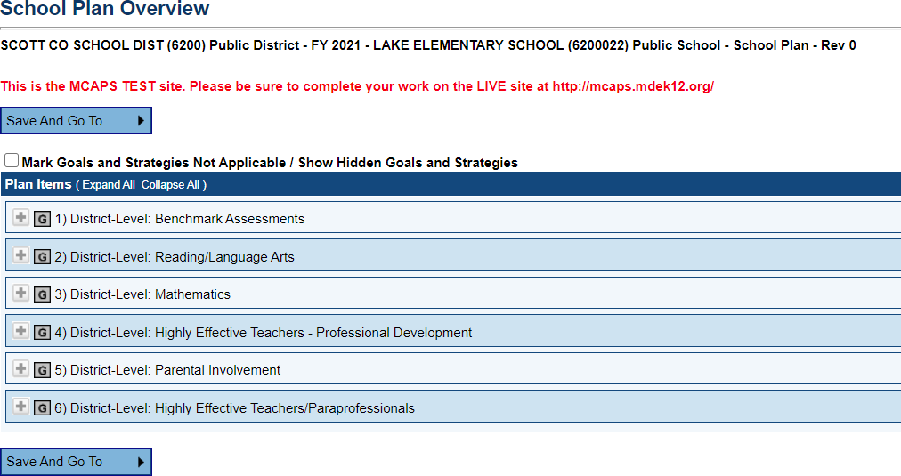

Determine the Goal and Strategy that fits how the school will use their Title I, Part A allocation.

Create an Action Step

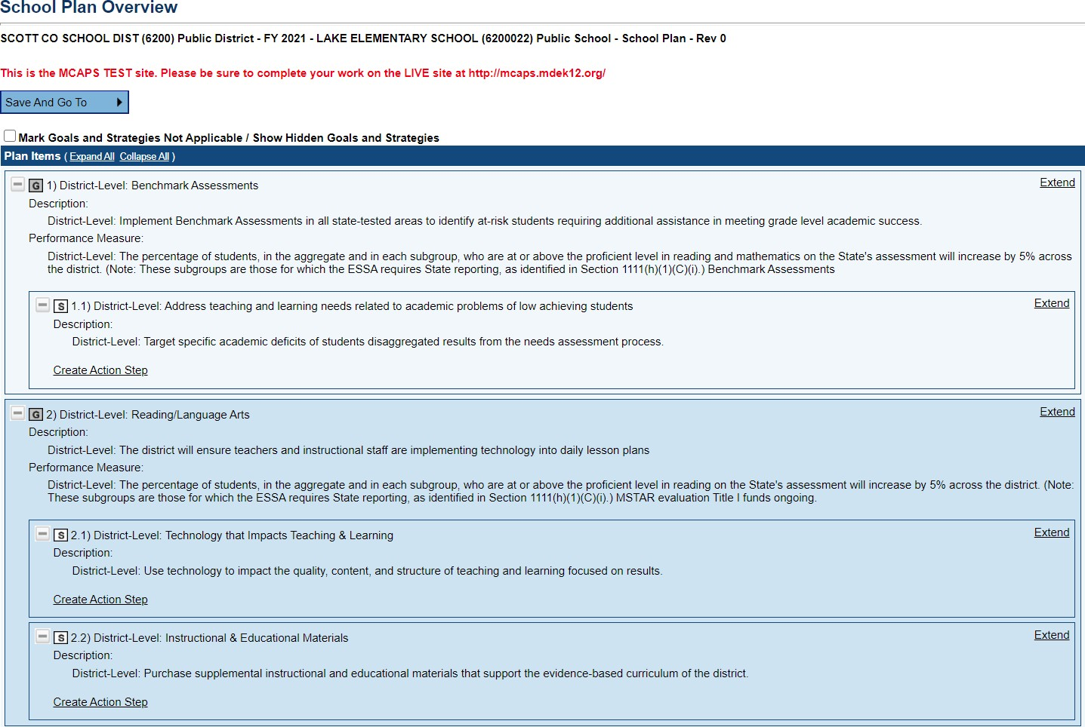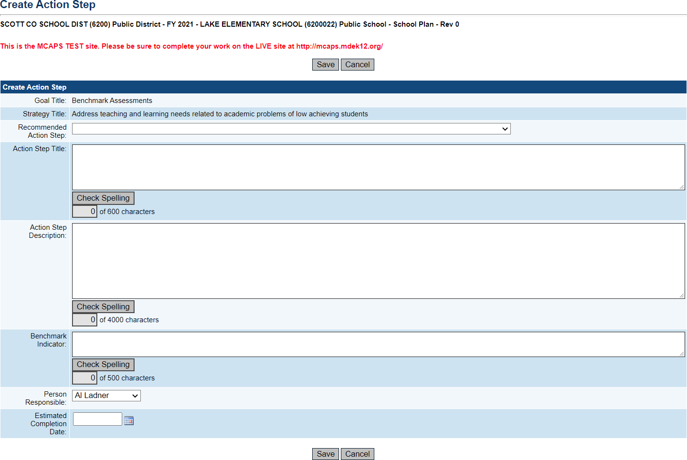

The school can choose to:

1. Create their own action step and fill in each area. The school must “save” the action step upon completion.

***OR***

1. Use a recommended action step.

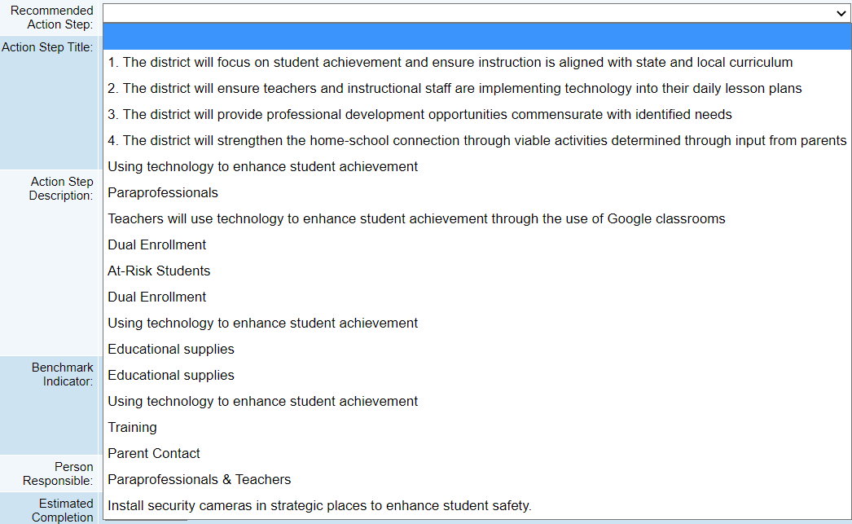

The school can choose a preset action step and edit it or create their own action step. The following steps are for using preset action steps.

If the School selects one of the recommended Action Steps, the Action Step Title and Action Step Description will prepopulate. The School can then edit it to meet its need.

**Creating a Funding Source:**

**A Complete Action Step with Funding Source Example:**

**Approval Process:**

School Plans Approval is a 3-level process in MCAPS that is required.

* Tier I- **Draft Completed** (School Level)
* Tier II- **School Plan Reviewer Approved** (School Level)
* Tier III- **LEA School Plan Reviewer Approved** (District Level)

No two levels can be approved by the same person. Each person must have a defined role. Please see the Federal Programs Director in your LEAs to determine each person’s role.

School Plans must have Tier III- **LEA School Plan Reviewer Approved** by the close of business Friday, February 25, 2022, in MCAPS. Each LEA will set their own deadline to ensure they have time to review and approve the School’s Plan.

**Please contact your LEA’s Federal Program Director for the date that Schools Plans must be submitted to the district**. School Plan are approved at the LEA level.