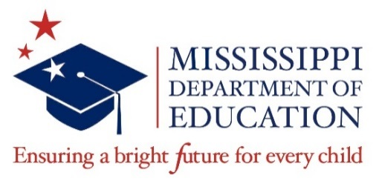
Mississippi State Board of Education
2021 - 2023 Student Representative Program
Application and Recruitment Timeline

Date | Action | Responsible Person(s)
December 1, 2020 | - Application released to district superintendents, high school principals, and counselors  - Application posted on SBE web site  - Press Release | Secondary Education  Educational Accountability  Communications
January 29, 2021 | Application deadline for submission. | Educational Accountability
February 2021 | Application packets reviewed to ensure they are complete and all eligibility requirements have been met in order for an applicant to be considered for interview. Application binders prepared for the Ad-Hoc Screening Committee. | Educational Accountability
March 2021 | - Ad-Hoc Screening Committee will review all qualified applications. The Committee will rate each application holistically, selecting at least 10 semifinalists who reflect the best cross-section of the many outstanding students who apply.  - Press Release | Ad-Hoc Screening Committee  Communications
April - May 2021 | Semifinalists will be interviewed by the Accountability Subcommittee and up to the top 4 highest scoring finalists will be recommended to the SBE for interview. | Accountability Subcommittee
June 16, 2021  SBE Work Session  8:30 a.m. | - The State Board of Education will interview the finalists.  - The State Board of Education will appoint a Student Representative and a Student Representative Alternate.  - Final Press Release | State Board of Education  Communications
July 1, 2021 | The term of office will begin for the new Student Representative. The Student Representative will attend an orientation session and the State Board of Education meeting in July. | Student Representative  MS School Boards Association  State Board of Education

