7:30 – 8:00  Breakfast | 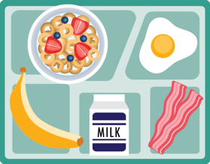
[insert time]
[insert time]
[insert time]
10:55 – 11:15
Lunch
[insert time]
[insert description]
[insert time]
[insert description]
[insert time]
[insert description]
[insert time]
[insert description]
2:00
Transportation
home

