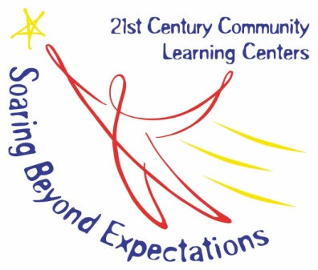
SUPPLEMENTAL FORM E

FY 21 Nita M. Lowey 21st Century Community Learning Centers
Notice of Intent to Apply
, 2020

Dear Mr. Norwood:

This notice confirms that (organization) is interested in applying for the FY 21 Nita M. Lowey 21st Century Community Learning Centers grant and intends to submit a proposal by the June 9, 2020 deadline.

Organization Name________________________________________________

Superintendent/Director/Fiscal Agent___________________________________

Address________________________________________________________

City_____________________State______________Zip__________________

Email_________________________________________________________

Phone_________________________________________________________

Sincerely,

Authorized Signature

Title of Authorized Person

Please complete this form and email to Chris Norwood at 21century@mdek12.org by June 3, 2020.

