Financial Literacy
Requirements for Mississippi Students

The Mississippi Department of Education (MDE), MS Council on Economic Education (MCEE), and Get2College working collaboratively have made great strides over the past five years in requiring students to take personal finance and in providing professional development for the teachers teaching this content. Mississippi is one of only twelve states to require all high school students to take at least one semester of personal finance (embedded in the College and Career Readiness course) prior to graduation. Click here to see Mississippi specifically mentioned on Next Gen Personal Finance (NGPF) website.

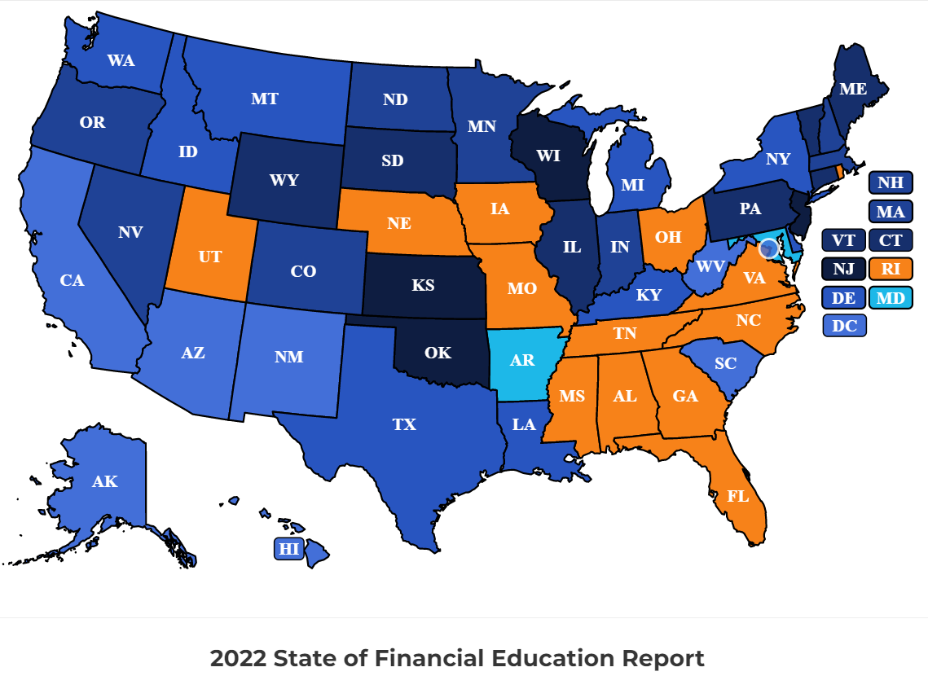

Beginning with cohort class of 2018-2019, the MDE implemented new graduation requirements which included diploma endorsement options and the College and Career Readiness (CCR) class. In addition to MDE, staff from the MCEE, Get2College, the MS Secretary of Treasury, and many other stakeholders, developed the CCR curriculum with financial literacy embedded into the course.

The Class of 2022 is the first class required to take and pass the CCR course as a graduation requirement. Within the CCR course, students are expected to engage in the following activities:
- Explain what it means to be college-and-career ready
- Create academic and personal S.M.A.R.T goals
- Explore career opportunities
- Evaluate postsecondary programs (including traditional 4-year colleges, community colleges, trade schools, the military, internships, apprenticeships, etc.) based on career interests
- Create resumes
- Compose and present portfolios
- Develop a college financial plan
- Research career paths and participate in job shadowing/internships/interviews
- Perform community service
- Explore digital literacy and citizenship
- Learn about financial literacy, including the following:
  - Comparing sources of personal income and compensation and analyzing factors that affect net income
  - Applying reliable information and systematic decision making to personal finance decisions
  - Analyzing strategies to monitor income and expenses, plan for spending, and save for future goals
  - Developing strategies to control and manage credit and debt
  - Explaining how investing helps build wealth and meet financial goals
  - Analyzing appropriate and cost effective risk management strategies
Click here for more information regarding the College and Career Readiness course.

The Mississippi Council on Economic Education and Get2College have been instrumental in educating and training our teachers to teach the content of the course. MCEE developed a Master Teacher of College and Career Readiness (MTCCR) course that hundreds of teachers have gone through in the past year and hundreds more will go through within the next year. Click here for more information about the MTCCR course. In addition to the MTCCR course, many teachers take the Master Teacher of Personal Finance course as well. The courses implement a plethora of resources from NextGen Personal Finance and The Federal Reserve Bank.

The organizations supporting MDE have excellent resources available at no cost. In partnership with the Federal Reserve Bank of St. Louis and Atlanta and Get2College, MCEE has created additional student courses in personal finance available to any teacher in MS wanting to use it at no cost.
NOTE: The following link contains the April 6, 2022 CNBC event where Gov. Reeves highlighted the College and Career Readiness course that includes personal finance. State Governors Weigh in on Financial Literacy

