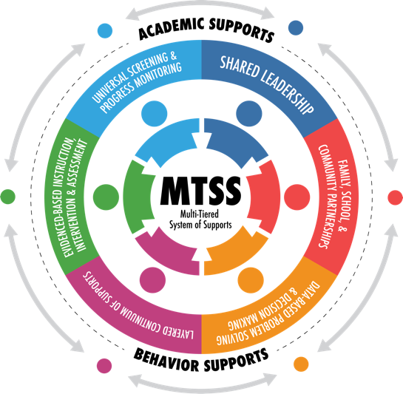

Multi-Tier System of Supports
Model for Behavior

Student Intervention Services
Office of Elementary Education and Reading

Acknowledgements

Raymond C. Morgigno, Ph.D. | Interim State Superintendent of Education
Donna H. Boone, Ph.D. | Chief Academic Officer

Marla Davis, Ph.D. | Associate Superintendent, Academic Liaison
Tenette Smith Ed. D. | Executive Director, Office of Elementary Education and Reading

Michelle McClain | Behavior Support Specialist
Tocarra Arnold | Regional MTSS Coach
Kelli Crain | Assistant State Literacy Coordinator K-3
Sandra Elliott | English Learner and Intervention Specialist
Chancey Fort, Ph.D. | Director of Counseling and Support Services
Bacardi Harris, Ed.D. | MTSS Regional Coach
Ginger Koestler | Director of Policy and Practice, Office of Special Education
Teresa Laney | Early Learning Collaborative Coordinator
Mathis Sheriff | Gifted Contact and Intervention Specialist
Lori Sisk | Gifted Support Service Specialist

In Collaboration With:

Erika X. Anderson | Behavior Counselor/PBIS Coordinator, TJ Harris Elementary School
Amy Bynum | Lead Interventionist, Lamar County School District

MTSS Model for Behavior

Tier I: Quality Classroom Instruction

In Tier I (T1), effective classroom management strategies are implemented. These approaches are intended for ALL students, staff, and settings. They include the development of school-wide expectations, a behavioral matrix (Center on PBIS | Behavior Matrix), and reinforcement systems that reward desired school appropriate behaviors. Outcomes, systems, data, and practices are continually evaluated using Positive Behavioral Interventions and Support (PBIS.) The following are examples of researched and evidence based T1 interventions:

- Active teaching of school/classroom procedures and rules
- Consistent acknowledgement of appropriate behavior in the school setting
- Incorporation of Social Emotional Learning during instruction
- Active supervision by teacher of student behavior by scanning, moving around the room, and interacting with students
- Providing students with frequent and varied opportunities to respond during instruction
- Providing structured breaks
- Access For All Guide 2.0
- MS Early Warning System
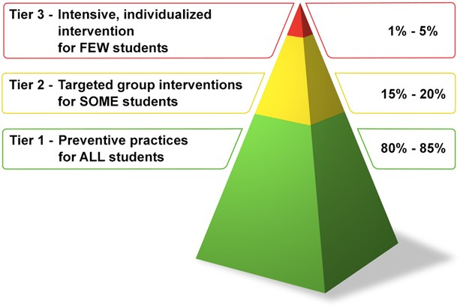
- The School Counselor and Multitiered System of Supports - American School Counselor Association (ASCA)
When rules and expectations are established and regularly taught throughout the school, 80-85% of misbehaviors that typically occur may be prevented. The remaining 15% of students may need Tier II or Tier III interventions.

Tier II Supplemental Instruction

A referral will be made to Tier II (T2) when a student is not responding to general classroom management methods. Before progressing, ensure that the school administrator or designee has evaluated the teacher and determined that the teacher’s classroom management strategies are appropriate and consistently employed.
Information collected from the teacher(s) should include:

- MTSS TI Documentation (report card, progress report, attendance report, discipline records, teacher documentation of TI strategies and results)
- Results from the most recent Behavior Screener (if applicable)
- Any behavior logs from the problem behavior area(s) noted

Once this information has been collected, it will be reviewed by the counselor and/or administrator, along with the MTSS team, to initiate the T2 process.

T2 interventions are for individuals or small groups of students who exhibit difficulties despite school-wide and classroom PBIS. This may include but not limited to:

- Students with three or more discipline referrals for “major” misconduct
- Students at-risk for academic/behavioral concerns
- Students who continue to engage in frequent problem behaviors despite effective school- wide TI prevention efforts
- Students who demonstrate a need for additional teaching, monitoring, and redirection
- Students who could benefit from extra attention or support during the school day before they are in crisis
- Students identified as individuals with both academic and behavioral difficulties
- Inappropriate student behavior that occurs over multiple settings
- Students with attendance concerns

- While focus is on students with three or more office referrals, remember the children who are:
- At risk on the Behavior Screener
- referred by parents
- Early Warning System (ABC)
- transitioning back to home school or district (e.g. alternative school, juvenile detention center, inpatient/out patient mental health center, etc)
- “under the radar” (internalizing behaviors or that may not be attention seeking or overt)
List of Behaviors:
Externalizing Behaviors: Internalizing Behaviors:
Disrupting the class Displays depression or sadness
Refusing to do work Sleeps often
Noncompliance/refusing to follow directions Acts unmotivated
Minor physical contact Does not participate in games
Vandalism Appears shy and timid
Inappropriate language Self-injury
Poor task completion Withdrawn

Key Points:
- All staff are trained on how to make referrals and how to implement the intervention(s) (Ensure that teachers are aware of the procedures for making referrals and steps to follow through the process)
- Develop a system for communicating with participating student, staff, and families
- MTSS Coordinator or other personnel are responsible for maintaining the integrity of the intervention(s) and ensuring that teacher(s) and/or staff member(s) are conducting the progress monitoring with fidelity
- The MTSS Coordinator, counselor or other personnel will maintain a log to record all times when he/she meets with the student as part of the intervention (small group, individual counseling, etc.)
- Data is used continuously to monitor progress and to determine when any modification(s) to the plan should be applied.

Recommended Documentation:
- Parent notification of T2 implementation
- MTSS T2 Documentation of behavior interventions (with supporting documents)
- Antecedent-Behavior-Consequence (ABC) Data
(https://www.pbisworld.com/wp-content/uploads/Antecedent-Behavior-Consequence-Log.doc)
- Progress monitoring (point system, behavior log, etc.)
- MTSS Meeting Summary Form

Evaluation:
- Progress monitoring data should be collected daily and examined on a bi-weekly basis at minimum.
- The percentage of points earned should be graphed daily, over time, to allow for more timely and accurate decision making.
- At least 10 days of data should be collected before considering making modifications to the student’s plan. (unless a MAJOR incident occurs)
- In addition to the behavior progress monitoring; discipline, grades, and attendance reports should be reviewed to determine the impact (positive or negative) of the intervention plan implementation.
- Following five weeks of monitored implementation (including one week of baseline data), the plan will be reviewed by the TST team to determine the need to continue or modify. Document outcomes using the Meeting Summary Sheet.
- A lack of implementation with integrity and fidelity, will result in a restart of the data tracking timeline. Consistency is key for tracking behavior.
- Lack of progress on student behavioral goals will result in a consideration of referral
for T3 interventions.

**If a student’s behavior negatively impacts his/her learning, the MTSS Coordinator should be contacted to determine the need to begin implementation of the Academic MTSS process. Documentation of all interventions and progress monitoring will be completed for academics as well as behavior if the student meets requirements per MTSS academic guidelines.

Tier III: Intensive Interventions

Students are identified for Tier III (T3) supports when interventions implemented with fidelity at TII have not produced the desired results in student behavior. To establish the efficacy of this process, it is essential to confirm that Tier 1 and Tier 2 behavior supports have consistently been applied and monitored for the student.

To initiate a referral to Tier 3, the following must occur:

- Parent/guardian is notified
- Hearing/Vision screening is conducted
- Complete Appendix A: Social/Emotional Worksheet
- Identify target behaviors (data collected from behavior logs; focus should be on 1-2 behaviors only)
- The TST team will develop a Tier 3 Functional Behavior Assessment and Behavior Intervention Plan, based on the function of behavior
- The teacher will collect daily progress monitoring of identified behavior(s) to be graphed for easy interpretation
Next Steps:
The TST team meet prior to Multi-disciplinary Evaluation Team (MET) to determine if the student would benefit from mental health services or if the student should be referred to MET for a comprehensive evaluation to determine need for special services.

Addressing Alternative School Interventions

When a student that is already placed in alternative school automatically populates on the MSIS intervention screen, the home school will notify the alternative school immediately. The home school should complete the data on the intervention screen and document that the alternative school will provide the interventions.

When a student is placed in the alternative school but was referred to TST at the homeschool prior to placement, the alternative school TST should provide assistance as outlined by the home school TST. The home school should document that the alternative school will provide the interventions.

When a student is NOT referred by the home school TST but is referred by the alternative school TST, the home school TST should provide assistanceas outlined by the alternative school TST upon the student's return.

When to contact your district MTSS Coordinator and/or Behavior Support Personnel:
- With any questions about T2 interventions
- When a child is failing to respond to T2 interventions
- Prior to a student being moved to T3
- With any questions related to the MTSS process for behavior
- With any questions about progress monitoring, data collection or graphing
- With any questions about students transition from juvenile detention, inpatient/outpatient facilities, ect.)---Behavior, SEL, Mental Health Issues

**Child Find is the ongoing obligation to identify, locate, and evaluate all children suspected of disabilities who need special education and related services as a result of those disabilities.
Note: A district should not violate its Child Find duty by repeatedly referring a student for interventions rather than evaluating the student’s need for special education and related services.

Resource Links

- Access for All Guide: https://issuu.com/rcumedia/docs/afa_2.0

- American School Counselor Association: www.schoolcounselor.org

- Attendance Works: https://www.attendanceworks.org/

- Center on PBIS | Behavior Matrix: https://pbis.org/search?query=behavior+matrix

- Center on Positive Behavior Intervention & Supports: https://www.pbis.org

- Early Warning System: www.mdek12.org/sites/default/files/Offices/MDE/OAE/OEER/Intervention/early_warning_system_benton_final2.pdf

- Frequently Asked Questions Intervention Services: www.mdek12.org/oeer/faq

- Intervention Central: https://www.interventioncentral.org/

- MDE Counseling and Support Services : www.mdek12.org/ESE/Counseling-and-Support-Services

- MTSS Documentation Packet:
https://www.mdek12.org/sites/default/files/offices/MDE/OAE/OEER/Intervention/updated_mtss_packet_april_2023_lw_1.docx

- MTSS Guidance Document:
https://www.mdek12.org/sites/default/files/Offices/MDE/OAE/OEER/Intervention/guidance_document_mtss_june2020.pdf

- PBIS World: https://www.pbisworld.com/

- Realizing Excellence for All Children in Mississippi (REACH MS): https://reachms.org

