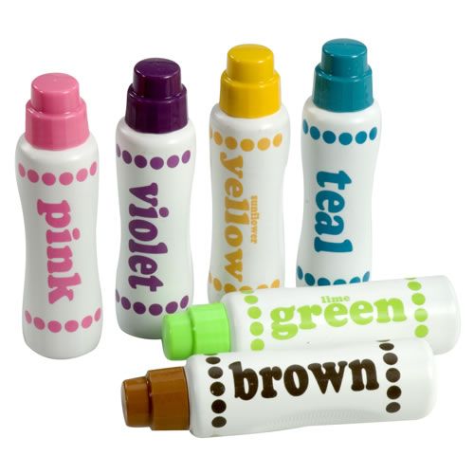
Dot Markers | Title Here
Title Here | Title Here
Title Here | Title Here
Title Here | Title Here
Title Here | Title Here
Title Here | Title Here

