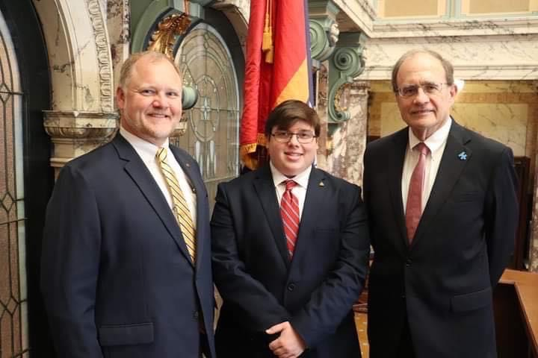

Thank you, Lt. Governor Delbert Hosemann for extending an invitation to State Vice President of Records of Mississippi FCCLA and Morton Zone FCCLA’s Vice-President, Senior of Morton High School- Kayden Johnson. Kayden’s strong leadership skills were sharpened with a week-long role of serving as a page at the State’s Capitol. Kayden also had the opportunity to extend an invitation to his peer of choice, Junior of Morton High School, Emma Grace Thomas to also experience how policies for the state of Mississippi are carried out.

When asked what the most impactful or unforgettable experience during the week was, Kayden’s response was, “having a conversation with Senator Hillman Frazier and sharing his wisdom with me. Senator Frazier made me feel important; he also informed me that he was impressed by me as most students would have moved quickly from the seat next to him. That statement fueled me to want to talk more to other politicians, and the Most exciting was witnessing SB 2346 public school and public library content restrictions. The conversations and points made were such a highlight because as a student leader the discussions involved me, personally as a public-school student leader and resources that are used daily.”

