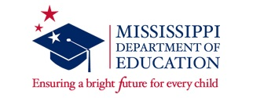
2021-2022 Early Childhood Specialized Bootcamp Training
The MDE Office of Early Childhood is pleased to offer training to teachers that need to acquire twelve hours of approved early childhood coursework to teach in pre-k classrooms. The completion of this training program will be the equivalent of twelve hours of early childhood course work needed for teachers and assistants of pre-k classrooms, general education and special education.
Completion of this training program includes:
- a two-week online training (June 14-25, 2021, excluding the weekend)
- two online courses (beginning August 2021)
- submission of all assignments to receive certification
The online components of bootcamp training may also be used by administrators of pre-k classrooms to meet Early Childhood professional development requirements.
If teachers would like more of an in-person group environment for the bootcamp training sessions, consult with your school administrators for permission to gather at a district site.
Below is a graphic to help determine if you should attend the Specialized Early Childhood Training Bootcamp. If you are a teacher or assistant in an Early Learning Collaborative, your requirements are different from the ones listed below. Please see this link for additional information: https://mdek12.org/sites/default/files/early_learning_collaborative_teacher_and_assistant_teacher_requirements_6-17-2020.pdf
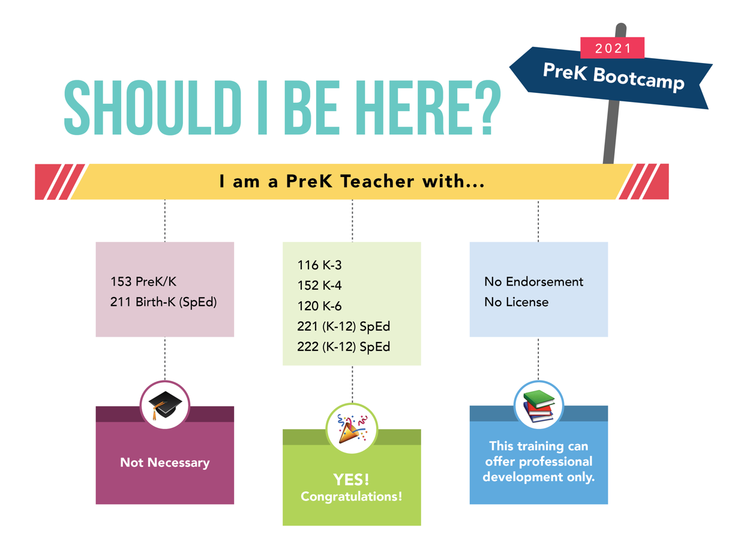
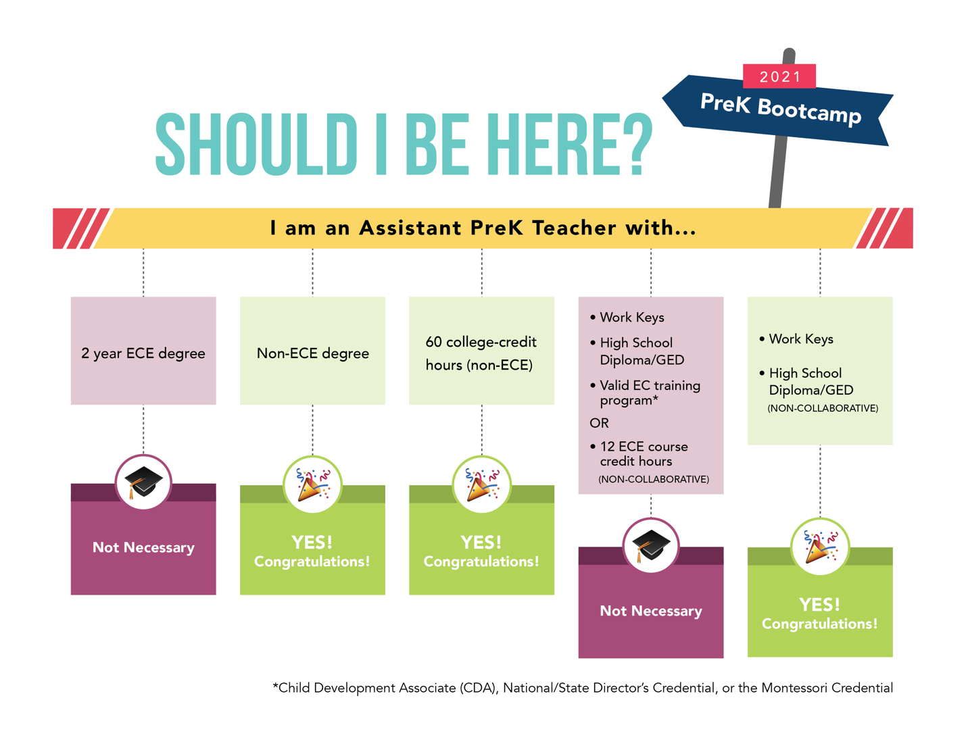
Registration: Registration will be handled through North Mississippi Education Consortium (www.northmsec.com). Participants will be required to create an account and provide a valid email address that is checked on a regular basis for the two-week on-line training that you will be attending.
Please register at this link: Approved Specialized Early Childhood Education Training Program | North MS Education Consortium (msresaservices.com).

