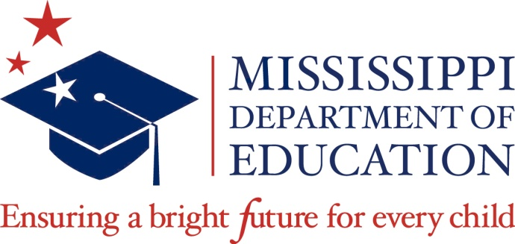

Guidelines for Recognitions of Student Achievement
We have many great achievements by students in Mississippi’s public schools, and we need to celebrate those accomplishments. To honor these achievements, guidelines for recognitions have been developed.
State Board of Education recognitions, which occur during monthly Board meetings, are reserved for individuals or groups that have earned national, regional, or statewide awards, honors, and achievements.
District superintendents are encouraged to nominate students for Board recognition. Upon return of the attached recommendation form, recognitions will be assigned to one of the three categories. The person submitting the nomination form will be notified if the nominee will be recognized.
Recognition categories:
- Exemplary Academic and/or Career and Technical Education Achievement

- Community Service

- Extracurricular Achievement

District Superintendents may nominate, during the school year, students who have excelled in any of the above categories. Nominations will be reviewed for possible SBE recognition.

After completion, this form should be delivered to Suite 310 or e-mail to tburkett@mdek12.org.

If your request is approved, you will be contacted about the date your requested recognition will take place and/or the category of recognition.

Name, telephone and e-mail of person submitting request: | Date of submission:
Name of individual(s), address, school and/or school district:

District Superintendent and Principal contact info: address, telephone and e-mail:
Requested month for recognition (must be at least two months after submission):

Description of honor to be recognized:

Please do not notify your nominee until selection has been confirmed by the Communications Office.

