commercialcard-
www.commercialcardcenter.com

CommercialCard is a web-based tool which provides for real-time electronic transaction and billing information to cardholders and program coordinators, allows access to 4 months of statement cycles, and all unbilled transactions for the current cycle. CommercialCard also provides electronic statements for cardholders or administrators with an automated email alert sent to notify the user when the statement is ready to be viewed or printed.

To enroll as a cardholder, simply register the account by entering your card number in the space provided under Register Now.

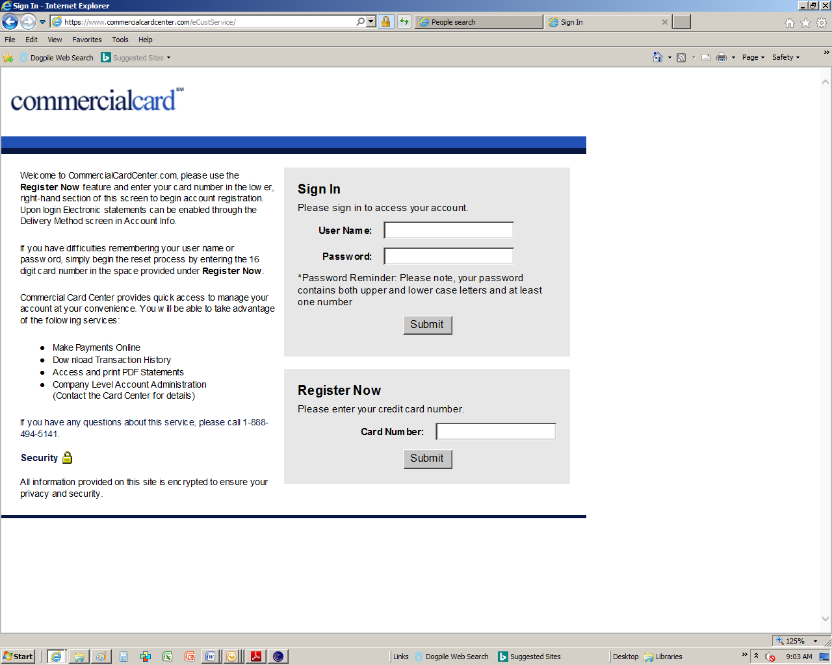
The cardholder will then be prompted to enter four pieces of information for verification purposes. The cardholder must enter the following information:

  - State
  - Zip Code (from statement address)
  - Card Expiration Date

The cardholder will then be prompted to create their own unique username and password in order to complete the enrollment process.

