SUGGESTED
INSTRUCTIONAL
PLANNING GUIDE
for the Mississippi College- and Career-Readiness Standards
q Literacy/English
Language Arts
Grades 4-5

The Mississippi State Board of Education, the Mississippi Department of Education, the Mississippi School for the Arts, the Mississippi School for the Blind, the Mississippi School for the Deaf, and the Mississippi School for Mathematics and Science do not discriminate on the basis of race, sex, color, religion, national origin, age, or disability in the provision of educational programs and services or employment opportunities and benefits. The following office has been designated to handle inquiries and complaints regarding the non‑discrimination policies of the above-mentioned entities: Director, Office of Human Resources, Mississippi Department of Education, 359 North West Street, P.O. Box 771, Jackson, MS 39205‑0771, (601) 359-3513.

Mississippi Department of Education
359 North West Street
P. O. Box 771
Jackson, Mississippi 39205-0771
(601) 359-3513
www.mdek12.org

MISSISSIPPI DEPARTMENT OF EDUCATION
Carey M. Wright, E.d.D.
State Superintendent of Education
Nathan Oakley, Ph.D.
Chief Academic Officer
Wendy Clemons  Executive Director, Offices of Secondary  Education/Dropout Prevention and Professional Development | Tenette Smith, Ed.D.  Executive Director, Office of Elementary  Education and Reading
Marla Davis, Ph.D.  State Director of Curriculum and Instruction | Kristen Wynn  State Literacy Director (K-12)
Natalie Crowder  English Language Arts Content Director | Jill Hoda  Assistant State Literacy Coordinator | Lori Stringer  Assistant State Literacy Coordinator
 | Melissa Beck  Assessment Coordinator (K-3) | LeighAnne Cheeseman Assistant State Literacy/English Learner Coordinator (K-3)

Special Acknowledgements
Bailey Education Group
Barksdale Reading Institute
The Kirkland Group

INTRODUCTION
The unprecedented, nationwide school closures in the spring of 2020 due to the COVID-19 pandemic have created a shift in how districts plan for school re-entry. Instead of the traditional brick-and-mortar planning, administrators are now identifying models that will support a variety of instructional delivery scenarios as they plan for school reopening. The traditional methods of planning and delivery are nearly impossible to implement as a stand-alone model; instead, innovative educators are developing and identifying strategies and resources to support a variety of distance learning scenarios as part of their plans. When using new models of delivery, it is important to recognize that the traditional approach to remediation—providing work better suited for earlier grades—may be insufficient. Instead, the conventional approach to remediation will likely compound the problem educators are trying to correct. According to a 2018 study, The Opportunity Myth,, the approach of “meeting students where they are”, while often well-intended, only widens the achievement gap. Instead of remediation, teachers and administrators are encouraged to look toward acceleration methods to support student growth and close the gaps.

PURPOSE
This document is intended to provide guidance to schools and districts as they develop instructional plans to address unfinished learning. It includes recommendations to assist educators as they diagnose learning loss and create an instructional plan to put every student on track to mastering grade-level standards. In addition, this guide is intended to compliment resources released by various organizations, including Student Achievement Partners (SAP), EdReports, The New Teacher Project (TNTP), and the Council of Chief State School Officers, that also address the challenges of prioritizing instruction, addressing unfinished learning, and meeting the social-emotional and mental health needs of students.

Recommendations for Addressing Unfinished Learning and Acceleration in ELA/Literacy

RECOMMENDATION 1 u | Focus on foundational skills instruction
Proficient word reading requires rapid recognition of all relevant layers of word structure in a mental process called orthographic mapping (Kilpatrick, 2015). Knowing a word well means being able to identify all the aspect of language represented in the printed word, including its meaningful parts, syllables, graphemes, and phonemes. (Moat, Tolman, 2019)  The MS CCRS includes the Reading Standards: Foundational Skills  (K–5). These standards foster students’ understanding and working knowledge of the concepts of print, the alphabetic principle, and other basic conventions of the English writing system. The Foundational Skills do not represent an endpoint—they are necessary and important components of an effective, comprehensive reading program designed to develop proficient readers who comprehend texts across a range of types and disciplines (MS CCSS, 2010).  Morphology Instruction  There is a significant increase in the number of complex word forms in text between 3rd and 8th grade (Nagy & Anderson, 1984) In fact, 60% of vocabulary acquired by school-age children is morphologically complex.  Students who understand more morphologically complex words have an easier time thriving in subjects such as reading, comprehension, oral language and writing. |  | FOUNDATIONAL SKILLS OF READING  - Print Concepts and Letter Sound Recognition (K-1):  Print concepts include the features of print and organization of print. The most important early print concept is letter recognition, which should begin immediately in kindergarten. Additionally, students should begin learning basic skills such as page-by- page reading and following words from left to right and top to bottom. They should begin noticing that words are separated by spaces and that these spaces are the same size.  - Phonological Awareness (K-2): A broad skill that includes identifying and manipulating units of oral language – parts such as words, syllables, and onsets and rimes.  - Phonics and Word Recognition (K-5): The learning of sound and spelling patterns in a distinct sequence that allows students to recognize, decode, and encode the sounds letters make in print.  - Fluency (K-5): Fluency consists of three things: rate, accuracy, and expression. Expression, or prosody, includes timing, phrasing, emphasis, and intonation. Fluency is built through word recognition, one word at a time. Teaching systematic phonological awareness and phonics, and applying these skills to text, allows students to build automaticity in word reading.

RECOMMENDATION 2 u | Prioritize grade-level content and learning through the use of  High-Quality Instructional Materials (HQIM)
Building the stamina and skills to read widely and deeply from a range of challenging fiction, informational texts, and other materials is fundamental to grades 4 and 5. Building knowledge about subjects through informal research projects and responding analytically to literary and informational sources in history, science, and the arts are key to students’ continuing success. |  | #MATERIALSMATTER  When teachers don’t have access to great  materials, they spend valuable time searching for them online or create content themselves. A 2017 RAND analysis found that 96 percent of teachers use Google and 75 percent of teachers use Pinterest to find lessons and materials. These materials are mostly unvetted and of varying quality. Inconsistent access to aligned materials impacts student learning in schools across the country, but particularly hits schools that have a higher proportion of low income and students of color the most, perpetuating inequities and opportunity gaps.

RECOMMENDATION 3 u | Plan your approach to diagnosing students’ unfinished learning
Universal Screeners  Universal screeners are valid and reliable data collection tools and processes used to assess students’ current level of performance in relation to grade- level benchmarks, identifying students who need intervention and those who do not. Because screening takes place multiple times per year with all students, screeners are typically designed to be easy, quick, and repeatable.  Diagnostic Assessments  Diagnostic Assessments are used to assess specific skills or components of reading such as phonemic awareness, phonics skills, and fluency. The results of diagnostic assessments inform instruction and intervention. Diagnostic assessments can be formal standardized tests of children’s component reading and language abilities or informal measures such as criterion-referenced tests and informal reading inventories. Not all children need this kind of in-depth reading assessment, which is most important for struggling and at-risk readers.  Suggested Diagnostic Assessments  - DIBELS: https://dibels.uoregon.edu/  - Phonological Awareness Skills Test (PAST): https://www.thepasttest.com/  - Really Great Reading’s Complimentary Assessments: https://www.reallygreatreading.com/diagnostics |  | APPROVED LIST OF  READING SCREENERS  State statute requires that the Mississippi Department of Education shall select early literacy and numeracy screening assessment instrument or instruments to be used throughout the state in the screening of students in Kindergarten through Grade 3. (Mississippi Code § 37-23-16; Mississippi Code § 37-177-5) The Mississippi Department of Education, in collaboration with Mississippi Reading Panel, has established an approved list of reading screeners to be used by local school districts in grades K-3. The following universal screeners are approved for use in Mississippi schools:  - FAST: Adaptive Reading, CBMReading, and earlyReading English (suite of three administered together) (Grades K-12)  - iReady® (Grades K-12)  - Measures of Academic Progress (MAP) Growth (Grades K-2), MAP (Grades 2-10)  - STAR Reading (Grades 1-12)
Schools and districts should prioritize gathering information about students’ unfinished learning by using assessments from high-quality adopted materials as often as possible. Designing assessments is truly challenging, so using the assessments provided by the high-quality instructional materials you have adopted is the best way to diagnose gaps that students might have in their learning.

RECOMMENDATION 4 u | Promote Social, Emotional, and Academic (SEAD) Development
As we narrow the focus and recommit to what matters most academically, research also tells us that four learning mindsets are particularly important in supporting students’ academic development. Learning mindsets focus on students’ sense of 1) belonging and safety, 2) efficacy, 3) value for effort and growth, and 4) engagement in work that is relevant and culturally responsive (Aspen Institute, 2019).

Within classrooms, within schools, attention must be given to restoring relationships and building a sense of community, so students feel safe, fully engage and work hard. As educators, we need to help students know that we believe they can succeed and that their ability and competence will grow with their effort. And more than ever, students need to see value and relevance in what they are learning to their lives and their very beings. Investing in students' social-emotional development is done by the entire system of adults in schools. This investment is key to promoting engagement in—not a substitute for—teaching academic content; it represents a change in how academic content is taught. There is a stunning opportunity to curate high-quality instructional materials aligned to healing and resilience for next year. Efforts should be made to facilitate Social Emotional Academic Development (SEAD) even in remote learning environments, using synchronous and asynchronous approaches and the capabilities afforded by remote learning technologies.

Recommended Instructional Content and Practices in ELA/Literacy
Adopted from Student Achievement Partners: ELA/Literacy Considerations 2020-2021
Keep the “Simple View of Reading” in View
The two most important components of reading are the ability to decode the written word and the ability to comprehend the language of the text. The Simple View of Reading (SVR), emphasizes that proficient readers have well-developed skills in both domains (Gough and Tunmer, 1986). Word recognition, or the fast retrieval of decoded word form, is essential for the development of reading comprehension (Moats, Tolman, 2019). Language comprehension, the other domain which reading depends, refers to listening comprehension or the linguistic processes involved in comprehension of oral language (Moats, Tolman, 2019).

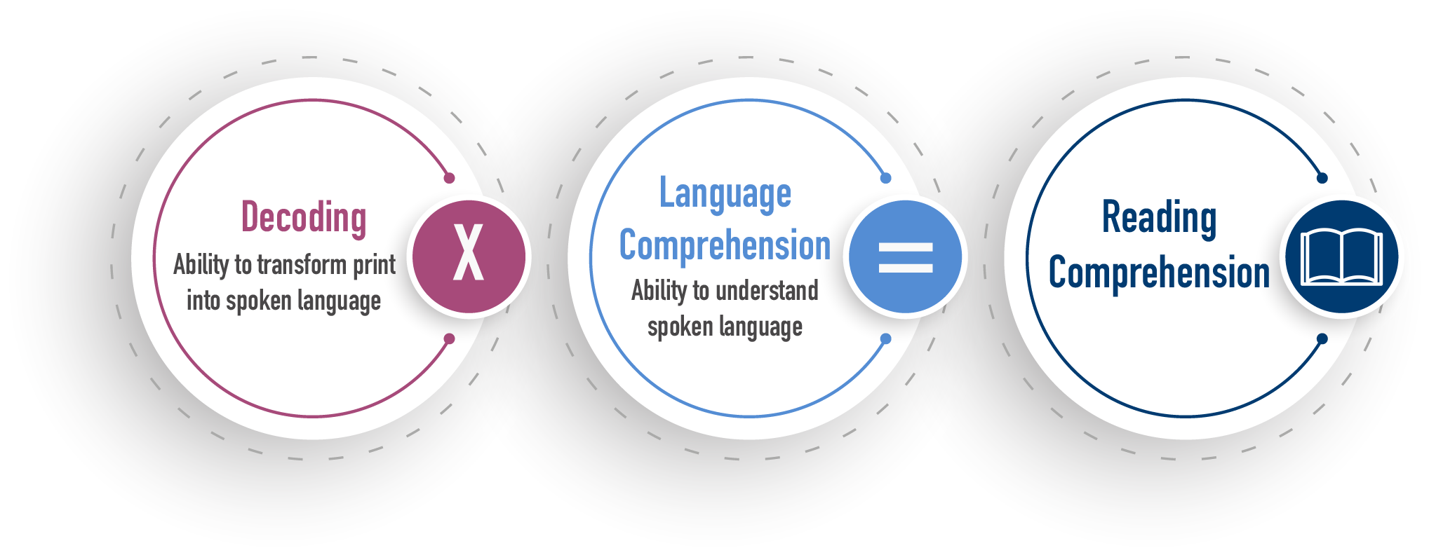

Focus on Standards That Represent the Major Work of ELA/Literacy Instruction
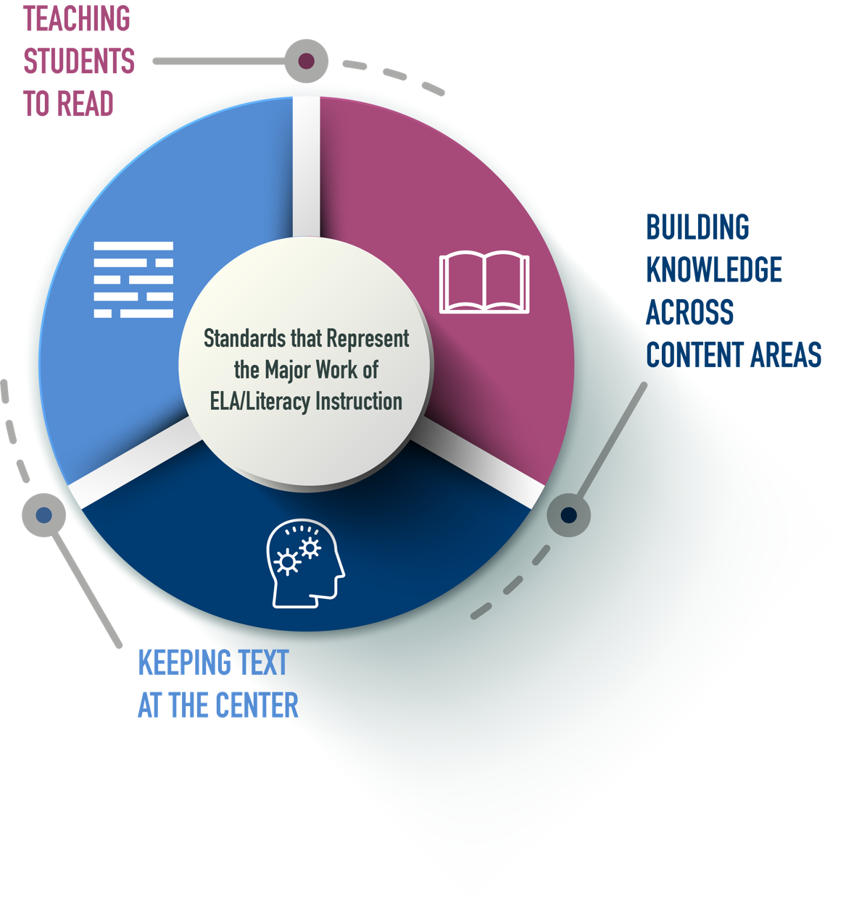
As students learn more within and across grades, they will gain greater access to more and richer texts. Students will learn about the world around them and about themselves and their role in that world. They will also learn more and more words, many of them wrapped in complex sentences. The more words students recognize, the more comfortable they will get with varied syntax and the more learning they will be able to access.

SUGGESTED
INSTRUCTIONAL
PLANNING GUIDE
for the Mississippi College- and Career-Readiness Standards
Grades 4-5

Keep Text at the Center of Reading, Writing, Speaking, Listening and Language Comprehension

PRIORITY u Regular Close Reading of Complex, Anchor Texts through Read-Alouds
STANDARDS
GRADE 4 |  |  | GRADE 5
RL.4.10 By the end of the year, read and comprehend literature, including stories, dramas, and poetry, in the grades 4–5 text complexity band proficiently, with scaffolding as needed at the high end of the range. |  |  | RL.5.10 – By the end of the year, read and comprehend literature, including stories, dramas, and poetry, at the high end of the grades 4-5 text complexity band independently and proficiently.
RI.4.10 – By the end of year, read and comprehend informational texts, including history/social studies, science, and technical texts, in the grades 4–5 text complexity band proficiently, with scaffolding as needed at the high end of the range. |  |  | RI.5.10 – By the end of the year, read and comprehend informational texts including history/social studies, science, and technical texts, at the high end of the grades 4–5 text complexity band independently and proficiently.
RECOMMENDED INSTRUCTIONAL PRACTICES
- Focus all students on the same rich, grade-level anchor texts as defined by the quantitative chart below and the qualitative features of texts (such as meaning, structure, language, and knowledge demands). Focus on these anchor texts, multiple times a week.
- Organize units around conceptually related topics (and content-rich themes for literary texts) that build knowledge through anchor texts and volume of reading.
- Provide and adjust instructional scaffolds so every student can engage with the anchor texts, rather than restrict students to texts at their prescribed independent reading level. Scaffolds could include building knowledge about the topic of the text under study, providing access to texts read aloud, etc.
 | Grade Level | Lexile Range* |  | *For all grade bands also consider qualitative features (such as levels of meaning, structure, language, and knowledge demands) as well as readers and tasks.
 | 4-5 | 740-1010

PRIORITY u Sequence of Text-Specific Questions and Tasks to Support Close Reading
STANDARDS
R.1 Read closely to determine what the text says explicitly and to make logical inferences from it, cite specific textual evidence when writing or speaking to support conclusions drawn from the text.
Additional Guidance for Grades 4-5 Reading Standards should be identified through the use of a high-quality, standards-aligned curriculum.
RECOMMENDED INSTRUCTIONAL PRACTICES
- Provide sequences of questions that engage students deeply with the text and build understanding.
- Design instruction to cultivate every students’ ability to read carefully and grasp information—both what the text says explicitly and when drawing inferences from texts.
- Encourage students to cite specific text evidence (quotes and examples) when supporting their own points in writing and speaking, making their reasoning clear to the reader or listener and constructively evaluating others’ use of evidence.
- Provide time for students to engage meaningfully with the anchor text by reading or rereading portions.

PRIORITY u Systematic Work with Text-Based Vocabulary and Syntax
STANDARDS Vocabulary and Syntax Important to Comprehension or Expression
Additional Guidance for Grade 4-5 Reading and Language Standards should be identified through the use of a high-quality, standards-aligned curriculum.
GRADE 4 | GRADE 5
RL. 4.4 Determine the meaning of words and phrases as they are used in a text, including those that allude to significant characters found in mythology (e.g., Herculean). | RL 5.4 Determine the meaning of words and phrases as they are used in a text, including figurative language such as metaphors and similes.
RI.4.4 Determine the meaning of general academic and domain-specific  words or phrases in a text relevant to a grade 4 topic or subject area. | RI.5.4 Determine the meaning of general academic and domain-specific words and phrases in a text relevant to a grade 5 topic or subject area.
L.4.4 Determine or clarify the meaning of unknown and multiple-meaning words and phrases based on grade 4 reading and content, choosing flexibly from a range of strategies. | L.5.4 Determine or clarify the meaning of unknown and multiple-meaning words and phrases based on grade 5 reading and content, choosing flexibly from a range of strategies.
L.4.5 Demonstrate understanding of word relationships and nuances in word meanings. | L.5.5 Demonstrate understanding of figurative language, word relationships, and nuances in word meanings.
L.4.6 Acquire and use accurately grade-appropriate general academic and domain-specific words and phrases, including those that signal precise actions, emotions, or states of being (e.g., quizzed, whined, stammered) and that are basic to a particular topic (e.g., wildlife, conservation, and endangered when discussing animal preservation). | L.5.6 Acquire and use accurately grade-appropriate general academic and domain-specific words and phrases, including those that signal contrast, addition, and other logical relationships (e.g., however, although, nevertheless, similarly, moreover, in addition).

RECOMMENDED INSTRUCTIONAL PRACTICES
- Use text-based questions/tasks to focus on academic and domain-specific words that merit more attention (e.g., critical for understanding the text, parts of large word families). Do this rather than memorizing text-agnostic word lists.
- Provide supplemental practice on text-based vocabulary through games, exercises, and focus on word parts and their morphology.
- Encourage the use of the targeted words from the anchor text throughout discussions and writing assignments.
- Regularly—and daily if possible—choose one complex and compelling sentence from the anchor text to deconstruct and reconstruct with students.
Resource: Academic Word Finder https://achievethecore.org/page/1027/academic-word-finder
PRIORITY u Frequent Evidence-Based Discussions About Grade-Level Anchor Texts
STANDARDS Conversations and Collaborations Centered on Evidence
GRADE 4 | GRADE 5
SL.4.1 Engage effectively in a range of collaborative discussions (one-on-one, in groups, and teacher-led) with diverse partners on grade 4 topics and texts, building on others’ ideas and expressing their own clearly. | SL.5.1 Engage effectively in a range of collaborative discussions (one-on-one, in groups, and teacher-led) with diverse partners on grade 5 topics and texts, building on others’ ideas and expressing their own clearly.
RECOMMENDED INSTRUCTIONAL PRACTICES
- Design collaborative, small-group, or partner discussions about anchor texts—daily if possible—for students to process and extend their learning:
  - Make strategic use of peer partnerships to promote as much productive talk as possible.
  - Ask students to reflect on each other’s thinking using evidence, as well as considering and challenging others’ perspectives.
Step in (and out) of discussions to keep students focused and encourage them to construct longer and deeper responses.

PRIORITY u Regular Evidence-Based Writing About Grade-Level Anchor Texts
STANDARDS Research to Build and Present Knowledge
Additional Guidance for Grades 4-5 Writing Standards should be identified through the use of a high-quality, standards-aligned curriculum.
GRADE 4 | GRADE 5
W.4.9 Draw evidence from literary or informational text to support analysis, reflection, and research. | W.5.9 Draw evidence from literary or informational text to support analysis, reflection, and research.
RECOMMENDED INSTRUCTIONAL PRACTICES
- Connect writing to what students are reading (or listening to) to deepen comprehension, check for understanding, and ensure all students have equal access to the topic on which they are writing.
- Include writing tasks connected to the literary texts students are reading that target perspective-taking and exploring the emotions and motivations of characters as an on-ramp to self-exploration and reflection.
- Support students to make use of knowledge gained from the anchor text in their writing without requiring direct text evidence.
Within these writing opportunities, address and support students’ ability to demonstrate command of writing and conventions, including use of capitalization, punctuation, and spelling.

PRIORITY u Fluency Practice With Grade-Level Anchor Texts
STANDARDS Fluency of Grade-Level Text
GRADE 4 | GRADE 5
RF.4.4 Read with sufficient accuracy and fluency to support comprehension. | RF.5.4 Read with sufficient accuracy and fluency to support comprehension.
RECOMMENDED INSTRUCTIONAL PRACTICES
- Engage in fluency exercises—daily if possible—through regular and repeated readings of texts.
- Attend to prosody (pitch, stress, and timing) as students read aloud.
- Ensure students have time to discuss the meaning of the text and address text-based vocabulary as needed, even when improving fluency is the focus.
Resources:
Four classroom strategies that can help build fluent readers https://achievethecore.org/aligned/building-reading-fluency/
Fluency Packet for the 4-5 Grade band https://achievethecore.org/page/886/fluency-packet-for-the-4-5-grade-band
Reading prosody and word identification accuracy predicts more than half of the variance in a standardized test of reading comprehension administered to struggling ninth-grade readers. Many students can experience reading improvement in minutes (Paige & Magpuri-Lavell, 2014).

Build Knowledge Through Reading, Writing, and Speaking about Topics Across Content Areas

PRIORITY u Regular Reading of Multiple Texts and Media on a Range of Conceptually Related Topics
STANDARDS Research to Build and Present Knowledge
Additional Guidance for Grade 4-5 Writing Standards should be identified through the use of a high-quality, standards-aligned curriculum.
GRADE 4 | GRADE 5
W.4.8 Recall relevant information from experiences or gather relevant information from print and digital sources; take notes and categorize information and provide a list of sources. | W.5.8 Recall relevant information from experiences or gather relevant information from print and digital sources; summarize or paraphrase information in notes and finished work and provide a list of sources.
RECOMMENDED INSTRUCTIONAL PRACTICES
- Choose content-rich informational texts that are topically connected to the anchor texts to build students’ knowledge about the topic and maximize their breadth of exposure to academic vocabulary.
- Literary: 50%
- Informational: 50%
- Offer students texts that span a range of complexity levels so they can read the texts independently, with peers, or with modest support. This should include a balance of literature and informational texts across ELA, science, history, and the arts.
Consider focusing on organized units around topics that build knowledge through anchor texts and volume of reading instead of isolated skill-paced calendars.

PRIORITY u Regular Research Discussion and Writing About Topics
STANDARDS
Additional Guidance for Grades 4-5 Reading and Language Standards should be identified through the use of a high-quality, standards-aligned curriculum.
GRADE 4 | GRADE 5
W.4.8 Recall relevant information from experiences or gather relevant information from print and digital sources; take notes and categorize information and provide a list of sources. | W.5.8 Recall relevant information from experiences or gather relevant information from print and digital sources; summarize or paraphrase information in notes and finished work and provide a list of sources.
RI.4.9 Integrate information from two texts on the same topic in order to write or speak about the subject knowledgeably. | RI 5.9 Integrate information from several texts on the same topic in order to write or speak about the subject knowledgeably.
SL 4.1 Engage effectively in a range of collaborative discussions (one-on-one, in groups, and teacher-led) with diverse partners on grade 4 topics and texts, building on others’ ideas and expressing their own clearly. | SL.5.1 Engage effectively in a range of collaborative discussions (one-on-one, in groups, and teacher-led) with diverse partners on grade 5 topics and texts, building on others’ ideas and expressing their own clearly.
RECOMMENDED INSTRUCTIONAL PRACTICES
- Regularly ask students to participate in shared research tasks where they explore multiple texts and resources (e.g., illustrations, video clips, maps) to build knowledge on a topic.
- Ask students to integrate what they have just listened to with what they have listened to previously to build a more coherent understanding of a topic.
- Promote independent reading by providing options for students to choose topically connected texts.
- Design collaborative, small-group, or partner discussions on topics for students to process and extend their learning.

PRIORITY u Social, Emotional, and Academic (SEAD) Development
SAMPLE ACTIONS
- Promote a sense of belonging by including language routines, such as choral reading and word games, so students see themselves as a part of a learning community.
- Ensure that the richness and complexity of grade-level text is regularly available to every student, and no student is denied such access through the exclusive practice of assigning leveled or alternative texts.
- Encourage students to draw on their emotional and empathetic skills as they orally express their thoughts, feelings, ideas, and arguments.
- Create space and opportunity for students to identify and explore their own interests and fascinations.
- Develop and strengthen writing in response to feedback from others.
- Anchor topical knowledge building in collaborative opportunities for students to conduct research while practicing cooperation, communication, innovation, reflection, self-regulation, and empathy.

Use Remaining Standards to Support the Major Work of ELA/Literacy Instruction
PRIORITY u Intentionally Include All Supporting Standards
INSTRUCTIONAL PRACTICES
- Using high-quality, standards-aligned curriculum, plan instruction that intentionally includes supporting standards—represented by the more than two dozen remaining standards in each grade level—to engage students more fully in the Major Work of the Grade. The supporting standards can be incorporated into instruction in service of the major 14 standards. Promote independent reading, read-alouds and other options for students to choose topically connected texts. (These can be driven by student interest, topic of anchor text, and course content.
- For instance, in close reading lessons, supporting standards can help generate an effective sequence of text-specific questions that target central ideas, text structure, author’s purpose, and the like, to guide students in exploring and extracting the key ideas of texts.
- Likewise, when devising writing assignments, the supporting standards can help guide the qualities of explanations or arguments that students should be reaching for in one grade or another.

GRADES 4 THROUGH GRADE 5 APPENDICES & RESOURCES

Summary of Six Types of Syllables in English Orthography
Syllable Type | Examples | Definition
Closed | ac – cept  fan – tas – tic  bev – er -- age | A syllable with a short vowel spelled with a single vowel letter and ending in one or more consonants
Vowel-Consonant-e  (VCe) | com – plete  de – spite  con – trive | A syllable with a long vowel spelled with one vowel plus one consonant plus silent e
Open | pro – gram  tri – an – gle  re – cent | A syllable ending with a long vowel sound that is spelled with a single vowel letter
Vowel Team | aw – ful  train – er  con – geal  spoil – age | A syllable with a long or short vowel spelling that uses 2-4 letters to spell the vowel sound; includes diphthongs ou/ow and oi/oy
Vowel-r | mon – ster  con – sort  char – coal  fur – nish | A syllable with er, ir, or, ar, or ur; the vowel sound before the letter r often changes its pronunciation
Consonant-le (Cle) | drib – ble  bea – gle  lit – tle  tan – gle | An unaccented final syllable containing a consonant before l followed by a silent e
Leftovers: Odd and Schwa Syllables | dam – age  ac – tive  na – tion | Usually a final, unaccented syllable with an odd spelling

Outline of Word Study by Grade and Language Structure
(Based on Henry, 2010; Moats, 2010)

Historical Layer of English | Sound-Symbol Correspondence | Syllable Patterns | Morpheme Structures
Anglo-Saxon Layer (Grades 1-3) | Consonants  - Single  - Digraphs  - Blends  Vowels  - Single short/long  - VCe  - Vowel team  - Vowel-r patterns | - Closed (short V)  - Open (single long V)  - VCe (silent e)  - Vowel-r  - Vowel team  - Consonant-le  - Odd Syllables | - Compounds (e.g., daylight)  - Inflectional suffixes (e.g., -ed, -s, -es, -er, -est, ing)  - Prefixes  - Derivational suffixes (e.g., -en, -hood, -ly, -ward)  - Odd, high-frequency words (e.g., said, does)
French/Latin (Romance) Layer (Grades 4-6) |  |  | - Prefixes (e.g., pre-, inter-)  - Roots (e.g., gress, ject, vis)  - Suffixes (e.g., -ment, -ity)  - Latin plurals (e.g., alumni, minutiae, curricula, data)
Greek Layer  (Grades 6-8) | Spellings  - ph for /f/  (e.g., graph)  - ch for /k/  (e.g., chorus)  - y for / ĭ/ (e.g., gym) |  | - Combining forms (e.g., neuro, psych, ology, lex, chloro)  - Plurals (e.g., crises, metamorphoses, vertebrae)

Empowering Students as They Read Complex Text

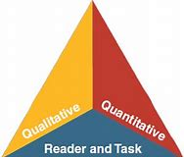
Qualitative-readability and other scores of text complexity often best measured by computer software.
Quantitative-levels of meaning, structure, language conventionality and clarity, and knowledge demands often best measured by an attentive human reader.
Reader and Task-background knowledge of reader, motivation, interests, and complexity generated by tasks assigned often best made by educators employing their professional judgement.

Five Step Strategy for Complex Text
Step 1: Scan for Unfamiliar Words | Decoding multisyllabic words:  - Identify affixes (prefixes and suffixes  - Look at the root or base word-decode that base word using information about syllable types or spelling pattern  - Read each part quickly  - Reread the word as a whole word  - Determine meaning from morphemes  - Determine meaning using context
Step 2: Set a Purpose for Reading | - Let’s read to see what will happen to….  - Let’s read to find out about….
Step 3: Read to See What the Text Says | - Decoding and meaning  - Choral reading  - Independent reading
Step 4: Reread to Determine How the Text Works | - Text Structure  - Grammar
Step 5: Reread to Determine What the Text Means | - Syntax  - Analysis

ELA/Literacy K-12 Instructional Planning Guides (IPG) References

Collaborative for Academic, Social, and Emotional Learning. (2017). Examples of Social and Emotional Learning in High School English Language Arts Instruction. Retrieved from https://www.casel.org/wp-content/uploads/2017/08/SEL-in-High-School-ELA-8-20-17.pdf

Council of the Great City Schools. (2020). Addressing unfinished learning after COVID-19 school closures . Washington, DC: Author. www.cgcs.org

Gough, P. and Tunmer, W. (1986). Decoding, reading, and reading disability. Remedial and Special Education, 7, 6–10.

Kilpatrick, D. A. (2015). Essentials of Assessing, Preventing, and Overcoming Reading Difficulties. Hoboken, New Jersey: John Wiley & Sons.

“Micro-Apartments Hope to Ease Living Costs for Young City Residents.” PBS LearningMedia, PBS NewsHour, 21 June 2020, Retrieved from mpb.pbslearningmedia.org/resource/6624c308-5a2c-4551-9f94-c8927a058be2/micro-apartments-hope-to-ease-living-costs-for-young-city-residents/.

Moats, L., & Tolman, C. A. (2019). LETRS 3rd Edition: Language essentials for teachers of reading and spelling. Boston, MA: Sopris West.

Nagy W., Herman P., & Anderson R. C. (1985). Learning words from context. Reading Research Quarterly, 20(2), 233–253.

Student Achievement Partners, 2020-21 Priority Instructional Content, https://www.achievethecore.org/2020-2021_PriorityInstructionalContent

Student Achievement Partners. (n.d.). Academic Word Finder. https://achievethecore.org/page/1027/academic-word-finder

Student Achievement Partners. (n.d.). Increasing Reading Fluency for Middle and High School Students. https://achievethecore.org/page/3254/increasing-reading-fluency-for-middle-and-high-school-students

Student Achievement Partners. (n.d.). Selecting and Using Academic Vocabulary in Instruction. Retrieved from https://achievethecore.org/content/upload/Selecting%20and%20Using%20Academic%20Vocabulary%20in%20Instruction.pdf

Student Achievement Partners. (n.d.). Supporting All Learners with Complex Texts. https://achievethecore.org/aligned/supporting-all-learners-with-complex-texts/

Student Achievement Partners. (n.d.). Text Complexity. https://achievethecore.org/category/1206/ela-literacyfoundational-skills

Student Achievement Partners. (n.d.). Text Dependent Questions. https://achievethecore.org/category/1158/elaliteracy-text-dependent-questions

Student Achievement Partners. (n.d.). 3 Steps to Engage Students in Research Writing. http://achievethecore.org/aligned/3-steps-engage-students-in-research-writing/
Wassermann, Selma. “Effective Classroom Discussions.” Effective Classroom Discussions - Educational Leadership, 2010, Retrieved from www.ascd.org/publications/educational-leadership/feb10/vol67/num05/Effective-Classroom-Discussions.aspx.

https://tntp.org/assets/documents/TNTP_The-Opportunity-Myth_Web.pdf
https://mdreducation.com/reports/classroom-trends-teachers-buyers-instructional-materials-users-technology/
https://www.rand.org/pubs/research_reports/RR1529-1.html
https://fordhaminstitute.org/national/research/supplemental-curriculum-bazaar
https://journals.sagepub.com/doi/pdf/10.3102/0013189X15603982
https://www.mdek12.org/sites/default/files/Offices/MDE/OA/OSA/Universal%20Screener%20and%20Diagnostic%20Assessment/screener-guidance-april-2018-04-18_20180419134804_279631.pdf

