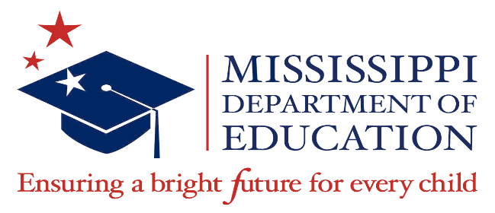

2021-2022

McKinney-Vento Education for Homeless Children and Youth Program Awards

School District | Award Amount
Corinth School District | $137,089.38
George County School District | $111,890.43
Hattiesburg Public School District | $112,923.17
Jackson Public School District | $710,055.72
Senatobia Municipal School District | $105,280.87
Starkville-Oktibbeha School District | $109,618.39
Tupelo Public School District | $135,023.89
TOTAL | $1,421,881.85

Funding Period: March 1, 2022 – May 30, 2024
(with a liquidation of December 30, 2024)

