Mississippi

2023 – 2024
T-Shirt Design

The purpose of this contest is to provide students with an opportunity to graphically illustrate the SkillsUSA theme by displaying it on a T-Shirt.

Please follow the guidelines when creating your design. Each chapter is encouraged to enter this contest. All chapters will get to vote on the T-Shirt electronically. I will put all submitted T-shirt designs in a power point and email to advisors. Each chapter will get 6 votes. I will explain when I email the power point. Each chapter can enter two (2) designs.

The design is supposed to communicate the 2023-2024 Theme:
SkillsUSA: No Limits

Eligibility
This contest is open to any SkillsUSA chapter that is affiliated with the organization. Two (2) designs/ entry per chapter is permitted.

Deadline
All entries must be received in the MS SkillsUSA State Office by the close of business on
November 9, 2023:

Please read the design guidelines before creating your design. All designs must be submitted electronically.

Design Guidelines
All entries for the contest must comply with the following materials and specifications or they will be disqualified.

Material and Specifications
- Submit 8 ½ X 11” in size electronically.
- Dimensions of the art should be approximately 7” wide by 7” tall.
- The art does not have to be square.
- The art should not be a picture of a T-Shirt .
- Entry must be rendered in no more than three (3) colors.
- Entry may be created in a design software package or hand drawn.
- Entry must include the following exact wording: (no other words/wording allowed)
- Organization Name: SkillsUSA
- Conference Year: 2024
- National Theme: SkillsUSA: No Limits
- The shape of the state of Mississippi included within the design
- Do not put your school information on the design.
- Email the following information 1) Chapter’s Name, 2) Teacher’s Name, 3) Student’s name.
- Do not use images that are offensive. If the State Director determines that symbols in the design are offensive, the entry will not be considered.
- The State Director reserves the right to make corrections/changes to the graphics of the winning entry if there is a typographical error or if an offensive symbol appears in the graphics.

Judging
All entries must meet the criteria guidelines. All designs will be emailed in a PowerPoint presentation to every affiliated chapter. Each chapter will be allowed to email 6 votes for the design(s) of their choice.

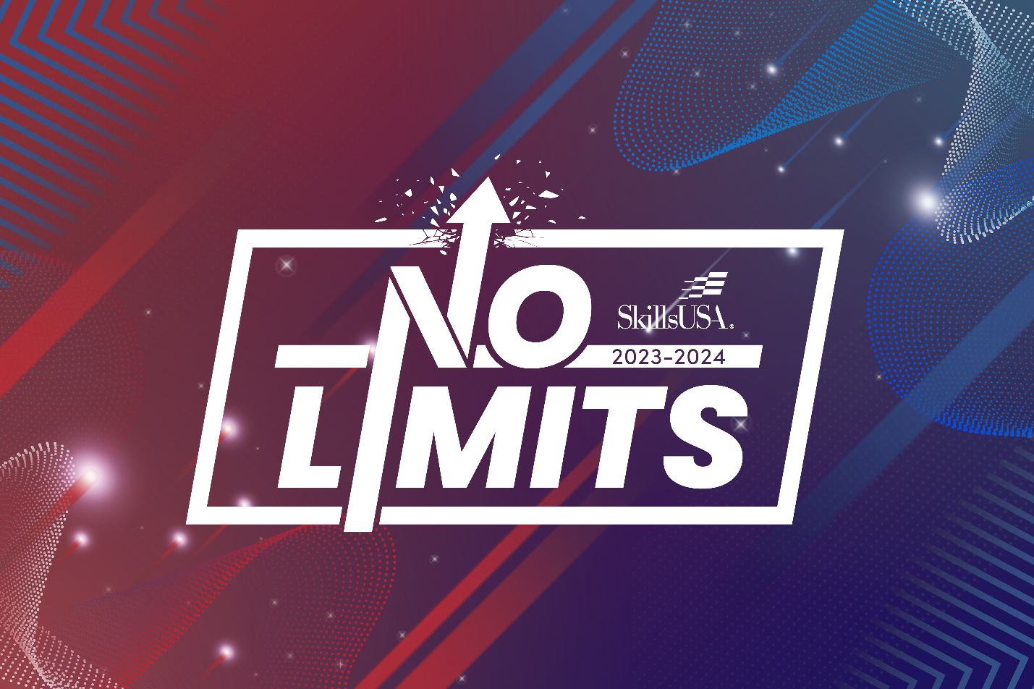

8/2/2023 (ntw)

