2019 Mississippi Administrator of the Year

Program Application

Sponsored by

Mississippi Department of Education

Office of Teaching and Leading
P.O. Box 771 - Jackson, MS 39205-0771
Phone: 601-359-3631
Website: www.mdek12.org/OTL

ADMINISTRATOR OF THE YEAR
NOMINATION AND APPLICATION PROCEDURES
- The applicant must be qualified for nomination by currently serving as an elementary or secondary principal, assistant principal, vocational-technical or alternative school director.
- Include the district superintendent’s signature on the original application.

- Complete all sections of the application and submit the following as part of a complete packet:

- Part I – Application
- Part II – Resume
- Part III – Professional Biography
- Part IV – Four (4) Response Questions
- Part V – Three (3) Letters of Support
- One orignal and four stapled copies of the application packet

- Please do not include a photograph and only submit the items listed above.

- The application packet must be received in the Office of Teaching and Leading by the close of business on Friday, January 11, 2019. Please send the complete packet via postal mail to:

Mississippi Department of Education
Administrator of the Year Program
Office of Teaching and Leading
P.O. Box 771
Jackson, Mississippi 39205-0771

For questions, contact the Office of Teaching and Leading at 601.359.3631 or Sandra Hilliard at shilliard@mdek12.org.

CONGRESSIONAL DISTRICT MAP

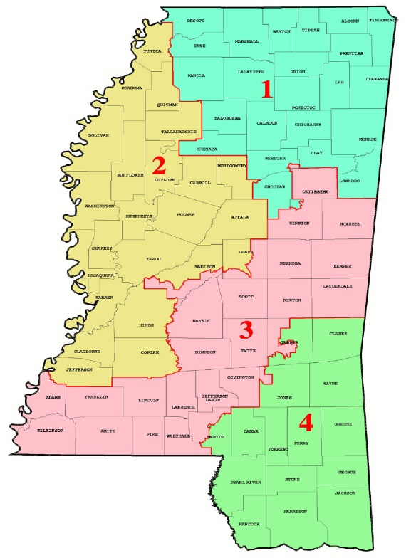

2019 Mississippi Administrator of the Year Program Timeline
(Tentative)

Date(s) | Activity
October 2018 | 2019 Administrator of the Year nomination application emailed to district superintendents. The application is available on the Mississippi Department of Education, Office of Teaching and Leading webpage:  https://www.mdek12.org/OTL/OTC/recognition
January 11, 2019 | The original application and 4 stapled copies must be submitted to the Mississippi Department of Education, Office of Teaching and Leading. Faxed entries will not be accepted.
February 2019 | A Letter of Congratulations and luncheon registration form will be emailed to nominees.
February 2019 | 2019 Mississippi Administrator of the Year Selection Committee will meet to select the four Congressional District Finalists.
March 1, 2019 | Registration deadline for Awards Luncheon
TBD | Congressional District Finalists Interviews
March 29, 2019 | Mississippi Administrator and Teacher of the Year Awards Luncheon (Jackson Convention Center)

2018-2019 Mississippi Administrator of the Year
Application

Please type
Part I

Employment Information
___Mr. ___Mrs. ___Ms. ___Dr. |  | Nominee Name:
1 | 2 | 3 | 4
Congressional District:
Select One (X)
School District: | County:
School Name:
School Address:
City: | State: |  |  |  |  | Zip Code:
Phone: | Fax:
School’s Website Address:
Total Years Administrator Experience: | Type of Administrator (currently)  __Elementary __Middle __ High School
Candidate’s Personal Information
Home Address:
City: | State: |  |  |  | Zip Code:
Cell Phone: | Home Phone:
Work Email:
Alternate Email:
Twitter Handle (if applicable):
Facebook Profile (if applicable):
Instagram Profile (if applicable):
Other Social Media Profile (if applicable):
For Publicity Purposes Only
Spouse’s Name (if applicable):
Spouse’s Occupation (if applicable):
Enter Children’s Name Below (if applicable): |  |  | Ages | School or Occupation
Professional Information
Please list all professional association memberships in which you are currently active (i.e. MASS, MASA, etc.):

School District Superintendent

Name Title

Superintendent’s Email Address _________________________________________________________________

District Address

City State Zip Code Telephone

I acknowledge that the nominee submits this application with my approval and if the nominee is selected as the State Administrator of the Year, he or she may be requested for various speaking and/or professional development engagements during the year of recognition.

Signature of District Superintendent Date

Administrator of the Year Candidate

I hereby give my permission that any or all of the attached materials (other than home address and telephone) may be shared with persons interested in promoting the Administrator of the Year Program. I also acknowledge that if selected as the 2019 Administrator of the Year, I may be requested for various speaking and/or professional development engagements during the year of recognition.

Signature of Candidate Date

Instructions for Required Documents

Please review the instructions for each item to ensure that all details/requirements are included for a complete application packet.

 | ITEM DESCRIPTION/INSTRUCTIONS
Application (Part I) | Complete the application and include the following signatures:  - School District Superintendent  - Candidate
Resume (Part II) | Attach a formatted resume that includes the following components:  - Education (colleges and universities attended)  - Certifications  - Teaching Experience  - Teacher Leadership  - Awards and Other Recognition  Include the year(s) and/or time frames where appropriate.
Professional Biography  (Part III) | Complete a professional biography in 3rd person. The professional biography should include the following details and should not be more than 500 words (double-spaced), 1 inch margins, and 12 point font size:  - Heading that includes candidate name and school district  - Personal philsophy of education and teaching  - Community Involvement  - Your greatest contribution and accomplishments while in the profession  - Evidence (quantitative or qualitative) of student achievement
4 Response Questions  (Part IV) | Respond to the four questions located on Pages 10-13 of the application. Each response should not be more than 500 words (double-spaced).
Letters of Support  (Part V) | Include three (3) different letters of support from any of the following: superintendent, principal, administrator, colleague, student/former student, parent or civic leader. Submit all letters with the application. Letters should be one page in length and double-spaced between the paragraphs.

Note: The above instructions and the Evaluation Rubric/Rating form is a guide for the candidate. Please do not return the instructions and the rubric rating form with your application packet. Return only the required documents (Part I, II, III, IV, V).

2018-2019 Mississippi Administrator of the Year Application

Part II: Resume

2018-2019 Mississippi Administrator of the Year Application

Part III: Professional Biography (Complete in 3rd Person)

2018-2019 Mississippi Administrator of the Year Application

Part IV: Response Questions 1-4

- Describe three (3) programs/projects that you have initiated to improve student achievement in your school or district. Explain the results of those programs/projects.

- Describe your most rewarding professional experience as an administrator.

- What do you consider to be a major public education issue today? Describe why this is important to you and how you are addressing this in your role as an administrator. Describe only one issue.

- Describe your commitment to your community through: 1) service-oriented activities such as volunteer work, 2) civic and other group activities, AND 3) community or business partnerships with your school in which you have helped initiate.

2018-2019 Mississippi Administrator of the Year Application

Part V: Three (3) Letters of Support

EVALUATION RUBRIC/RATINGS

Each candidate will be rated on the components of the application. The following rubric will be used to evaluate each candidate’s completed application. Incomplete applications will not be reviewed. Each candidate may receive up to 28 total points. If there are candidates who are tied for the highest number of points in the same congressional district, they may be asked for additional information to break the tie.

RESUME
□ 1 POINT Resume is poorly organized. One or more of the required components are missing and/or includes significant gaps in the professional timeline. Resume contains spelling, grammar or formatting errors that make it difficult to read. White space is poorly distributed and leaves some components lacking useful detail and others crowded with unnecessary text.
□ 2 POINTS Resume is somewhat fairly organized and includes all required components. Components are lacking a comprehensive view of the educator. Resume contains some spelling, grammar or formatting errors.
□ 3 POINTS Resume is organized well. All components are included; however, some lack important details. White space usage is somewhat well-distributed.
□ 4 POINTS Resume is exceptional. It is well-organized and demonstrates clear details of the administrator’s Education, Certifications, Teaching Experience(s), Leadership, Awards and Other Recognition. Resume uses white space adequately and includes thorough and succinct explanations for each component.
COMMENTS:

PROFESSIONAL BIOGRAPHY
□ 1 POINT Professional Biography is poorly organized. Responses do not provide a comprehensive nor succinct view of the administrator’s personal philosophy of education and teaching, community involvement, his/her greatest contribution and accomplishments, nor evidence of student achievement. No evidence is presented to support the required elements.
□ 2 POINTS Professional Biography is somewhat organized. Responses provide little view on the administrator’s philosophy of education and teaching, community involvement, greatest contribution and accomplishments, and evidence of student achievement. Little evidence is included to support these elements.
□ 3 POINTS Professional Biography is well organized. Responses provide an adequate view of the administrator’s philosophy of education and teaching, community involvement, greatest contribution and accomplishments, and evidence of student achievement. Ample evidence is included to support these elements.
□ 4 POINTS Professional Biography is exceptionally organized and detailed. A comprehensive view of the administrator’s philosophy of education and teaching, community involvement, greatest contribution and accomplishments, and evidence of student achievement is provided. Extensive evidence is provided for these elements and are directly tied to student success.
COMMENTS:

RESPONSE QUESTION #1: Describe three (3) programs/projects that you have initiated to improve student achievement in your school or district. Explain the results of those programs/projects.
□ 1 POINT Responses do not address all questions asked. The administrator does not provide a succinct and/or clear response to each question item. Details are lacking.
□ 2 POINTS Responses address questions, but are not succinct. Administrator provides little to no evidence in addressing the questions.
□ 3 POINTS Responses address all questions and are specific. Details are presented for each item and evidence is provided.
□ 4 POINTS Responses comprehensively address each item. Administrator provides substantial specifics in the responses and detailed descriptions. Substantial evidence is provided for each of the questions.
COMMENTS:

RESPONSE QUESTION #2: Describe your most rewarding professional experience as an administrator.
□ 1 POINT Responses do not address all questions asked. The administrator does not provide a succinct and/or clear response to each question item. Details are lacking.
□ 2 POINTS Responses address questions, but are not succinct. Administrator provides little to no evidence in addressing the questions.
□ 3 POINTS Responses address all questions and are specific. Details are presented for each item and evidence is provided.
□ 4 POINTS Responses comprehensively address each item. Administrator provides substantial specifics in the responses and detailed descriptions. Substantial evidence is provided for each of the questions.
COMMENTS:

RESPONSE QUESTION #3: What do you consider to be a major public education issue today? Describe why this is important to you and how you are addressing this in your role as an administrator.
□ 1 POINT Responses do not address all questions asked. The administrator does not provide a succinct and/or clear response to each question item. Details are lacking.
□ 2 POINTS Responses address questions, but are not succinct. Administrator provides little to no evidence in addressing the questions.
□ 3 POINTS Responses address all questions and are specific. Details are presented for each item and evidence is provided.
□ 4 POINTS Responses comprehensively address each item. Administrator provides substantial specifics in the responses and detailed descriptions. Substantial evidence is provided for each of the questions.
COMMENTS:

RESPONSE QUESTION #4: Describe your commitment to your community through: 1) service-oriented activities such as volunteer work, (2 civic and other goup activities, AND 3) community or business partnerships with your school in which you have helped initiate.
□ 1 POINT Responses do not address all questions asked. The administrator does not provide a succinct and/or clear response to each question item. Details are lacking.
□ 2 POINTS Responses address questions, but are not succinct. Administrator provides little to no evidence in addressing the questions.
□ 3 POINTS Responses address all questions and are specific. Details are presented for each item and evidence is provided.
□ 4 POINTS Responses comprehensively address each item. Administrator provides substantial specifics in the responses and detailed descriptions. Substantial evidence is provided for each of the questions.
COMMENTS:

3 LETTERS OF SUPPORT
□ 1 POINT All letters are brief and provide little evidence about the candidate’s qualifications to become Mississippi’s 2018-2019 Administrator of the Year.
□ 2 POINTS At least two of the letters are brief, but provide a description of the candidate’s qualifications for Mississippi’s 2018-2019 Administrator of the Year.
□ 3 POINTS Some or all of the letters are 1 page in length and provides a description of the candidate’s qualifications for Mississippi’s 2018-2019 Administrator of the Year. Letters also provide specifics and evidence regarding the candidate.
□ 4 POINTS Letters are 1 page in length and provide detailed and substantiated descriptions of the candidate including his/her contribution to student success, achievement in and outside the classroom, or other specific evidence. Letters also provide a compelling view of the candidate’s qualifications to become Mississippi’s 2018-2019 Administrator of the Year.
COMMENTS:

FINAL SCORE
Tally the Points allotted in each of the sections. This is the candidate’s final score. The highest total any candidate may earn is 28 Points. | CANDIDATE’S TOTAL

