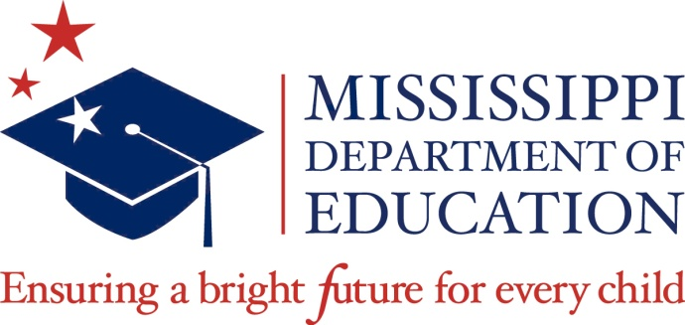

Guidelines for Recognitions of Achievement
We have many great achievements in public education in the state, and we need to celebrate those accomplishments. To honor these achievements, guidelines for recognitions have been developed.
Upon return of the attached recommendation form, recognitions will be assigned to one of the categories. The person submitting the nomination form will be notified as to which category of achievement the nominee will be recognized. Please do not invite your nominee until selection has been confirmed by the Communications Office.
Recognition categories:
- State Board of Education recognitions, which occur during monthly Board meetings, are reserved for individuals, groups, or schools that have earned national, regional, or statewide awards, honors, and achievements. These recognitions are designed to highlight the exceptional work in public education across Mississippi.

- At the discretion of the State Superintendent of Education, a congratulatory letter to those who have an achievement that deserves congratulations but may not qualify for Board recognition. The Superintendent’s letter will be personalized and mailed to the recipient’s home. Details about the nominee and the purpose of the recognition must be submitted after notification about this category of achievement.

After completion, this form should be delivered to Suite 310 or e-mail to tburkett@mdek12.org.

If your request is approved, you will be contacted about the date your requested recognition will take place and/or the category of recognition.

Name, telephone and e-mail of person submitting request: | Date of submission:
Name of individual(s), address, school and/or school district:

District Superintendent and Principal contact info: address, telephone and e-mail:
Requested month for recognition (must be at least two months after submission):

Description of honor to be recognized :

Please do not invite your nominee until selection has been confirmed by the Communications Office.

