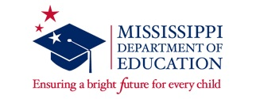
2020/2021 Early Childhood Specialized Bootcamp Training
This training is offered to teachers that need to acquire twelve hours of approved early childhood coursework to teach in pre-k classrooms. The completion of this training program will be the equivalent of twelve hours of course work needed for teachers and assistants of pre-k classrooms, general education and special education, lacking an emphasis in early childhood.
Completion of this training program includes:
- one one-day onboarding training (July 2020)
- two on-line courses (beginning August 2020)
- submission of all assignments to receive certification
- and a two-week face-to-face training at one of our six locations across the state (Jackson, Hattiesburg, Indianola, Columbus, Brookhaven, and Oxford, June 14-25, 2021, excluding the weekend)
The face-to-face components of bootcamp training will also meet the requirements of professional development for administrators of pre-k classrooms.
Below is a graphic to help determine if you should attend the Specialized Early Childhood Training Bootcamp. If you are a teacher or assistant in an Early Learning Collaborative your requirements are different from the ones listed.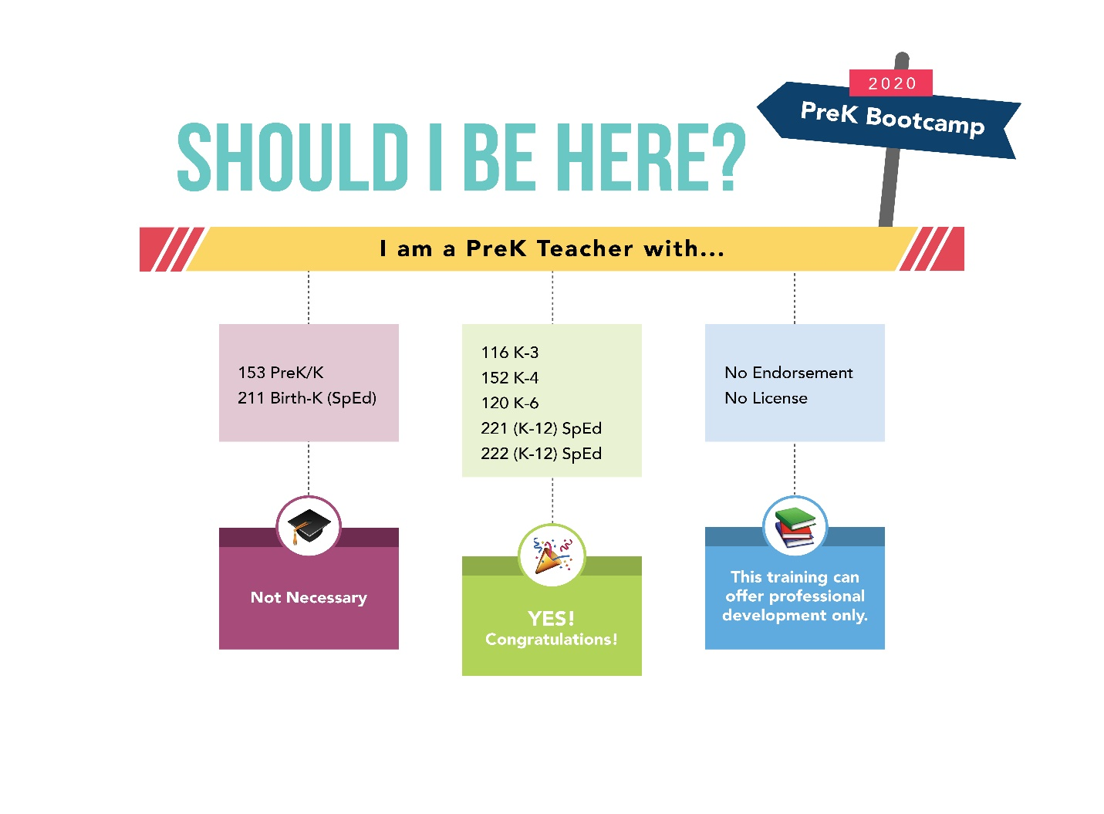
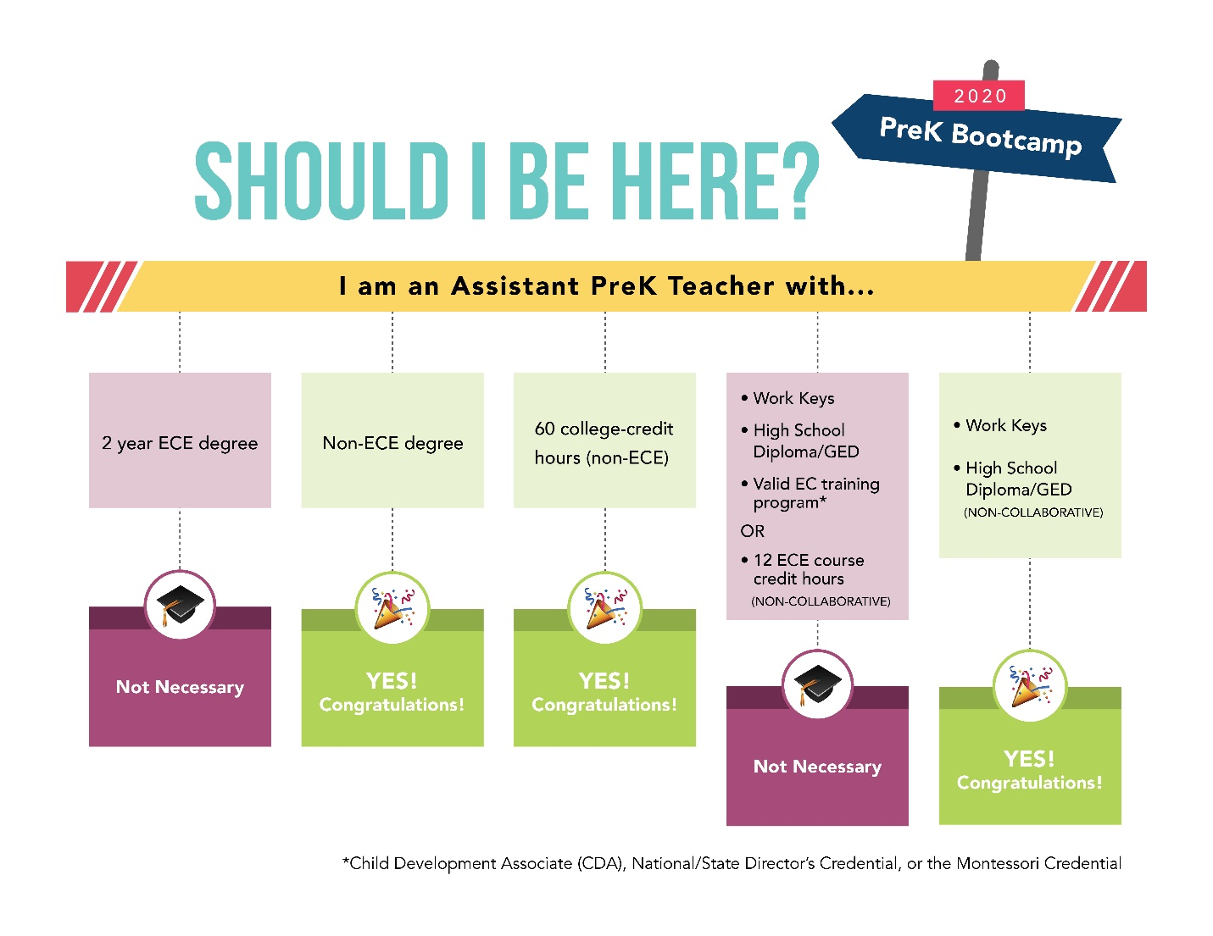
Registration: Additional information regarding registration will be coming soon. Registration will be handled through North MS Education Consortium (www.northmsec.com). Participants will be required to create an account, provide a valid email address that is checked on a regular basis, and select one of the six sites for the two-week face-to-face training that you will be attending.
Each participant will need to bring a laptop or iPad to the training.
During the two-week face-to-face training, you will be provided approximately an hour to have lunch with your training colleagues on your own. Information on convenient local eateries will be provided at the training.

