58th Annual U.S. Senate Youth Program
Requirements and Instructions
Any high school junior or senior is eligible for the program, provided he or she has not previously been a delegate to the program. The student must be currently serving, for the entire 2019-2020 academic year in an elected or appointed capacity in any of the following student government, civic, or educational organizations:

- Student Body president, vice-president, secretary, or treasurer
- Class president, vice-president, secretary, or treasurer
- Student Council representative
- Student representative elected or appointed (appointed by a panel, commission or board) to a district, regional or state-level civic and/or educational organization approved by the state selection administrator

To be eligible for consideration for this program, please complete the following:

- Complete the attached application.
- Complete the USSYP National Qualifying Exam registration form (attached).
- Attach an official copy of the high school transcript. This must include a listing of the current courses in which the student is enrolled.

Please submit your application, exam registration form, and transcript via postal mail or email to:

Latawnia Mainor
Mississippi Department of Education
Office of Teaching and Leading, Ste. 101
P.O. Box 771
Jackson, MS 39205
Email: LMainor@mdek12.org

All documents must be received or postmarked no later than Friday, October 11, 2019 by 5:00 p.m. No faxed or late entries will be accepted. A confirmation email will be sent to all applicants.

Mississippi Department of Education
United States Senate Youth Program
2019-2020 Student Application

SECTION 1: GENERAL INFORMATION
SCHOOL INFORMATION
School District ______________________________ High School ________________________________
School Address ___________________________________________ State ____ Zip ________________
Principal’s Name ______________________________ Email Address ____________________________
County ______________________________ Congressional District in which school is located _________
STUDENT INFORMATION
Last Name ___________________________ First Name __________________________ M.I. _______
Street Address __________________________________________________________________________
City ____________________________________ State _____ Zip ________________ Grade _______
Phone ____________________________ Email Address ________________________________________
Date of Birth ______________ Parent/Guardian’s Name ________________________________________
Parents’ Phone ________________________ Parents’ Email Address ______________________________
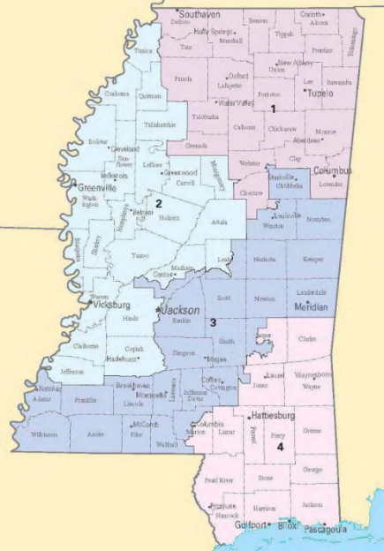
MISSISSIPPI CONGRESSIONAL DISTRICT MAP
SECTION 2: LEADERSHIP IN SCHOOL ACTIVITIES AND COMMUNITY SERVICE
Please list all school and community activities in which you are/were involved each year beginning with the 2019-2020 school year.
CLUB/ORGANIZATION | POSITION | YEAR(S) | RESPONSIBILITIES

Essay Question 2: In 100 words or less, describe your vision of leadership and government. What have you learned from your leadership experience(s)? Please use the space provided.
Essay Question 1: In 100 words or less, describe your higher education goals. How will this scholarship help you achieve those goals? Please use the space provided.
SECTION 3: VERIFICATION AND SIGNATURE
This is to verify that I nominate the student named above; and to the best of my knowledge, the information provided on this form is true. Note: The principal of the school should also sign.

Nominated by ____________________________________ _________________________________
Name Position
Principal’s Signature __________________________________ Date ____________________________

TEST SCORES
To be completed by the counselor only.
GPA _____________ Composite ACT Score ____________ SAT score _________________
Counselor’s Name ________________________________ Signature _______________________________

United States Senate Youth Program
National Qualifying Exam
Registration Form
The United States Senate Youth Program National Qualifying Examination will be administered on Saturday, October 19, 2019 from 8:30 a.m. until 12 noon. Registration begins at 8:00 a.m. Due to the program’s national deadline, this is the ONLY examination date.
As a nominee, you must register to take the exam at one of the sites listed below. Please select the testing site of your choice and return this form with your application by mail or email to:

Latawnia Mainor
Mississippi Department of Education
Office of Teaching and Leading, Ste. 101
P.O. Box 771
Jackson, MS 39205
Email: LMainor@mdek12.org

Website: https://mdek12.org/OTL/OTC/USSYP

Student Name ______________________________________ Date ___________

Place a check mark (√) or X in the box for the testing location of your choice.
Northern Region | Central Region | Southern Region
LaFayette High School | Ridgeland High School | Petal High School
160 Commodore Drive | 586 Sunnybrook Road | 1145 Hwy 42
Main Building | Main Building | Main Building
Oxford, MS 38655 | Ridgeland, MS 39157 | Petal, MS 39465

Please note that a PHOTO ID IS REQUIRED on the day of the exam. Signs will be visible at each location designating where the exam will be held.
Note: All documents must be received or postmarked no later than Friday, October 11, 2019 by 5:00 p.m.
Disclaimer: Students may be asked to confirm their proof of U.S. citizenship or legal permanent resident status.

